|  |  |  |
| --- | --- | --- |
|  |  |  |

National Level Paper Presentation

Design Document – Semester IV

|  |  |  |  |
| --- | --- | --- | --- |
| **Guide Teacher :** | Phạm Công Thành | | |
| **Class :** | GC0862 | | |
| **Group :** | 3 | | |
| **Group’s Members:** | Full Name | | Enrollment No. |
|  | 1. | Võ Minh Nhựt | Student687836 |
|  | 2. | Trần Nguyễn Công Nguyên | Student687854 |
|  | 3. | Nguyễn Ngọc Kiều Trinh | Student687822 |
|  | 4. | Đỗ Ngọc Quý | Student687813 |
|  |  |  |  |

# <04 – 2014>

National Level Paper Presentation

Design Document – Semester IV

|  |  |  |  |
| --- | --- | --- | --- |
| **Guide Teacher :** | Phạm Công Thành | | |
| **Class :** | GC0862 | | |
| **Group :** | 3 | | |
| **Group’s Members:** | Full Name | | Enrollment No. |
|  | 1. | Võ Minh Nhựt | Student687836 |
|  | 2. | Trần Nguyễn Công Nguyên | Student687854 |
|  | 3. | Nguyễn Ngọc Kiều Trinh | Student687822 |
|  | 4. | Đỗ Ngọc Quý | Student687813 |
|  |  |  |  |

# <04 – 2014>

**Table Of Contents**

**Review 1** 4

* 1. Introduction 5
  2. Existing Scenario 5
  3. Customer Requirement Specification 5
  4. Functional Requirement Specification 7
  5. System Requirements 11
  6. Development Software 12
  7. Technology 13

**Review 2** 15

* 1. Use Case and Sequence Diagram 16
  2. Entity Relationship Diagram (ERD) 75
  3. Entity Properties…………………….…………………………..……………………………76

**Review 3** 81

* 1. Database Relationship Diagram 82
  2. Table Definition…………………..………………………………………………………….83
  3. Site map 90
  4. GUI Design 92
  5. Report 139

**Task sheet** ………… 144

Task sheet 145

**Monitoring report** ………… 154

Monitoring report 155

REVIEW 1

# Introduction

KSC Technology and Sciences is the educational university which runs the classes for the categories like Engineering, Pharmaceutical sciences, Literature, etc. It is one of the famous universities in the country. They generally conduct Paper Presentations at state level and national level. They also conduct seminars, Techno-Feat, etc. to inputtain the students in the technical backgrounds.

Each time when they conduct seminars, symposiums, or paper presentation, etc. They used to send the invitations for the participation of the students of other colleges, etc. So that the knowledge of the student can be enhanced and at the same time, the students who does not belong to this university can also have the opportunity in participating in these activities.

While sending the invitations to the other colleges, universities, they quote some registration fees for the gate pass and they will provide the details like the topics for which seminars, paper presentations, symposiums, or techno-feats are conducted. For the seminars and the Techno-feats, they also provide the names of the speakers who are conducting or providing this. Along with the invitation, they also send the format of application, which is to be filled and sent back to the address as mentioned in the invitation for participating in the activities

In general, to participate in these activities, the students who do not belong to this university send their requests by filling in the application form as per the format sent and send it along with the payment through courier or directly dropping it at the address in personal. In case of the Paper presentations, along with the courier, they also used to submit both the soft copy and the hard copy, so that they can reach the mentioned address before the end date of the participation. After sending these copies, they used to verify and then finalize which students are to be participated in this paper presentation. The selection is purely based on the technology (as mostly they prefer the new implementations in the technology, etc.).

# Existing Scenario

Now the university wants to provide a facility where the participants can register themselves online and as well, the invitation can be displaysed directly online itself in the specific portal. Once they are registered online they can send the details of the payment along with the print out of the application along with the signature of the participant and for the paper presentation, the hard copy of the paper presentation will be sent along with it. Therefore, they have approached us in order to help them.

# Customer Requirement Specification

* There should be a logo indicating the brand of the institute on all the web pages.
* On the home page of the website the details of the upcoming activities, and the winners of the recent activity conducted is to be displaysed. In addition, the details of the participants like how many are registered for the recent or for the latest activity conducted can be displaysed on the home page.
* The user can also create the account with the website, with his/her personal mail id. So that if any activity is going to be launched a mail will be marked to the mail id that is mentioned during the time of registration with the site.
* When a user tries to access the link of the activity like symposium, seminar, techno-feat, etc. he/she should be able to view the details like
  + Date and time of conducting
  + The procedure for applying for the participation
  + The fees details
  + Payment options
  + Eligibility criteria
  + Speakers name or guest’s name
  + Topics on which the activity is performed
  + Price details if any
  + Address for sending the applications for the participation
  + Terms and conditions, etc.
* The navigation bar should include the following
  + Home Page
  + Login Page
  + Application or enroll Page
  + Update/Edit Page
  + Subscribe Page (through this one can create the account)
  + Unsubscribe Page (through this one can deactivate the account created)
  + About Us Page
  + Contact Information Page
* Through Login page, users and admin can login.
* Through the Enroll page one can enroll or apply for symposiums, seminars, Techno-Feat, etc.
* Through Subscribe Page, one can subscribe for the mailing lists and create the account with the site.
* Through Unsubscribe Page, one can unsubscribe.
* Through Update page that is available after login one can Manage Personal Information
* It should also include the About Us and Contact information.
* The payment options to be included are
  + Payment through Demand Draft
  + Payment through Cheque
  + Payment by cash
* The application can be done in both the ways
  1. Online application
  2. Taking the print out of the application and filling it up and sending it through courier to the address mentioned

# Functional Requirement Specification

## Guest can register as User

### Description

* + 1. The system must provide a page to allow guest create their accounts with the following information:
* Mail ID(This will be Username)
* Password
* Confirm password
* Name
* Birthday
* Gender
* Address
* Phone.

### Functional Requirements

1. User must provide Mail ID, Password, Name, Birthday, Gender, Address, and Phone to create an account.

## Guest can login as User

### Description

* + 1. The system must provide a page to allow guest login as User. The system must distinguish User from KSC and User not from KSC University.Login form should content :
* Mail ID
* Password

### Functional Requirements

1. Guest must provide Username and Password to login into the website.
2. System must distinguish User type to displays pages which user can view.
3. User can only access to pages they have permission.

## Enquiry from Guests (not registered users)

### Description

* + 1. System must provide a tool to allow guests send enquiries.

### Functional Requirements

1. The enquiries from guests must be sent to system.

## Management of User

### Description

* + 1. System must provide for User a management page to edit his personal information as follow:
* Password
* Name
* Birthday
* Gender
* Address
* Phone.

### Functional Requirements

1. User can modify his profile.
2. User must provide correct password to update his information

## Users can search for events.

### Description

Users can search for events. System must provide for Users a search function. They can search for an event by properties.

These are information Users should provide when search for an event:

1. Date of Event
2. Name of Event

## Users can enroll himself as an event paticipant

### Description

* + 1. System must provide “an enroll button” at the end of each Event Detail Page for users to enroll an event.
    2. When User click “enroll button” system must distinguish User from KSC and User not from KSC University.
    3. If User is not from KSC University,a payment option will appear for user to choose appropriate payment method, then a payment request of gate fee must be supply before the enroll request is accepted. The payment request should include these information:
       1. Username
       2. Event Name
       3. Date
       4. Gate Fee
       5. Payment Method

### Functional Requirements

1. Users must provide Username and Password to login into the website.
2. Users must choose Payment through Demand Draft, Cheque or by Cash.

## Users can review their participated events

### Description

* + 1. System must provide Users a page that have a friendly interface for user to have a look at their recent activities
    2. Page should provide the following information:
       1. Date of Event
       2. Name of Event
       3. Event Score
       4. Is Winner
       5. Event Status

### Functional Requirements

1. All information should be displaysed as tabular data

## Users can upload their contents

### Description

* + 1. System must provide Users a page that have an upload bar for user to upload their contents.
    2. Page should contain a combo box of user’s upcoming events, through which users can determine which event that they want to upload contents for.

### Functional Requirements

1. User must provide a single file to upload contents to server
2. User must select an event before upload contents

## Users can download their event’s contents

### Description

* + 1. When user enrolled for an events, if that event have any approved content then a “Download content” button should appear at the end of event’s details page to allow user to download contents.

### Functional Requirements

1. Users must enrolled for a specific event
2. Event’s contents must be approved by Website Admin

## Users can comment an event

### Description

* + 1. For each an event that user participated there should be able to comment. The system must provide a page to allow users to comment with the following information:

1. Event Name
2. Event Date
3. Comment

### Functional Requirements

1. User can view other comments
2. User should be able to comment only after they participated event.
3. Administrators can answer for comments

## Users can feedback

### Description

The system must provide a page to allow users to feedback. Page should have following fields:

-Title

-Feedback Info.

### Functional Requirements

1. User can view Feedback page
2. User should be able to feedback
3. Administrators can answer for feedback.
4. Administrators can delete these.

## Admin can manage events

### Description

System must provide for Admin to manage events.Through this, Admin can create events by supply these info:

* + 1. Date of Event
    2. Host
    3. Name of Event
    4. Price(If Any)
    5. Type of Event
    6. Minimum Participant/Maximum Participant
    7. Gate Fee(For Students who not belong to this university)

Along with those info Admin can also update event info like:

* + 1. Winner of the event(Contest)
    2. Upload or Confirm an uploaded document for event

### Functional Requirements

1. Admin must provide Event, Name, Host, Number of participants, Date to create an event.
2. Topic must be unique.
3. Event must be valid.
4. Host must be valid.
5. Number of participants must be valid.
6. Date must be valid.
7. After all information are validated and Event is created, admin will be redirected to Manage Event to update Manage Event list.

## Admin can update User’s event-score

### Description

After the event finished, Admin can insert point for Participants in that event

### Functional Requirements

1. Admin can insert Point for participants.
2. After update score, admin will be redirected to Event Participant List to update List of Participants.
3. Administrators can view list of Participants.

## Reporting Page

### Description

System must provide a page through which by selecting a period of time Users/Admin can see a quick sumary about events and also about Users Ranking in that time

By selecting “Top 10 active user” page will displays a list of Top 10 active user

By selecting “User Ranking” page will displays a list of Top 10 User who has best score

In Back-end (Admin page) system must provide a page through which by selecting a period of time Admin can see a quick sumary about events.

By selecting “Top 10 popular events” page will displays a list of Top 10 event that have most participants.

By selecting “Top 10 unpopular events” page will displays a list of Top 10 event that have least participants.

## Administrators can manage feedbacks

### Description

System should provide for Administrators a page, which allows they manage feedback, view Feedback’s information, view list of Feedback that includes follow information:

* + 1. Title
    2. Feedback info

### Functional Requirements

1. Administrators can answer feedback.
2. Administrators can view Feedback’s information.
3. Administrators can view list of Feedback.

## FAQ Page

### Description

System must provide to Users a page, which displayss frequently questions and answers. Administrators can add, modify or delete these.

* + 1. Question
    2. Answer

### Functional Requirements

1. Customers can view FAQs page.
2. Administrators can add, modify or delete these.

## GUI Requirements

### Description

System should provide to Customers an attractive home page.

### Functional Requirements

1. An attractive home page.

# System Requirements

## Hardware

### Web Server

|  |  |
| --- | --- |
| Processor | Core i3 gen3 or higher is recomended |
| Memory | 4GB RAM or greater. |
| Modem/ADSL | Connecting to internet 24/24 |

### Client

|  |  |
| --- | --- |
| Processor | Core i3 gen3 or higher is recomended |
| Memory | 4GB RAM or greater. |
| Monitor | 1024x768 or higher resolution with true color |
| Pointing Device | Microsoft Mouse, Microsoft IntelliMouse®, or compatible pointing device. |
| Modem/ADSL | Connecting to internet |

## Software

### Web Server

|  |  |
| --- | --- |
| Operation System | Windows 7 |
| Browser | Mozilla Firefox 28 or higher |
| Database | Microsoft SQL Server 2012 |
| Software | Java SDK 1.6 |
|  | Apache Tomcat 5.5 |
|  | ZK Framework 3.0 |
|  | Jboss 5.x |

### Client

|  |  |
| --- | --- |
| Operation System | Windows 7 |
| Browser | Mozilla Firefox 28 |

1. Development Software

* Microsoft Windows 7 Professional
* Java SDK 1.6
* Apache Tomcat 5.5
* Jboss Server

1. Technology

* J2EE
* Java Web Service
* JSP, Servlet
* HTML
* EJB
* CSS 3
* Jquery

|  |  |  |
| --- | --- | --- |
|  | **Prepared by (Student)** | **Approved by (Faculty)** |
| **Signature** | Team leader  **Vo Minh Nhut** | **Pham Cong Thanh** |
| **Date** |  |  |

REVIEW 2

# Use Case and Sequence Diagram

# GUEST

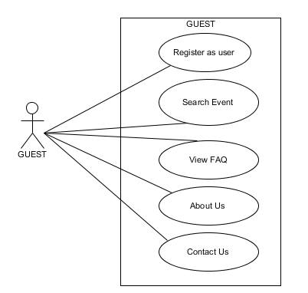

* + 1. **Register as a user**

|  |  |  |
| --- | --- | --- |
| **Author** | Nguyen Ngoc Kieu Trinh | |
| **Use Case Name** | Register as user | |
| **Actors** | Guest | |
| **Description** | Guest wants to register with the website to become a user. | |
| **Requirements** | Guest provides Guest’s information about EmailID, Password,Name, birthday,Phone,Address,Gender | |
| **Pre-conditions** |  | |
| **Post-conditions** | Success: Guest creates a user account in this website  Fail: Refill information | |
| **Basic flow** | Actor Actions:  1. Actor clicks ‘Sing Up’ button in Home page  3. Actor clicks on to Submit button.  5. Actor inputs register’s information, and click ‘Submit’ button. [Alternative 1] | System Responses:  2. System redirects to Registration page.  4. System redirects to Registration page and displayss Registration form with the following control :  - ‘Email ID’ text field  - ‘Password’ text field  - ‘Confirm Password’ text field  - ‘Name’ text field  - ‘Birthday’ date picker  - ‘Gender’ dropdownlist  - ‘Address’ text field  - ‘Phone’ text field  -‘I agree to subscribe’ checkbox  - ‘Submit’ button  -‘Cancel’ button  6. System checks the information  [Exception 1]  7. System inserts the account into database, show message: ‘Your account has been created!’ and then redirects to Login page. |
| **Alternative flow** | Actor Actions:  [Alternative 1]  1. Actor click ‘Cancel’ button. | System Responses:  2. System returns to Home page. |
| **Exception** | Actor Actions:  [Exception 1]  1. Actor lefts ‘Mail ID’ text field blank.  2. Mail ID has already exists.  3. Actor lefts ‘Password’ text field blank.  4. Actor lefts ‘Confirm Password’ text field blank.  5. Password and confirm password don’t match.  6. Actor lefts ‘Name’ text field blank.  7. Actor lefts ‘Birthday’ calendar blank.  8. Input age to ‘Birthday’ calendar less than 16.  9. Actor lefts ‘Address’ text field blank.  10. Actor lefts ‘Phone’ text field blank.  11. Input phone not in numeric or phone length not in range 8 – 11 character. | System Responses:  System displayss message to Actor :  - ‘Mail ID ‘shouldn’t be blank’.  - ‘This Mail ID has already exist!’.  - ‘Password shouldn’t be blank’’.  - ‘Confirm Password shouldn’t blank’.  - ‘Confirm password not match password.’  - ‘Name shouldn’t be blank’.  - ‘Birthday is invalid’ and ‘Age must over 16’.  - ‘Address shouldn’t be blank’.  - ‘Phone is invalid’.  - ‘The phone number should be numeric only and must be between 8 and 11 digits’. |

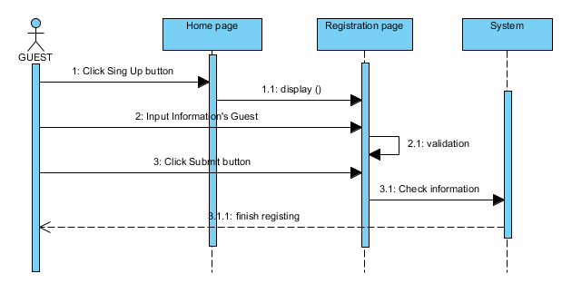

* + 1. **View FAQ**

|  |  |  |
| --- | --- | --- |
| **Author** | Nguyen Ngoc Kieu Trinh | |
| **Use case name** | FAQs Show | |
| **Actors** | Guest or User | |
| **Description** | View List of FAQs | |
| **Requirements** | Actor can view some FAQ example | |
| **Post-conditions** | Success: View List of Questions | |
| **Basic flow** | Actor actions:  1. From ‘Home’ page, actor clicks on to the ‘FAQ’ in the navigation bar. | System response:  2. System redirects to ‘FAQ’ page and displays list of all of FAQs in table form with :  -Question  -Answer |
| **Alternative flow** |  |  |
| **Exception** |  |  |

* + 1. **About Us**

|  |  |  |
| --- | --- | --- |
| **Author** | Nguyen Ngoc Kieu Trinh | |
| **Use case name** | View AboutUs | |
| **Actors** | Guest or User | |
| **Description** | View AboutUs | |
| **Requirements** | Actor can view some information’s KSC university | |
| **Post-conditions** |  | |
| **Basic flow** | Actor actions:   1. From ‘Home’ page, actor clicks on to the ‘About’ in the navigation bar.   . | System response:  2. System redirects to ‘About’ page and displays information ‘s KSC university in table form with :  -History ‘s KSC  -Special ‘s KSC |
| **Alternative flow** |  |  |
| **Exception** |  |  |

* + 1. **Contact Us**

|  |  |  |
| --- | --- | --- |
| **Author** | Nguyen Ngoc Kieu Trinh | |
| **Use case name** | View ContactUs | |
| **Actors** | Guest or User | |
| **Description** | View address , phone or some information’s KSC university | |
| **Requirements** | Actor can view some branch’s KSC | |
| **Post-conditions** |  | |
| **Basic flow** | Actor actions:   1. From ‘Home’ page, actor clicks on to the ‘Contact’ in the navigation bar. | System response:  2. System redirects to ‘Contact’ page and displays some branch’s KSC in table form with information about:  -“Phone”  -“Email website”  -“Address” |
| **Alternative flow** |  |  |
| **Exception** |  |  |

* + 1. **Search Event**

|  |  |  |
| --- | --- | --- |
| **Author** | Nguyen Ngoc Kieu Trinh | |
| **Use Case Name** | Property for event | |
| **Actors** | Guest | |
| **Description** | User wants to perform a Property for event | |
| **Requirements** | Actor provides search information | |
| **Post-conditions** | Success: Properties match the condition show up.  Fail: Do not have any property match the condition. | |
| **Basic flow** | Actor Actions:  1. Actor clicks ‘Search’ button on the Actor Home page menu.  3. Actor clicks on ‘Property for Event Searching’ tab.  5. Actor inputs searching’s information and click ‘Search’ button’. | System Responses:  2. System show the Search contains the following tabs:  - ‘Property for event Searching’ tab.  4. System show Property for event Searching page with Property for event Searching form contain the following controls:  - ‘Search from’ date picker  - ‘Search To’ date picker  - ‘Search’ button.  6. System select the properties in database that match searching condition and displays the result in the Searching Result list below the Property for Event Searching form. |
| **Alternative flow** |  |  |
| **Exception** |  |  |

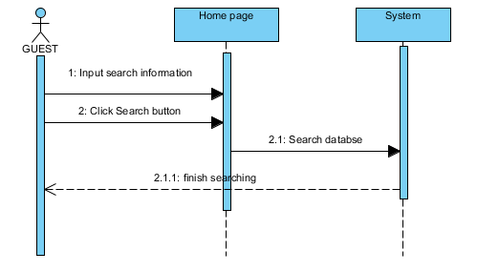

* 1. **USER**

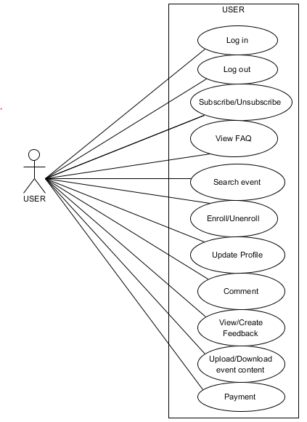

* + 1. **Login**

|  |  |  |
| --- | --- | --- |
| **Author** | Nguyen Ngoc Kieu Trinh | |
| **Use Case Name** | Login | |
| **Actors** | User | |
| **Description** | User or guest wants to login to website as a user. | |
| **Requirements** | Actor provides username and password | |
| **Pre-conditions** |  | |
| **Post-conditions** | Success: User logged in to website.  Fail: Refill information | |
| **Basic flow** | Actor Actions:  1. Actor go to Home page of website.  3. Actor inputs Mail ID and Password, then click the Login button. | System Responses:  2. System redirects to Home page and displayss Login form on the left with the following control:  - ‘Email ID’ text field  - ‘Password’ text field  - ‘Login’ button  4. System checks the information  [Exception 1]  5. System redirects to Actor’s Home page. |
| **Alternative flow** | Actor Actions:  Actor click ‘Login’ button, inputs Mail ID and Password, then click the Login button.  [Alternative 1]  1. Actor click ‘Register’ button. | System Responses:  2. System checks the information  [Exception 1]  3. System redirects to Actor’s Home page.  2. System returns to Registration Page. |
| **Exception** | Actor Actions:  [Exception 1]   1. Actor input invalid username and password. 2. Actor input Username and click Login button 3. Actor input username and password don’t same with database. | System Responses:  - System redirect to Login page with the following controls:  - ‘Mail ID’ text field  - ‘Password’ text field  - ‘Login’ button.  - ‘Register’ button.  -System show message:”Password shouldn’t be blank.Please input password”  -System show message :” Invalid username or password”. |

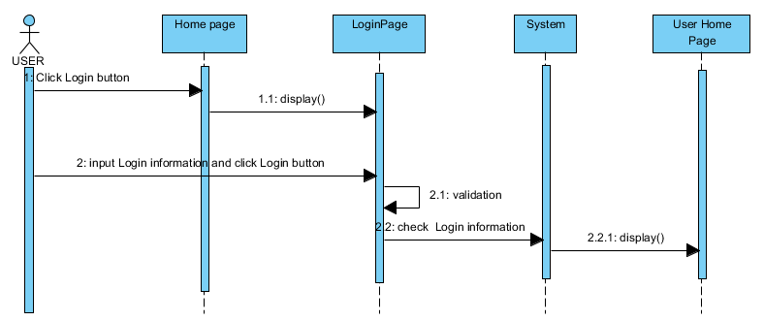

* + 1. **Log out**

|  |  |  |
| --- | --- | --- |
| **Author** | Nguyen Ngoc Kieu Trinh | |
| **Use Case Name** | Logout | |
| **Actors** | User | |
| **Description** | User wants to log out of the System. | |
| **Requirements** | Actor provides log out button | |
| **Pre-conditions** | Actor has logged in. | |
| **Post-conditions** | Success: Actor Logged out. | |
| **Basic flow** | Actor Actions:  1. Actor clicks ‘Log out’ button on the Actor’s Home menu. | System Responses:  2. System process to Log user out then redirect to Home page.. |
| **Alternative flow** |  |  |
| **Exception** |  |  |

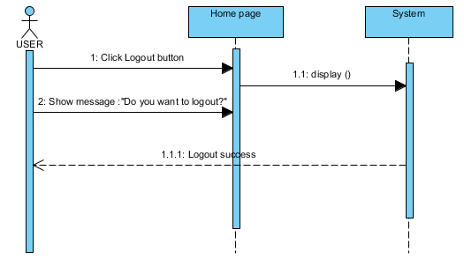

* + 1. **Change password**

|  |  |  |
| --- | --- | --- |
| **Author** | Nguyen Ngoc Kieu Trinh | |
| **Use case name** | Change Password | |
| **Actors** | User | |
| **Description** | Change Password | |
| **Requirements** | Actor provides Username and Password | |
| **Pre-conditions** | Actor has logged in as User | |
| **Post-conditions** | Success: The password of User has changed. | |
| **Basic flow** | Actor actions:  1. From ‘Home’ page, actor clicks on to the ‘Change Password’ button.  3. Actor clicks on to ‘Submit’ button to finish adding. [Alternative 1] | System response:  2. System redirects to ‘Change Password’ page and displays form with the following controls:  ‘Old Password’ textfield.  ‘New Password’ textfield.  ‘Confirm New Password’ textfield.  ‘Submit’ button.  ‘Cancel’ button  4. System checks input information.  [Exception 1]  5. System update new password of user into the database. |
| **Alternative flow** | [Alternative 1]  -Actor click ‘Cancel’ button | -System redirect to Home page. |
| **Exception** | [Exception 1]  1. Actor lefts ‘Old Password’ textfield.  2. Actor lefts ‘New Password’ textfield.  3. Actor lefts ‘Confirm New Password’ textfield.  4. ‘New Password’ textfield is not same as ‘Confirm New Password’ textfield. | System displayss a message to notice actor:  “Old Password shouldn’t be blank. Please input Old Password.”  “New Password shouldn’t be blank. Please input New Password.”  “Confirm New Password shouldn’t be blank. Please input Confirm Password.”  “New Password and Confirm New Password must be same.” |

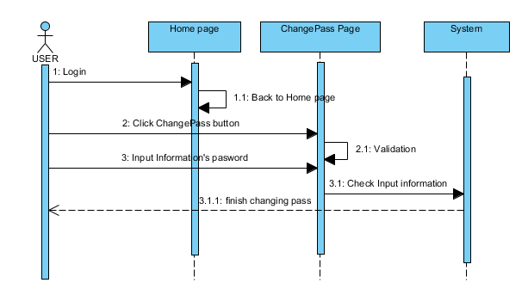

* + 1. **Update Profile**

|  |  |  |
| --- | --- | --- |
| **Author** | Vo Minh Nhut | |
| **Use Case Name** | Update Profile | |
| **Actors** | User | |
| **Description** | User wants to Update his/her profile’s information. | |
| **Requirements** | Actor provides profile information | |
| **Pre-conditions** | Actor has logged in. | |
| **Post-conditions** | Success: Profile’s information of this user has been updated.  Fail: Refill information | |
| **Basic flow** | Actor Actions:  1. Actor clicks ‘User Profile’ button in Actor’s Home page menu.  3. Actor updates information of user and click ‘Submit’ button. [Alternative 1] | System Responses:   1. System redirects to ‘UserProfile ‘page and displayss Update Profile form with the following control :   - ‘Name’ text field  -‘Image ‘ file  - ‘Birthday’ datepicker  - ‘Phone’ text field  - ‘Address’ text field  - ‘Gender’ dropdownlist  - ‘Address’ text field  -‘Upload’ button  - ‘Submit’ button  - ‘Cancel’ button  4. System checks the information  [Exception 1]  5. System update the account into database and then redirects to Actor Home page. |
| **Alternative flow** | Actor Actions:  [Alternative 1]   1. Actor click ‘Cancel’ button.   Actor click’Upload’ button | System Responses:   1. System returns to Home page.   System upload user image into database |
| **Exception** | Actor Actions:  [Exception 1]  1. Actor lefts ‘Name’ text field blank.  2. Actor lefts ‘Phone’ text field blank.  3. Actor lefts ‘Address’ text field blank. | System Responses:  System displayss message to Actor :  - ‘Name shouldn’t not blank’’.  - ‘Phone shouldn’t blank’.  -‘Address cant’t be blank’ |

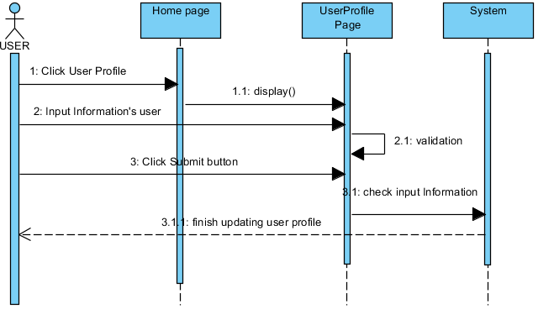

* + 1. **View Feedback**

|  |  |  |
| --- | --- | --- |
| **Author** | Vo Minh Nhut | |
| **Use case name** | View List of Feedback | |
| **Actors** | User | |
| **Description** | View List of Feedback | |
| **Requirements** | User can view some Feedback example | |
| **Post-conditions** | Actor login as User | |
| **Basic flow** | Actor actions:   1. From ‘Home’ page, actor clicks on to the ‘Feedback’ in the navigation bar. 2. Actor clicks ‘Submit’ button on the Actor Home page menu. | System response:  2. System redirects to ‘Feedback’ page and displays list of all of Feedback in table form with:  -Question  -Answer |
| **Alternative flow** |  |  |
| **Exception** |  |  |

* + 1. **Search Event**

|  |  |  |
| --- | --- | --- |
| **Author** | Vo Minh Nhut | |
| **Use Case Name** | Property for event | |
| **Actors** | User | |
| **Description** | User wants to perform a Property for event | |
| **Requirements** | Actor provides search information | |
| **Post-conditions** | Success: Properties match the condition show up.  Fail: Do not have any property match the condition. | |
| **Basic flow** | Actor Actions:  1. Actor clicks ‘Search’ button on the Home page menu.  3. Actor clicks on ‘Property for Event Searching’ tab.  5. Actor inputs searching’s information and click ‘Search’ button’. | System Responses:  2. System show the Search contains the following tabs:  - ‘Property for event Searching’ tab.  4. System show Property for event Searching page with Property for event Searching form contain the following controls:  - ‘Search from’ date picker  - ‘Search to ’ date picker  - ‘Search’ button.  6. System select the properties in database that match searching condition and displays the result in the Searching Result list below the table in page. |
| **Alternative flow** |  |  |
| **Exception** |  |  |

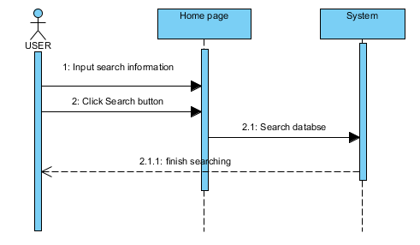

* + 1. **User Comment**

|  |  |  |
| --- | --- | --- |
| **Author** | Vo Minh Nhut | |
| **Use case name** | Write comment about event that they participated. | |
| **Actors** | User | |
| **Description** | User comment when they participated. | |
| **Requirements** | User should provide comment | |
| **Pre-conditions** | Actor has logged in as User | |
| **Post-conditions** | Success: send message to website  Fail: Refill information | |
| **Basic flow** | Actor Actions:  1. In ‘Home ’ page actor click Event button , next actor click ‘Read more’  At the end of event discription.  3. Actor inputs information and submit:  - Provide comment of the event in ‘Message’ text area  - Actor clicks ‘Submit’ button | System Responses:  2. System redirects to ‘EventDetail’page and displayss form for Actor to input information with the following control :  - ‘Message’ text area  - ‘Submit’ button  4. System checks the information  [Exception 1]  5. System displayss a message ‘Comment successful.Thank you’ |
| **Alternative flow** |  |  |
| **Exceptions** | [Exception 1]   1. Actor left‘Message’ text area and click Submit button | -System show message ‘Message shouldn’t be blank. Please input message.’ |

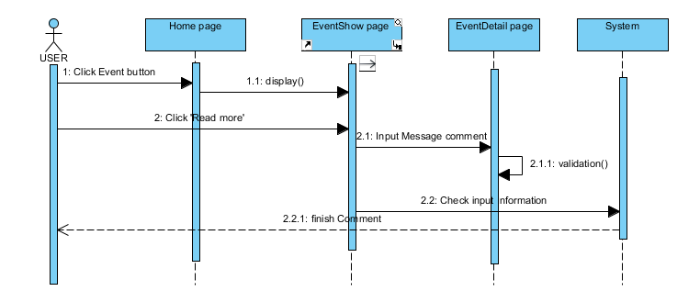

* + 1. **User Feedback**

|  |  |  |  |
| --- | --- | --- | --- |
| **Author** | Vo Minh Nhut | | |
| **Use Case Name** | Create Feedback | | |
| **Actors** | User | | |
| **Description** | User can feebdback about website. | | |
| **Requirements** | User must be provide Mail and Message to create Feedback | | |
| **Pre-conditions** |  | | |
| **Post-conditions** | Success: Feedback successful  Fail: Refill information | | |
| **Basic flow** | 1. Actor click’Feedback’ button in the ‘Home’ page 2. Actor click ‘Submit’ button | System Responses:  2. System redirects to this page and displayss form for Actor to input information with the following control :  -“Message” text area  -“Submit” button  System checks information input [Exception 1]  6. System add feedback into database then displays message ‘Thank for your feedback. | |
| **Alternative flow** |  |  |
| **Exceptions** | Actor Actions:  [Exception 1]  1. Actor left ‘Message text field blank. | System Response:  2. System displayss message to notice admin: ‘Message shouldn’t be blank. Please input Message’ |

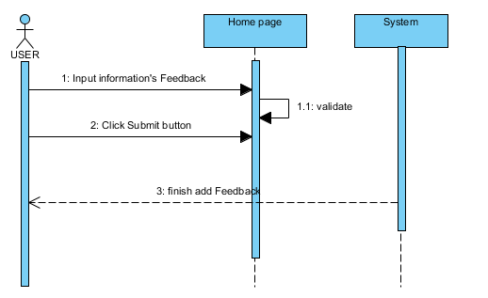

* + 1. **User Enroll**

|  |  |  |
| --- | --- | --- |
| **Author** | Vo Minh Nhut | |
| **Use case name** | User Unenroll Event | |
| **Actors** | User | |
| **Description** | Enroll the event by fill application’s information | |
| **Requirements** | Actor view information’s event | |
| **Pre-conditions** | Actor has already logged into the System as User | |
| **Post-conditions** | Success: Registered as participant of the event | |
| **Basic flow** | Actor actions:  1. From ‘Home’ page, actor clicks on to the ‘Event’ button and next actor click ‘Enroll’ button.  3. Actor clicks Enroll Button to enroll.  [Alternative 1] | System response:  2. System redirects to ‘EnrollShow ’ page and displays the following field:   * -Event Name * -Event Date   -Event Price  -Hosted By  -Username  -Fullname  - Confirm button  -Cancel button  4. System checks information.  [Exception 1] |
| **Alternative flow** | [Alternative 1] Actor clicks Cancel button. | System redirects to EventShow page. |
| **Exception** |  |  |

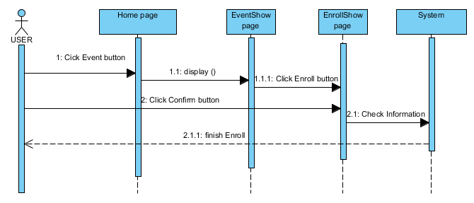

* + 1. **User Unenroll**

|  |  |  |
| --- | --- | --- |
| **Author** | Vo Minh Nhut | |
| **Use case name** | User Unenroll Event | |
| **Actors** | User | |
| **Description** | unroll the event has participated. | |
| **Requirements** |  | |
| **Pre-conditions** | Actor has already logged into the System as User | |
| **Post-conditions** | Success: Unroll the event . | |
| **Basic flow** | Actor actions:  1. From ‘Home’ page, actor clicks on to the ‘My Event’ and next click ‘Unenroll’ button.  3. Actor clicks Unroll Button .  [Alternative 1]  5.Actor click Yes Button | System response:  2. . System redirects to ‘EnrollShow ’ page and displays the following field:   * -Event Name * -Event Date   -Event Price  -Hosted By  -Username  -Fullname  - Confirm button  -Cancel button |
| **Alternative flow** | [Alternative 1] Actor clicks Cancel button. | System redirects to MyEvent page. |
| **Exception** |  |  |

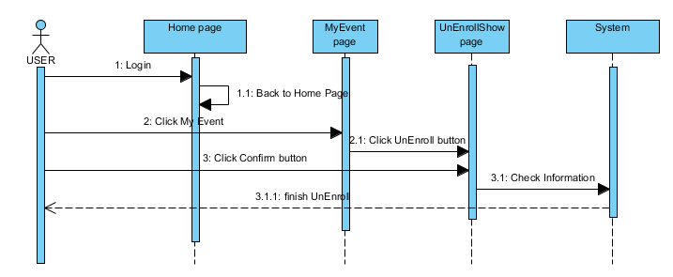

* + 1. **User Subscribe**

|  |  |  |
| --- | --- | --- |
| **Author** | Vo Minh Nhut | |
| **Use case name** | Subscribe | |
| **Actors** | User | |
| **Description** | User can subscribe to website. | |
| **Requirements** | Actor provides Email ID | |
| **Pre-conditions** | Actor has already logged into the System as User | |
| **Post-conditions** | Success: Registered as subscribe OR unsubscribe | |
| **Basic flow** | Actor actions:   1. From ‘Home’ page, actor login ,clicks “(Un)Subscribe” button. 2. Actor click Submit button.   [Alternative 1] | System response:   1. System redirects to ‘Subscribe ’ page and displays the following field:  * -Email ID text field.   - Submit button  System checks information.  If user were subscribed the System will unsubscribe user |
| **Alternative flow** |  | System redirects to Home page. |
| **Exception** | [Exception 1]  -Actor lefts Email ID text field. | “Email ID shouldn’t be blank. Please input Email ID” |

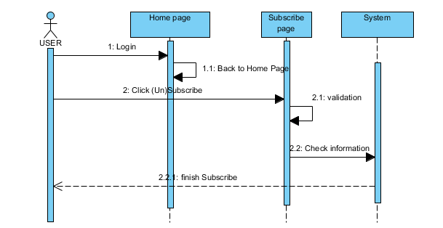

* + 1. **User Unsubscribe**

|  |  |  |
| --- | --- | --- |
| **Author** | Vo Minh Nhut | |
| **Use case name** | Unsubscribe | |
| **Actors** | User | |
| **Description** | User can subscribe to website. | |
| **Requirements** | Actor provides Email ID | |
| **Pre-conditions** | Actor has already logged into the System as User | |
| **Post-conditions** | Success: Registered as subscribe OR unsubscribe | |
| **Basic flow** | Actor actions:   1. From ‘Home’ page, actor login ,clicks “(Un)Subscribe” button. 2. Actor click Submit button.   [Alternative 1] | System response:   1. System redirects to ‘Subscribe ’ page and displays the following field:  * Email ID text field   - Submit button  System checks information.  If user were unsubscribed the System will subscribe user |
| **Alternative flow** |  | System redirects to Home page. |
| **Exception** | [Exception 1]  -Actor lefts Email ID text field. | “Email ID shouldn’t be blank. Please input Email ID” |

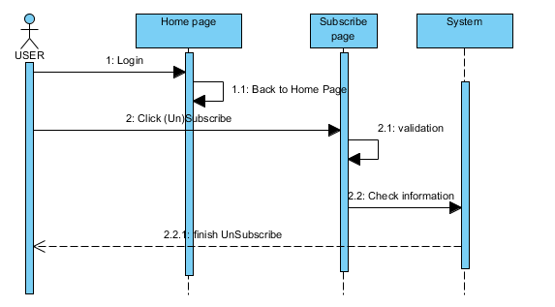

* + 1. **User Upload event content**

|  |  |  |
| --- | --- | --- |
| **Author** | Do Ngoc Quy | |
| **Use case name** | User upload contents | |
| **Actors** | User | |
| **Description** | If user had enrolled for an event they can upload or download event. | |
| **Requirements** | Actor provides link or file about event. | |
| **Pre-conditions** | User has already logged into the System as User | |
| **Post-conditions** | Success: Thank you.  Failed: Refill information | |
| **Basic flow** | Actor actions:  1. From ‘MyEvent’ page, actor clicks on to the ‘Upload’ button.  3. Actor clicks on to ‘Submit’ button to send event content. | System response:  2. System redirects to ‘UploadContent’ page and displays form with the following controls:  ‘Upload file’ file  ‘Submit ’ button.  4. System checks input information.  [Exception 1] |
| **Alternative flow** |  |  |
| **Exception** | [Exception 1]  1. Actor lefts ‘Upload file’ file | System displayss a message to notice actor:  “Event content shouldn’t be blank. “ |

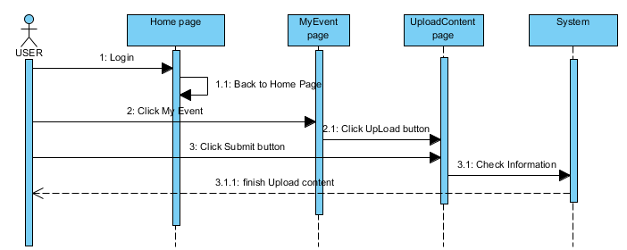

* + 1. **User payment**

|  |  |  |
| --- | --- | --- |
| **Author** | Do Ngoc Quy | |
| **Use case name** | User confirm payment | |
| **Actors** | User | |
| **Description** | If user were not belong to KSC University , user must complete payment before enroll event ortherwise if user were belong to KSC University , user can enroll an event without anyfee. | |
| **Requirements** | User select event name | |
| **Pre-conditions** | User has already logged into the System as User | |
| **Post-conditions** | Success: User’s payment is added into the database.  Failed: Refill information | |
| **Basic flow** | Actor actions:  1. From ‘EventShow’ page, actor clicks on to the ‘Enroll’ button., next actor click “Confirm ” button  3. Actor clicks on to ‘OK’ button to finish paying. [Alternative 1] | System response:   1. 2. if user were belong to KSC University , user can enroll an event without anyfee.System redirect to “MyEvent” page.   If user were not belong to KSC University ,System redirects to ‘PaymentShow’ page and displays form with the read only text field:  ‘Event Name’  ‘Event date’  ‘Eventfee ’  ‘Username’  ‘Fullname’  ‘AcceptPayment’ button.  ‘Cancel’ button   1. System checks information. |
| **Alternative flow** | [Alternative 1]  1. Actor clicks on to ‘Cancel’ button. | 2. System redirects to ‘ EventShow’ page. |
| **Exception** |  |  |

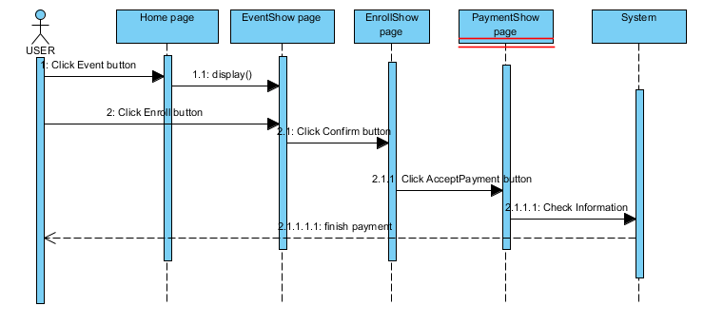

* 1. **ADMINISTRATOR**

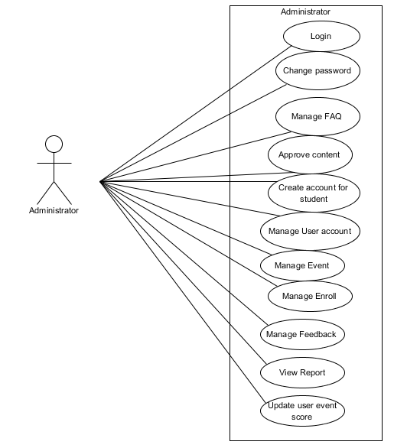

* + 1. **Login**

|  |  |  |
| --- | --- | --- |
| **Author** | Do Ngoc Quy | |
| **Use Case Name** | Login | |
| **Actors** | Administrator | |
| **Description** | Administrator wants to login to Admin page. | |
| **Requirements** | Actor provides username and password | |
| **Pre-conditions** |  | |
| **Post-conditions** | Success: Administrator logged in to website.  Fail: Refill information | |
| **Basic flow** | Actor Actions:  1. From ‘Home’ page, actor clicks on to the ‘Login’ button.  3. Actor inputs UserName and Password, then click the Login button. | System Responses:  2. System redirects to Login page and displayss Login form with the following control:  - ‘UserName’ text field  - ‘Password’ text field  - ‘Login’ button  -‘Register’ button  4. System checks the information  [Exception 1]  5. System redirects to Admin Home page. |
| **Alternative flow** | [Alternative 1] Actor click Register button | System redirect to Registration page. |
| **Exception** | Actor Actions:  [Exception 1]  1. Actor lefts ‘UserName’ text field blank.  2. Actor lefts ‘Password’ text field blank. | System Responses:  System displayss message to Guest :  - ‘UserName’ shouldn’t be blank.Please input username’  - ‘Password shouldn’t be blank. Please input password.’ |

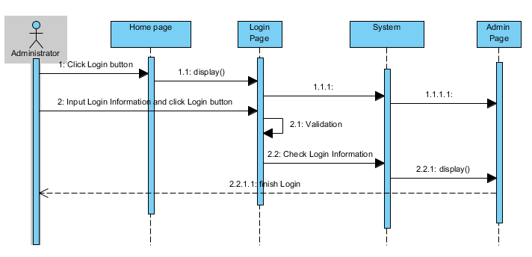

* + 1. **Change Password**

|  |  |  |
| --- | --- | --- |
| **Author** | Do Ngoc Quy | |
| **Use case name** | Change Password | |
| **Actors** | Administrator | |
| **Description** | Change Password | |
| **Requirements** | Actor provides Username and Password | |
| **Pre-conditions** | Actor has logged in as Administrator | |
| **Post-conditions** | Success: The password of Administrator has changed. | |
| **Basic flow** | Actor actions:  1. From ‘Admin’ page, actor clicks on to the ‘Change Password’ button.  3. Actor clicks on to ‘Submit’ button to finish adding. [Alternative 1] | System response:  2. System redirects to ‘Change Password’ page and displays form with the following controls:  ‘Old Password’ textfield.  ‘New Password’ textfield.  ‘Confirm New Password’ textfield.  ‘Submit’ button.  ‘Cancel’ button  4. System checks input information.  [Exception 1]  5. System adds new Administrator into the database. |
| **Alternative flow** | [Alternative 1]  Actor click ‘Cancel’ button | System redirect to Home page |
| **Exception** | [Exception 1]  1. Actor lefts ‘Old Password’ textfield.  2. Actor lefts ‘New Password’ textfield.  3. Actor lefts ‘Confirm New Password’ textfield.  4. ‘New Password’ textfield is not same as ‘Confirm New Password’ textfield. | System displayss a message to notice actor:  “Old Password shouldn’t be blank. Please input Old Password.”  “New Password shouldn’t be blank. Please input New Password.”  “Confirm New Password shouldn’t be blank. Please input Confirm Password.”  “New Password and Confirm New Password must be same.” |

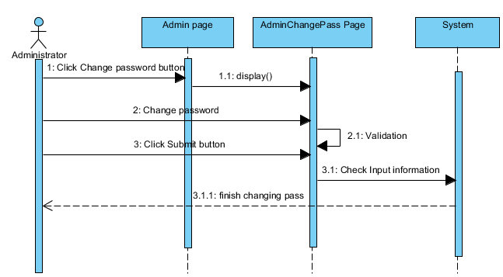

* + 1. **Administrator Approve Contents**

|  |  |  |
| --- | --- | --- |
| **Author** | Do Ngoc Quy | |
| **Use case name** | Approve Contents | |
| **Actors** | Administrator | |
| **Description** | Administrator checks the upload file which user was uploaded. | |
| **Requirements** |  | |
| **Pre-conditions** | Actor has already logged into the System as Administrator. | |
| **Post-conditions** | Success: File is Approved | |
| **Basic flow** | Actor actions:  1. From ‘AdminEventShow’ page, actor clicks on to the ‘Edit’ button  3. Actor clicks Approve Button to Update.  [Alternative 1] | System response:  2. System redirects to ‘AdminEvent ContentsUpdate’ page and displays the following field :  -Event ID  -ContentURL  -IsSelect  - Submit Button  -Cancel button  4. System will update file to database.  [Exception 1] |
| **Alternative flow** | [Alternative 1] Actor clicks Cancel button. | System redirect to AdminEventShow page |
| **Exception** | [Exception 1]  1. Actor lefts ‘EventID’ textfield.  2. Actor lefts ‘ContentURL’ textfield. | System displayss a message to notice actor:  “EventID shouldn’t be blank. Please input EventID.”  “ContentURL shouldn’t be blank. Please input ContentURL.” |

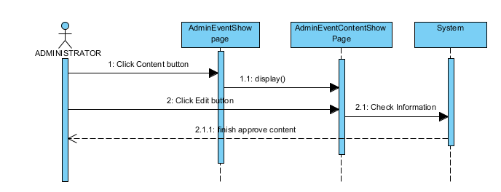

* + 1. **Manage Feedback**
       1. **View Feedback**

|  |  |  |
| --- | --- | --- |
| **Author** | Do Ngoc Quy | |
| **Use case name** | View List of Feedback | |
| **Actors** | Administrator | |
| **Description** | View List of Feedback | |
| **Requirements** |  | |
| **Pre-conditions** | Already login into the System as Administrator | |
| **Post-conditions** | Success: View List of Questions | |
| **Basic flow** | Actor actions:  1. From ‘Admin’ page, actor clicks on to the ‘Feedback’ button. | System response:  2. System redirects to ‘AdminFeedbackShow’ page and displays list of all of Feedback in table form with control :  .ID  .Date  .Question  .Answer  .Sender  .Edit button  .Delete button |
| **Alternative flow** |  |  |
| **Exception** |  |  |

* + - 1. **Update Feedback**

|  |  |  |
| --- | --- | --- |
| **Author** | Do Ngoc Quy | |
| **Use case name** | Update Feedback | |
| **Actors** | Administrator | |
| **Description** | Update Feedback | |
| **Requirements** |  | |
| **Pre-conditions** | Already login into the System as Administrator | |
| **Post-conditions** | Success: A Question is updated in the database. | |
| **Basic flow** | Actor actions:  1. From ‘AdminFeedbackShow’ page, actor clicks on to the ‘Edit’ button  3. Actor:   * Inputs Answer into ‘Answer’ text field. * Clicks on to ‘Submit’ button to finish updating. [Alternative 1] | System response:  2. System redirects to ‘AdminFeedbackUpdate’ page and displays form with the following controls:  ‘FromUser’ text field.(read only)  ‘Question’ text field. (read only)  ‘Answer’ text field.  ‘Feedback date’ date picker  ‘Submit’ button.  ‘Cancel’ button  4. System checks information.  [Exception 1] |
| **Alternative flow** | [Alternative 1]  1. Actor clicks on to ‘Cancel’ button | 1. System redirects to ‘AdminFeedbackShow’ page |
| **Exception** | [Exception 1]  2. Actor lefts ‘Answer’ text field. | System displayss a message to notice actor:  “Answer shouldn’t be blank. Please input Answer.” |

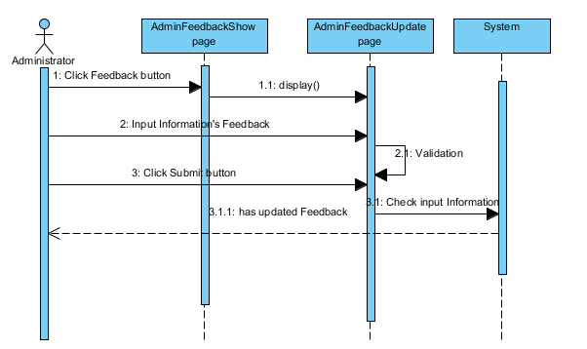

* + - 1. **Search Feedback**

|  |  |  |
| --- | --- | --- |
| **Author** | Do Ngoc Quy | |
| **Use Case Name** | Property for feedback | |
| **Actors** | Administrator | |
| **Description** | Administrator wants to perform a Property for feedback | |
| **Requirements** | Actor provides search information | |
| **Post-conditions** | Success: Properties match the condition show up.  Fail: Do not have any property match the condition. | |
| **Basic flow** | Actor Actions:  1. Actor clicks ‘Search’ button on the “AdminFeedbackShow” page menu.  3.Actor inputs searching’s information and click ‘Search’ button’ | System Responses:  2. System displays form with the following controls:  - ‘Username’ text field.  - ‘Search’ button.  4. System select the properties in database that match searching condition and displays the result in the Searching Result list below the table. |
| **Alternative flow** |  |  |
| **Exception** |  |  |

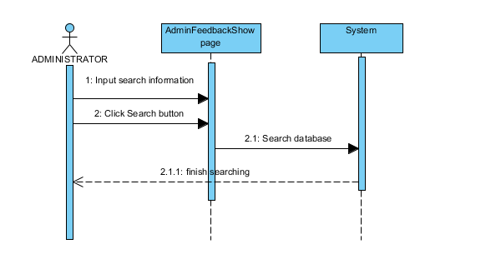

* + 1. **Manage FAQs**
       1. **View FAQ**

|  |  |  |
| --- | --- | --- |
| **Author** | Do Ngoc Quy | |
| **Use case name** | View List of FAQs | |
| **Actors** | Administrator | |
| **Description** | View List of FAQs | |
| **Requirements** |  | |
| **Pre-conditions** | Already login into the System as Administrator | |
| **Post-conditions** | Success: View List of Questions | |
| **Basic flow** | Actor actions:  1. From ‘Admin’ page, actor clicks on to the ‘FAQ’ button. | System response:  2. System redirects to ‘AdminFAQShow’ page and displays list of all of FAQ in table form with control :  .ID  .Question  .Answer  .Edit button  .Delete button |
| **Alternative flow** |  |  |
| **Exception** |  |  |

* + - 1. **Create FAQ**

|  |  |  |  |
| --- | --- | --- | --- |
| **Author** | Nguyen Ngoc Kieu Trinh | | |
| **Use Case Name** | Create FAQ | | |
| **Actors** | Adminnistrator | | |
| **Description** | Adminnistrator create FAQ forwebsite. | | |
| **Requirements** | Actor must be provide Quetsion and Answer | | |
| **Pre-conditions** |  | | |
| **Post-conditions** | Success: FAQ successful  Fail: Refill information | | |
| **Basic flow** | 1. 1.Actor click’Add FAQ’ button in the ‘AdminFAQShow’ page 2. 3.Actor click ‘Submit’ button | System Responses:  2. System redirects to ‘AdminFAQInsert’ page and displayss form for Actor to input information with the following control :  -‘Queation’ text field  -“Answer” text field  -“Submit” button .  -“Cancel” button .  System checks information input [Exception 1]  4. System add FAQ into database | |
| **Alternative flow** | Actor click ‘Cancel’ button | Redirect to ‘AdminFAQShow’ page. |
| **Exceptions** | Actor Actions:  [Exception 1]  1. Actors left ‘Question’ text field blank  2. Actor left ‘Answer’ field blank. | System Response:  1. System displayss message to notice admin: ‘Question shouldn’t be blank. Please input Question.’  2. System displayss message to notice admin: ‘Answer shouldn’t be blank. Please input Answer’ |

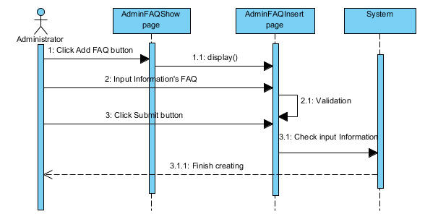

#### **Update FAQs**

|  |  |  |
| --- | --- | --- |
| **Author** | Tran Nguyen Cong Nguyen | |
| **Use case name** | Update FAQs | |
| **Actors** | Administrator | |
| **Description** | Update FAQs | |
| **Requirements** |  | |
| **Pre-conditions** | Already login into the System as Administrator | |
| **Post-conditions** | Success: A Question is updated in the database. | |
| **Basic flow** | Actor actions:  1. From ‘AdminFAQShow’ page, actor clicks on to the ‘Edit button  3. Actor:   * Inputs Question into ‘Question’ text field. * Inputs Answer into ‘Answer’ text field. * Clicks on to ‘Submit’ button to finish adding. [Alternative 1] | System response:  2. System redirects to ‘AdminFAQUpdate’ page and displays form with the following controls:  ‘Question’ text field.  ‘Answer’ text field.  ‘Submit’ button.  ‘Cancel’ button  4. System checks information.  [Exception 1] |
| **Alternative flow** | [Alternative 1]  1. Actor clicks on to ‘Cancel’ button | 1. System redirects to ‘AdminFAQShow’ page |
| **Exception** | [Exception 1]  1. Actor lefts ‘Question’ text field.  2. Actor lefts ‘Answer’ text field. | System displayss a message to notice actor:  “Question shouldn’t be blank. Please input Question.”  “Answer shouldn’t be blank. Please input Answer.” |

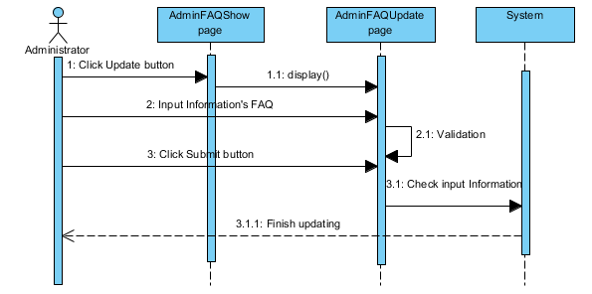

* + - 1. **Change Status FAQs (Delete FAQs)**

|  |  |  |
| --- | --- | --- |
| **Author** | Tran Nguyen Cong Nguyen | |
| **Use case name** | Change status FAQs | |
| **Actors** | Administrator | |
| **Description** | Change database FAQs | |
| **Requirements** |  | |
| **Pre-conditions** | Already login into the System as Administrator | |
| **Post-conditions** | Success: A FAQ is changed in the database. | |
| **Basic flow** | Actor actions:  1. From ‘AdminFAQShow’ page, actor clicks on to the ‘Change’ button which actor wants to Change.  3. Actor clicks ‘Yes’ button.[Alternative 1] | System response:  2. A confirms show message box: ”Do you want to change this Question?”  4. System changes status the question in the database. |
| **Alternative flow** | [Alternative 1]  1. Actor clicks on to ‘No’ button | 2. System redirects to ‘ AdminFAQShow’ page. |
| **Exception** |  |  |

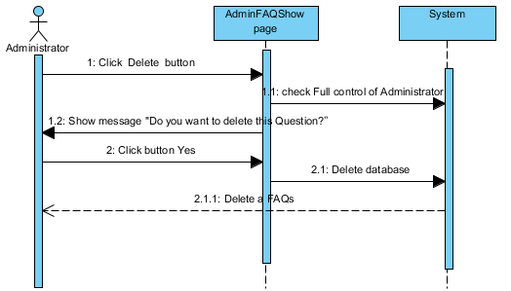

* + 1. **Manage Participants list**
       1. **View participants list**

|  |  |  |
| --- | --- | --- |
| **Author** | Tran Nguyen Cong Nguyen | |
| **Use case name** | View List of Participants | |
| **Actors** | Administrator | |
| **Description** | View List of Participants | |
| **Requirements** |  | |
| **Pre-conditions** | Actor has already logged into the System as Administrator | |
| **Post-conditions** | Success: View List of Participants | |
| **Basic flow** | Actor actions:  1. From ‘AdminEventShow’ page, actor clicks on to ‘Participants’ button. | System response:  2. System redirects to ‘AdminEventUserShow’ page and displays list of User in table form:   * UserName * EventScore * Date   - Status   * Edit button * Delete button |
| **Alternative flow** | Actor Actions:  [Alternative 1]  Actor click ‘Edit’ button | System Responses:  System redirect to“AdminEventUserUpdate”  page |
| **Exception** |  |  |

* + - 1. **Update participants list**

|  |  |  |
| --- | --- | --- |
| **Author** | Tran Nguyen Cong Nguyen | |
| **Use Case Name** | Update Participant List | |
| **Actors** | Administrator | |
| **Description** | Administrator wants to Update Participant List | |
| **Requirements** | Actor provides Participants List information | |
| **Pre-conditions** | Actor has logged in. | |
| **Post-conditions** | Success: Participant List has been updated.  Fail: Refill information | |
| **Basic flow** | Actor Actions:  1. Actor clicks ‘Edit’ button in AdminEventUserShow page menu.  3. Actor updates information and click ‘Submit’ button. [Alternative 1] | System Responses:   1. System redirects to “AdminEventUserUpdate”   page and displayss Edit participant list form with the following control :  -‘Winner’ check box  - ‘Status’ dropdownlist  -‘Enroll date’ datepicker  -‘Payment date’date picker  - ‘Fee’ text field  -‘Score’text field  - ‘Submit’ button  - ‘Cancel’ button  4. System checks the information  [Exception 1]  5. System update the participant into database and then redirects to AdminEventUserShow page. |
| **Alternative flow** | Actor Actions:  [Alternative 1]  1. Actor click ‘Cancel’ button. | System Responses:  2. System redirect to AdminEventUserShow page. |
| **Exception** | Actor Actions:  [Exception 1]   1. Actor lefts ‘Score’ text field .. 2. Actor left’Fee’ text field . | System Responses:  System displayss message to Actor :  - ‘Score shouldn’t blank’.  -‘Fee shouldn’t not blank’ |

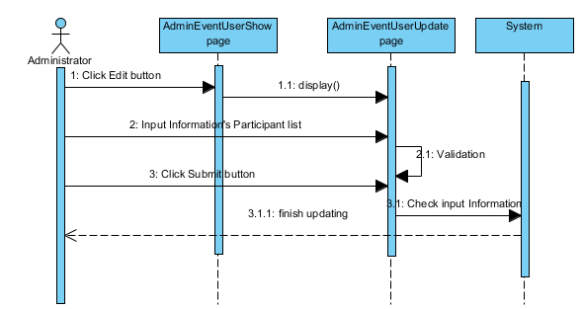

* + 1. **Manage User Account**
       1. **View user account list**

|  |  |  |
| --- | --- | --- |
| **Author** | Tran Nguyen Cong Nguyen | |
| **Use case name** | View List of Users | |
| **Actors** | Administrator | |
| **Description** | View List of Users | |
| **Requirements** |  | |
| **Pre-conditions** | Actor has already logged into the System as Administrator | |
| **Post-conditions** | Success: View List of Users | |
| **Basic flow** | Actor actions:  1. From ‘Admin’ page, actor clicks on to ‘User’ button. | System response:  2. System redirects to ‘AdminUserShow’ page and displays list of User in table form:   * UserType * UserName * Fullname * Birth * Image * Edit button * Delete button |
| **Alternative flow** | Actor Actions:  [Alternative 1]  1. Actor click ‘Edit’ button. | System Responses:  2. System redirect to AdminUserShow page. |
| **Exception** |  |  |

* + - 1. **Add User account for student**

|  |  |  |  |
| --- | --- | --- | --- |
| **Author** | Tran Nguyen Cong Nguyen | | |
| **Use Case Name** | Add User Account for Student | | |
| **Actors** | Administrator | | |
| **Description** | Administrator wish to add new Student Account | | |
| **Requirements** | Administrator must be provide Mail_ID And Password to add new User Account | | |
| **Pre-conditions** | Actor has logged in as Administrator | | |
| **Post-conditions** | Success: Add User Account successful  Fail: Refill information | | |
| **Basic flow** | Actor Actions:  1. Actor clicks ‘AddUser’ button on’AdminUserShow’ page  3. Actor inputs property type information :  - Provide the bank’s name in ‘Name’ text field.  5. Actor click ‘Submit’ button.  [Alternative 1] | System Responses:  2. System redirects to this page and displayss form for Actor to input information with the following control :  -‘Username’text field  -‘Password’ text field  -‘Confirm Password’ text field  ‘Fullname’ text field  ‘UserType’ dropdownlist  ‘Gender’ dropdownlist  -‘Phone’ text field  -‘Address’ text field  -‘DateOfBirth’ dropdownlist  -‘Image’  -‘Submit’ button  -‘Cancel’ button  4. System checks information input [Exception 1]  6. System add user into database then displays message ‘Your user has been add successful’. | |
| **Alternative flow** | Actor Actions:  [Alternative 1]  Actor click ‘Cancel’ button | System Response:  All field will blank  System redirects to View List of Users page. |
| **Exceptions** | Actor Actions:  [Exception 1]  1. Actors left ‘Username’ text field blank  2. Actor left ‘Password’ text field blank.  3.Actor left ‘Confirm Password’text field blank.  4.‘Password’ text field is not same as ‘Confirm Password’ text field.  -Actor left‘Fullname’ text field blank.  Actor left‘Address’ text field blank.  - Actor left‘Phone’ text field blank. | System Response:  1. System displayss message to notice admin: ‘Username of user shouldn’t blank. Please input Username .’  2. System displayss message to notice admin: ‘password shouldn’t blank. Please input Password’  3. System displayss message to notice admin: ‘Confirm password shouldn’t blank Please input again.’  4. “New Password and Confirm New Password must be same.”  - System displayss message to notice admin: ‘Fullname shouldn’t blank. Please input Fullname’  -. System displayss message to notice admin: ‘Address shouldn’t blank. Please input Address’  -System displayss message to notice admin: ‘Phone shouldn’t blank. Please input Phone’ |

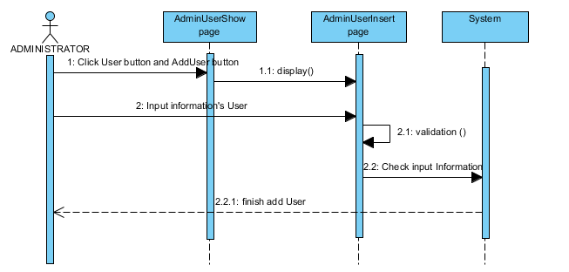

* + - 1. **Delete user**

|  |  |  |  |  |
| --- | --- | --- | --- | --- |
| **Author** | Tran Nguyen Cong Nguyen | | | |
| **Use Case Name** | Change Status User Account | | | |
| **Actors** | Administrator | | | |
| **Description** | Administrator wish to change status User Account | | | |
| **Requirements** | Administrator must be choose user to change | | | |
| **Pre-conditions** | Actor has logged in as Administrator | | | |
| **Post-conditions** | Success: Change status account successful  Fail: Error Page show | | | |
| **Basic flow** | | | Actor Actions:  1. Actor clicks Delete button on View list of banks page  3. Actor clicks Yes button on message  [Alternative 1] | System Responses:  2. System show popup message :”Do you want to delete this user ”. With Yes and No button  4. System delete user from database then displays message ‘Delete user successful’. |
| **Alternative flow** | | | Actor Actions:  [Alternative 1]  Actor clicks No button on message | System Responses:  System returns to current page. |
| **Exceptions** | | |  |  |

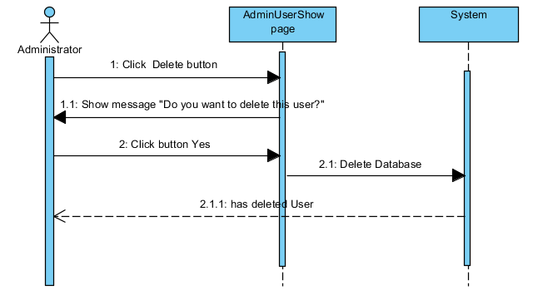

* + - 1. **Search User**

|  |  |  |
| --- | --- | --- |
| **Author** | Tran Nguyen Cong Nguyen | |
| **Use Case Name** | Search User | |
| **Actors** | Administrator | |
| **Description** | Administrator wants to perform a User Searching. | |
| **Requirements** | Actor provides search information. | |
| **Pre-conditions** | Actor has logged in as Administrator | |
| **Post-conditions** | Success: Properties match the condition show up.  Fail: Do not have any property match the condition. | |
| **Basic flow** | Actor Actions:  1.  Actor inputs searching’s information (User’s Name only) and click ‘Search’ button’ on View all Users page  [Alternative1] | System Responses:  2. System Submits the search query into database.  3. System select the properties in database that match searching condition and displays the result in the Searching Result table. [Alternative 3] |
| **Alternative flow** | Actor Actions:  [Alternative 1] searching’s information don’t match. | System Responses:  1. System response the message: ’There is no result about this User’. |
| **Exception** |  |  |

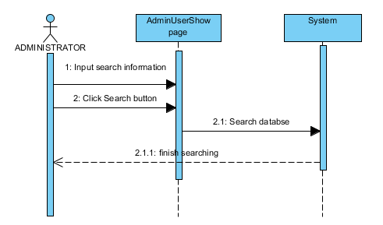

* + 1. **Manage Event**
       1. **View list of event**

|  |  |  |
| --- | --- | --- |
| **Author** | Tran Nguyen Cong Nguyen | |
| **Use case name** | View List of events | |
| **Actors** | Administrator | |
| **Description** | View List of events | |
| **Requirements** |  | |
| **Pre-conditions** | Actor has already logged into the System as Administrator | |
| **Post-conditions** | Success: View List of Topics | |
| **Basic flow** | Actor actions:  1. From ‘Admin’ page, actor clicks on to the ‘ ViewAllEvent’ button. | System response:  2. System redirects to ‘AdminEventShow’ page and displays list of all of Event in table form:   * ID * Name * Date * Status * Participant * Img * Edit button * Delete button * Participant button * Comment button * Content button. |
| **Alternative flow** | [Alternative 1]   1. Actor clicks on to’ Edit’ button 2. Actor clicks on to’ Delete’ button 3. Actor clicks on to’ Participant’ button 4. Actor clicks on to’ Comment’ button 5. Actor clicks on to’ Content’ button | System redirects to ‘AdminEventUpdate’ page.  -System Delete Event.  -System redirects to ‘AdminEventUserShow’ page.  -System redirects to’AdminCommentShow’ page.  -System redirect to ‘AdminContentShow’ page. |
| **Exception** |  |  |

* + - 1. **Add event**

|  |  |  |
| --- | --- | --- |
| **Author** | Tran Nguyen Cong Nguyen | |
| **Use case name** | Add Event | |
| **Actors** | Administrator | |
| **Description** | Add an event | |
| **Requirements** | Actor provides Event Name, Event Host, Min participants , Max participants ,Status, Price, Select a date, Register Begin, Description, Image | |
| **Pre-conditions** | Actor has already logged into the System as Administrator | |
| **Post-conditions** | Success: An event is added into the database.  Failed: Refill information | |
| **Basic flow** | Actor actions:  1. From ‘Admin’ page, actor clicks on to the ‘Add Event’ button.  3. Actor clicks on to ‘Submit’ button to finish adding. [Alternative 1] | System response:  2. System redirects to ‘AdminEventInsert’ page and displays form with the following controls:  ‘Event Name’ text field.  ‘Event Host’ text field.  ‘Min participants’ text field.  ‘Max participants’ text field.  ‘Status’ dropdownlist  ‘Price’ text field  ‘Select a date’ date picker  ‘Description’ text field  ‘Image’ file  ‘Submit’ button.  ‘Cancel’ button  4. System checks input information.  [Exception 1]  5. System adds new Event into the database. |
| **Alternative flow** | [Alternative 1]  1. Actor clicks on to ‘Cancel’ button. | 2. System redirect to AdminEventShow page. |
| **Exception** | [Exception 1]   1. Actor lefts ‘Event Name’ text field. 2. Actor lefts ‘Event Host’’ text field. 3. Actor lefts ‘Min participants’’ text field 4. Actor lefts ‘Max participants’’ text field 5. Actor lefts ‘Price’’ text field   Actor lefts ‘Description’’’ text field | System displayss a message to notice actor:  “Event Name’ shouldn’t be blank. Please input Event Name’.  “Event Host’ shouldn’t be blank. Please input Event Host’.”  “Minimum participants shouldn’t be blank. Please input Min participants’’  “Maximum participants’’ shouldn’t be blank. Please input Maximum participants’’.”  “Price’’ shouldn’t be blank. Please input Price’’.  “Description’’ shouldn’t be blank. Please input Description ‘ |

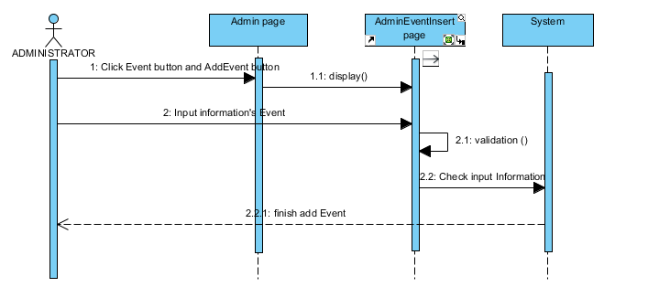

* + - 1. **Update event**

|  |  |  |
| --- | --- | --- |
| **Author** | Nguyen Ngoc Kieu Trinh | |
| **Use case name** | Update Event | |
| **Actors** | Administrator | |
| **Description** | Update an event | |
| **Requirements** | Actor provides Event Name, Event Host, Min participants , Max participants ,Price, Select a date, Description,Image | |
| **Pre-conditions** | Actor has already logged into the System as Administrator | |
| **Post-conditions** | Success: An event is updated into the database.  Failed: Refill information | |
| **Basic flow** | Actor actions:  1. From ‘AdminEventShow’ page, actor clicks on to the ‘Edit’ button, .  3. Actor clicks on to ‘Add’ button to finish adding. [Alternative 1] | System response:  2. System redirects to ‘AdminEventUpdate’ page and displays form with the following controls:  ‘Event Name’ text field.  ‘Event Host’ text field.  ‘Min participants’ text field.(read only)  ‘Max participants’ text field.(read only)  ‘Price’ text field  ‘Select a date’ date picker  ‘Description’ text field  ‘Image’ file  ‘Submit’ button.  ‘Cancel’ button  4. System checks input information.  [Exception 1]  5. System adds new Event into the database. |
| **Alternative flow** | [Alternative 1]  1. Actor clicks on to ‘Cancel’ button. | 2. System Redirect to Admin EventShow page |
| **Exception** | [Exception 1]   1. Actor lefts ‘Event Name’ text field. 2. Actor lefts ‘Event Host’’ text field. 3. Actor lefts ‘Price’’ text field   Actor lefts ‘Description’ text field | System displayss a message to notice actor:  “Event Name’ shouldn’t be blank. Please input Event Name’.  “Event Host’ shouldn’t be blank. Please input Event Host’.”  “Price’’ shouldn’t be blank. Please input Price’’.”  “Description’’ shouldn’t be blank. Please input Description ‘ |

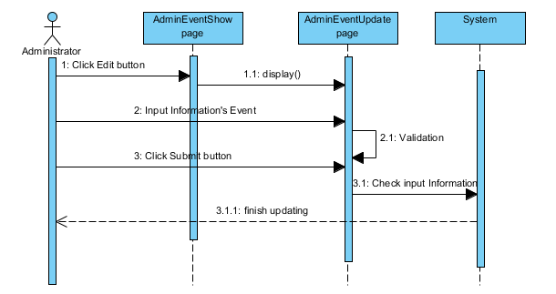

* + - 1. **Change event**

|  |  |  |
| --- | --- | --- |
| **Author** | Vo Minh Nhut | |
| **Use case name** | Change event status | |
| **Actors** | Administrator | |
| **Description** | Change status an Event | |
| **Requirements** |  | |
| **Pre-conditions** | Actor has already logged into the System as Administrator | |
| **Post-conditions** | Success: Deleted an event | |
| **Basic flow** | Actor actions:  1. From ‘AdminEventShow’ page, actor clicks on to the ‘Delete’ button of event which actor wants to change.  3. Actor clicks ‘Yes’ button.[Alternative 1] | System response:  2. A confirms message box appears: ”Do you want to delete this Event?”  4. System changes the Event in the database. |
| **Alternative flow** | [Alternative 1]  1. Actor clicks on to ‘No’ button | 2. System redirects to ‘AdminEventShow’ page |
| **Exception** |  |  |

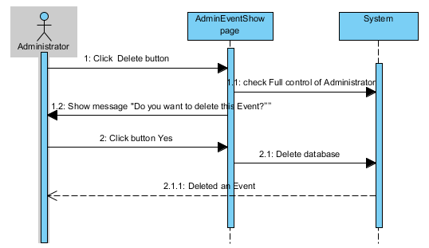

* + - 1. **Search event**

|  |  |  |
| --- | --- | --- |
| 1. **Author** | Do Ngoc Quy | |
| **Use Case Name** | Search Event | |
| **Actors** | Administrator | |
| **Description** | Administrator wants to perform an Event Searching. | |
| **Requirements** | Actor provides search information. | |
| **Pre-conditions** | Actor has logged in as Administrator | |
| **Post-conditions** | Success: Properties match the condition show up.  Fail: Do not have any property match the condition. | |
| **Basic flow** | Actor Actions:  1.  Actor inputs searching’s information (Event’s Name only) and click ‘Search’ button’ on AdminEventShow page.  [Alternative1] | System Responses:  2. System Submits the search query into database.  3. System select the properties in database that match searching condition and displays the result in the Searching Result table |
| **Alternative flow** | Actor Actions:  [Alternative 1] searching’s information don’t match. | System Responses:  1. System response the message: ’There is no result about this Event’. |
| **Exception** |  |  |

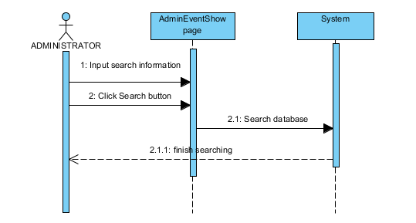

1. **Entity Relationship Diagram (ERD)**
   1. **Conceptual**

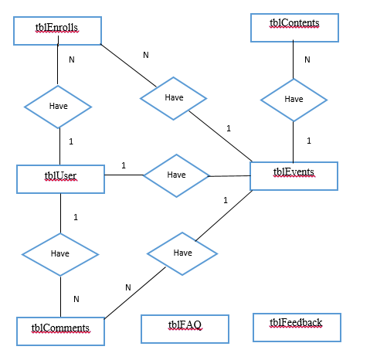

1. **Entity Properties**
   1. **Properties of tblContents**

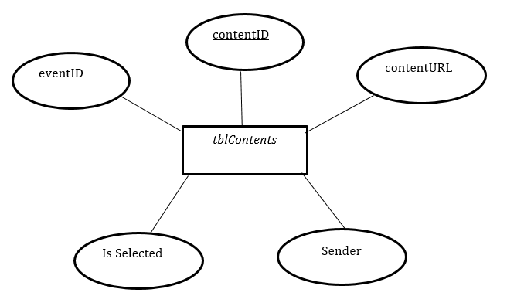

* 1. **Properties of tblEvents**

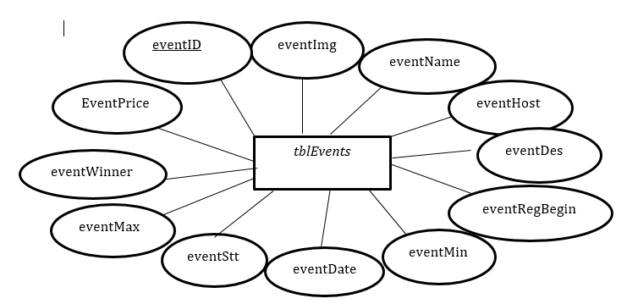

* 1. **Properties of tblFeedback**

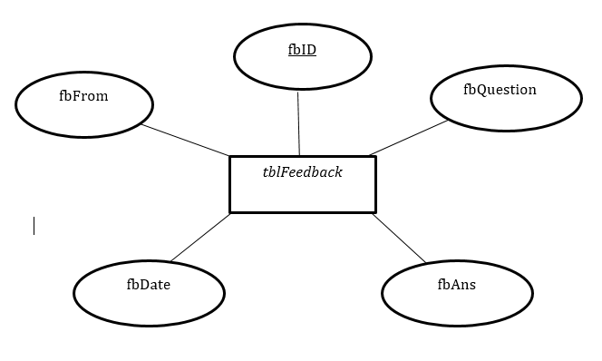

* 1. **Properties of tblEnrolls**

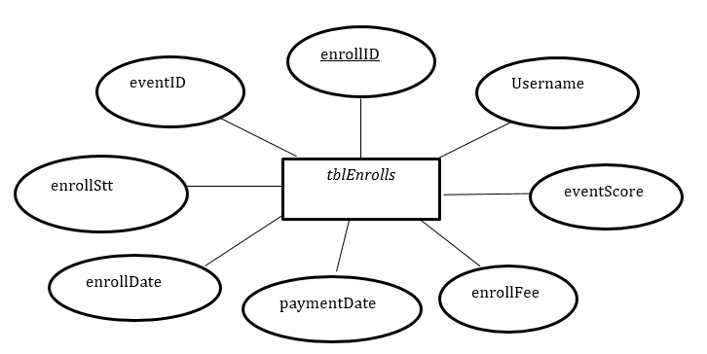

* 1. **Properties of tblFAQ**

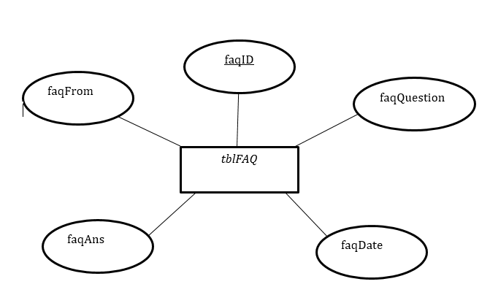

* 1. **Properties of tblComments**

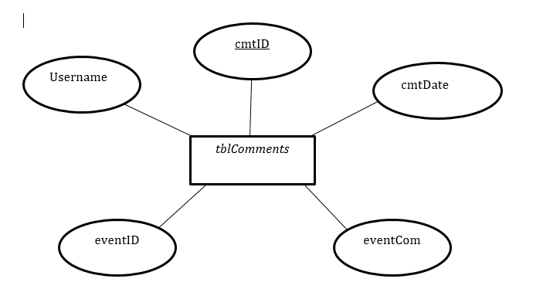

* 1. **Properties of tblUsers**

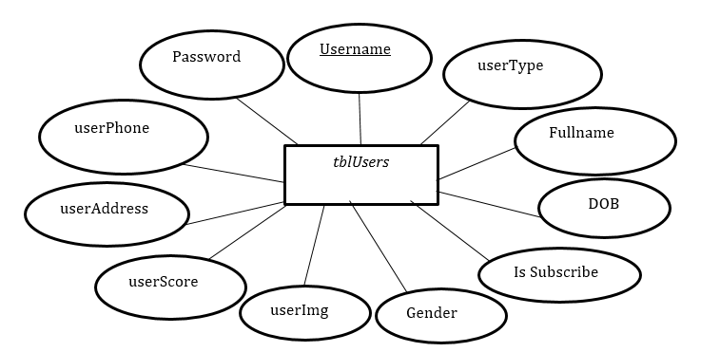

|  |  |  |
| --- | --- | --- |
|  | **Prepared by (Student)** | **Approved by (Faculty)** |
| **Signature** | Team leader  **Vo Minh Nhut** | **Pham Cong Thanh** |
| **Date** |  |  |

**REVIEW 3**

1. **Database Relationship Diagram**

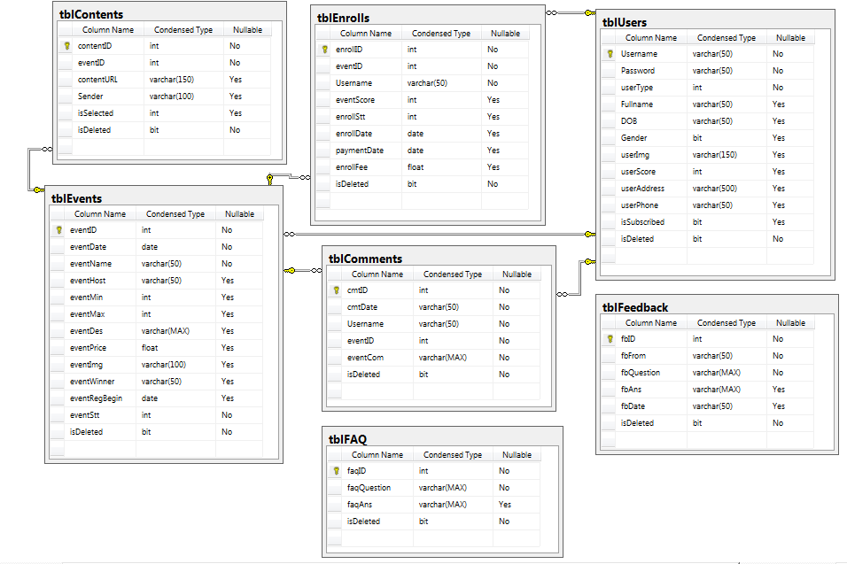

1. **TABLE DEINITION**
   1. ***tblContents***

|  |  |  |  |  |  |  |  |
| --- | --- | --- | --- | --- | --- | --- | --- |
| **Key** | **Field Name** | **Data Type** | **Length** | **Allow Null** | **Default value** | **Table-Field-Ref** | **Description** |
| PK | **contentID** | int | 4 | No |  |  | ID of contents |
| FK | eventID | int | 4 | Yes |  |  | eventID,FK of tblEvents table |
|  | contentURL | varchar | 150 | Yes |  |  | URL of content |
|  | Sender | varchar | 100 | Yes |  |  | Sender of content |
|  | Is Selected | int | 4 | No |  |  | To show if content is sellected  1:selected  0:unselected |
|  | isDelete | bit | 1 | No |  |  | IsDelete  0: is not deleted  1:deleted |

### ***Constraints:***

|  |  |  |  |
| --- | --- | --- | --- |
| **Name** | **Add** | **Delete** | **Update** |
| tblContents | + | + | + |

* 1. ***tblFeedback***

|  |  |  |  |  |  |  |  |
| --- | --- | --- | --- | --- | --- | --- | --- |
| **Key** | **Field Name** | **Data Type** | **Length** | **Allow Null** | **Default value** | **Table-Field-Ref** | **Description** |
| PK | **fqID** | int | 4 | No |  |  | ID of feedback |
|  | fqFrom | varchar | 50 | No |  |  | Indicate feedback sender |
|  | fqQuestion | varchar | Max | No |  |  | Question of feedback |
|  | fqAns | varchar | Max | Yes |  |  | Answer of feedback |
|  | fbDate | varchar | 50 | No |  |  | Date of feedback |
|  | isDeleted | bit | 1 | No |  |  | IsDeleted  0: is not deleted  1:deleted |

### ***Constraints:***

|  |  |  |  |
| --- | --- | --- | --- |
| **Name** | **Add** | **Delete** | **Update** |
| tblFeedback | + | + | + |

* 1. ***tblEvents***

|  |  |  |  |  |  |  |  |
| --- | --- | --- | --- | --- | --- | --- | --- |
| **Key** | **Field Name** | **Data Type** | **Length** | **Allow Null** | **Default value** | **Table-Field-Ref** | **Description** |
| PK | **eventID** | int | 4 | No |  |  | ID of event |
|  | eventDate | datetime | 8 | No |  |  | Date of event |
|  | eventName | varchar | 50 | No |  |  | Name of event |
|  | eventHost | varchar | 50 | Yes |  |  | Host of event |
|  | eventMin | int | 5 | Yes |  |  | Indicate minimum member of event |
|  | eventMax | int | 5 | Yes |  |  | Indicate maximum member of event |
|  | eventDes | Varchar | Max | Yes |  |  | Description of event |
|  | eventPrice | float | 15 | Yes |  |  | Price of event |
|  | eventImg | varchar | 150 | Yes |  |  | Image of event |
|  | eventWinner | varchar | 50 | No |  |  | Winner of event |
|  | eventRegBegin | datetime | 8 | No |  |  | Indicate the day from with user can enroll an event. |
|  | eventStt | int | 1 | No |  |  | Indicate status of an event  1: event happened  0: event will happen in the future  2:event cancel ( not enough user enroll) |
|  | isDeleted | bit | 1 | No |  |  | IsDeleted  0: is not deleted  1:deleted |

### ***Constraints:***

|  |  |  |  |
| --- | --- | --- | --- |
| **Name** | **Add** | **Delete** | **Update** |
| tblEvents | + | +  (no percentage references to this tblEvents table) | + |

* 1. ***tblEnrolls***

|  |  |  |  |  |  |  |  |
| --- | --- | --- | --- | --- | --- | --- | --- |
| **Key** | **Field Name** | **Data Type** | **Length** | **Allow Null** | **Default value** | **Table-Field-Ref** | **Description** |
| PK | **enrollID** | int | 4 | No |  |  | ID of enroll |
| FK | eventID | int | 4 | No |  |  | eventID ,FK of tblEvents table |
|  | Username | varchar | 50 | No |  |  | User’s name enrolled event |
|  | eventScore | int | 6 | Yes |  |  | Score of event |
|  | enrollStt | int | 4 | No |  |  | Status of enroll  1:enrolled  1:unenroll |
|  | enrollDate | datetime | 8 | Yes |  |  | Date of enroll |
|  | paymentDate | datetime | 8 | Yes |  |  | Date of payment |
|  | enrollFee | float | 10 | No |  |  | Fee of enroll |
|  | isDeleted | bit | 1 | No |  |  | isDeleted  0: is not deleted  1:deleted |

### ***Constraints:***

|  |  |  |  |
| --- | --- | --- | --- |
| **Name** | **Add** | **Delete** | **Update** |
| tblEnrolls | + | +  (no percentage references to this tblEnrolls table) | + |

* 1. ***tblComments***

|  |  |  |  |  |  |  |  |
| --- | --- | --- | --- | --- | --- | --- | --- |
| **Key** | **Field Name** | **Data Type** | **Length** | **Allow Null** | **Default value** | **Table-Field-Ref** | **Description** |
| PK | **cmdID** | int | 4 | No |  |  | ID of comment |
|  | **cmdDate** | varchar | 50 | No |  |  | Date of comment |
|  | Username | varchar | 50 | No |  |  | Name of user |
| FK | eventID | int | 4 | No |  |  | eventID,FK of tblEvents table |
|  | eventCom | varchar | Max | No |  |  | Comment of event |
|  | isDeleted | bit | 1 | No |  |  | IsDeleted  0: is not deleted  1:deleted |

### ***Constraints:***

|  |  |  |  |
| --- | --- | --- | --- |
| **Name** | **Add** | **Delete** | **Update** |
| tblComments | + | + | - |

* 1. ***tblUsers***

|  |  |  |  |  |  |  |  |
| --- | --- | --- | --- | --- | --- | --- | --- |
| **Key** | **Field Name** | **Data Type** | **Length** | **Allow Null** | **Default value** | **Table-Field-Ref** | **Description** |
| PK | **Username** | varchar | 50 | No |  |  | Name of user |
|  | Password | varchar | 50 | No |  |  | Date of event |
|  | userType | int | 4 | No |  |  | Type of user administrator , user belong to KSC university or user not belong to KSC  1:Administrator  2: user belong to KSC university  3: user not belong to KSC |
|  | Fullname | varchar | 50 | No |  |  | Fullname of user |
|  | DOB | varchar | 50 | Yes |  |  | Date of brith |
|  | Gender | bit | 1 | Yes |  |  | Gender of user  0:Male  1:Female |
|  | userImg | varchar | 150 | Yes |  |  | Image of user |
|  | userScore | int | 8 | Yes |  |  | Score of user participated event |
|  | userPhone | varchar | 50 | Yes |  |  | Phone of user |
|  | userAddress | varchar | 500 | Yes |  |  | Address of user |
|  | Is Subscribe | bit | 1 | No |  |  | Indicate if is subscribe to website  1:subscribed  0:unsubscribed |
|  | isDeleted | bit | 1 | No |  |  | IsDeleted  0: is not deleted  1:deleted |

### ***Constraints:***

|  |  |  |  |
| --- | --- | --- | --- |
| **Name** | **Add** | **Delete** | **Update** |
| tblUsers | + | +  (no percentage references to this tblUsers table) | +  (no percentage references to this tblUsers table) |

* 1. ***tblFAQ***

|  |  |  |  |  |  |  |  |
| --- | --- | --- | --- | --- | --- | --- | --- |
| **Key** | **Field Name** | **Data Type** | **Length** | **Allow Null** | **Default value** | **Table-Field-Ref** | **Description** |
| PK | **faqID** | int | 4 | No |  |  | ID of FAQ |
|  | faqFrom | varchar | 50 | No |  |  | People send FAQ |
|  | faqQuestion | varchar | Max | No |  |  | Question of FAQ |
|  | faqAns | varchar | Max | Yes |  |  | Answer for FAQ |
|  | faqDate | varchar | 50 | No |  |  | Date of FAQ |
|  | isDeleted | bit | 1 | No |  |  | IsDeleted  0: is not deleted  1:deleted |

### ***Constraints:***

|  |  |  |  |
| --- | --- | --- | --- |
| **Name** | **Add** | **Delete** | **Update** |
| tblFAQ | + | + | + |

1. **Side Map**
   1. **Home side**

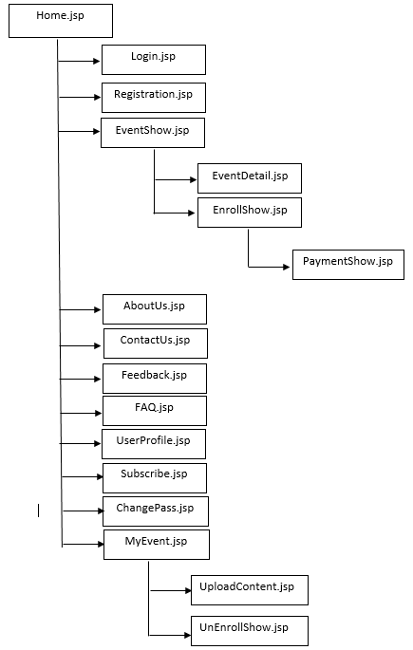

* 1. ***Admin side***

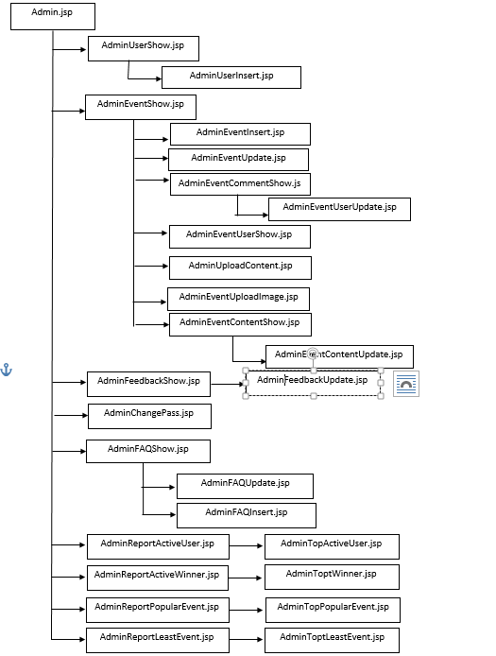

1. GUI Design
   1. Home side
      1. Home page

This is Home page of the website, the customers will first seeing this page.

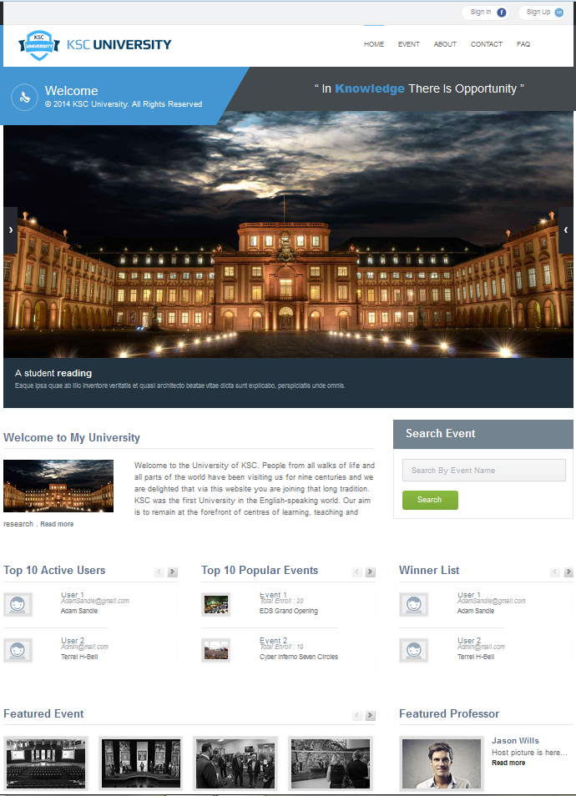



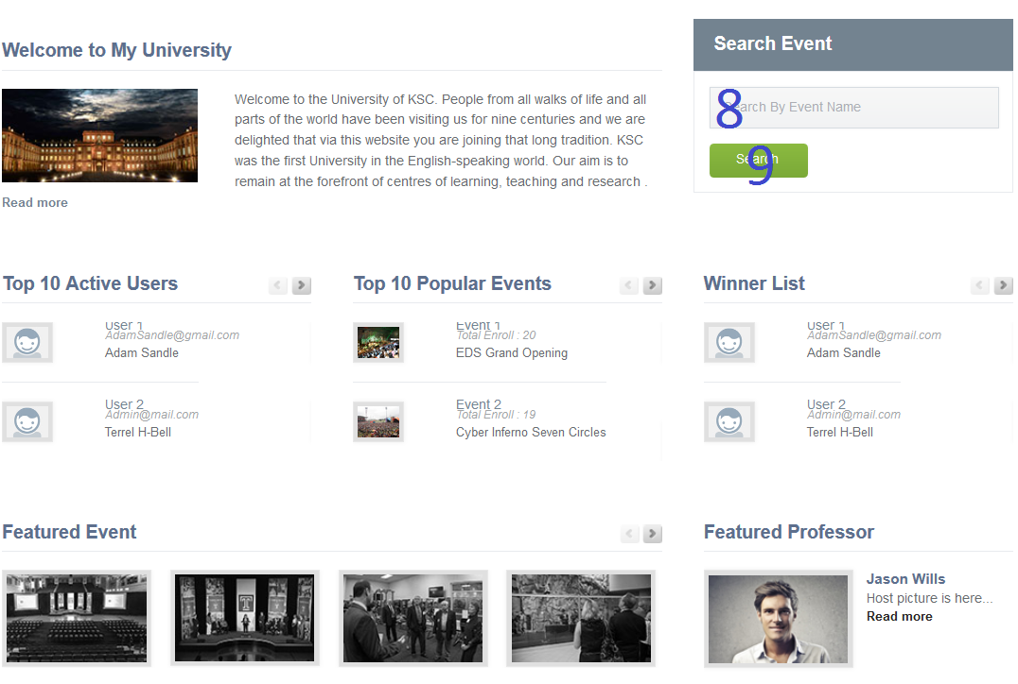

|  |  |  |  |  |  |  |
| --- | --- | --- | --- | --- | --- | --- |
| **No.** | **Name** | **Type** | **Validation** | **Event** | **Description** | **Status** |
| 1 | btnSignIn | Button |  | Click | Redirect to Login page |  |
| 2 | btnSignUp | Button |  | Click | Redirect to Registration page |  |
| 3 | btnHome | Button |  | Click | Redirect to Home page |  |
| 4 | btnEvent | Button |  | Click | Redirect to Site Map page |  |
| 5 | btnAbout | Button |  | Click | Redirect to About Us page |  |
| 6 | btnContact | Button |  | Click | Redirect to Contact Us page |  |
| 7 | btnFAQ | Button |  | Click | Redirect to FAQ page |  |
| 8 | txtSearch | Textfield | Length<=50 |  | Event Name for Search method |  |
| 9 | btnSearch | Button |  | Click | Redirect to Search method of Events Page |  |

* + 1. Event Page

-This is Event Page. Users can access this page via navigation bar.In this page, Users can see our upcoming event and enroll ones by clicking enroll button.

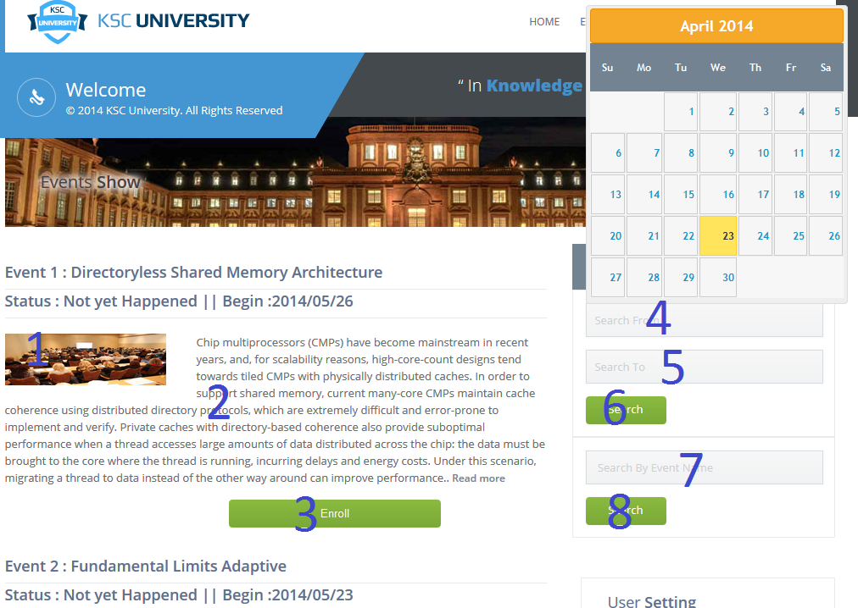

|  |  |  |  |  |  |  |
| --- | --- | --- | --- | --- | --- | --- |
| **No.** | **Name** | **Type** | **Validation** | **Event** | **Description** | **Status** |
| 1 | imgEvent | Image |  |  | Represent Event Image |  |
| 2 | EventDes | Text |  |  | Represent Event Description |  |
| 3 | btnEnroll | Button |  | Click | Redirect to Event Enroll Page |  |
| 4 | searchFrom | datepicker |  | Click | Represent Date search From | searchFrom |
| 5 | searchTo | datepicker |  | Click | Represent Date search To | searchTo |
| 6 | btnSearch | Button |  | Click | Redirect to Search method of Events Page | btnSearch |
| 7 | searchName | Text |  | Click | Represent Event name |  |
| 8 | btnSearchName | Button |  | Click | Redirect to Search method of Events Page | btnSearch |

* + 1. Event Details Page

-This is a page Event details that have description of event, image of event ,user click”Read more” the end description of event. User can enroll event in the this page.

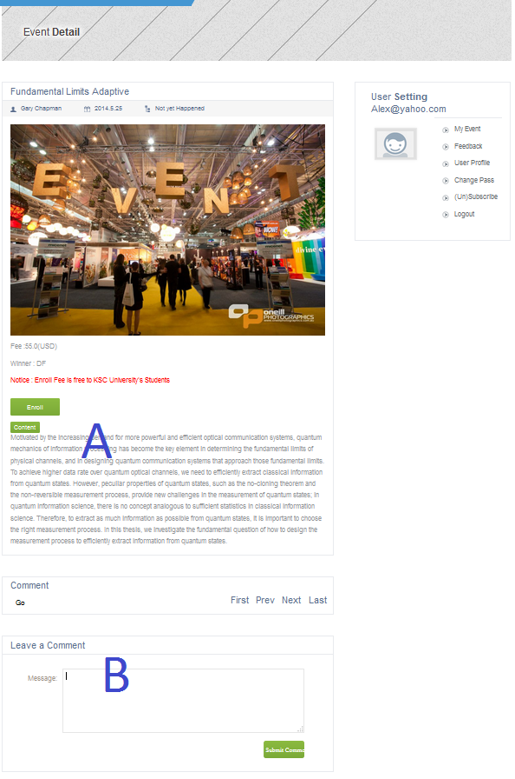

-This is sesscion “A”

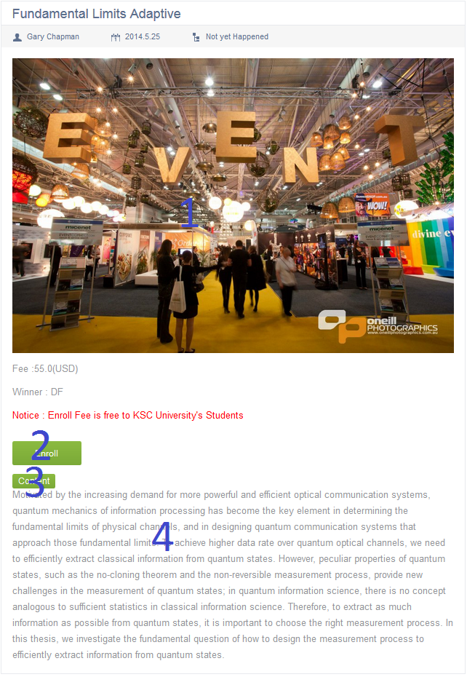

|  |  |  |  |  |  |  |
| --- | --- | --- | --- | --- | --- | --- |
| **No.** | **Name** | **Type** | **Validation** | **Event** | **Description** | **Status** |
| 1 | imgEvent | Image |  |  | Represent Event Image |  |
| 2 | btnEnroll | Button |  | Click | Represent EnrollShow page |  |
| 3 | btnContent | Button |  | Click | Process to download current content of this event |  |
| 4 | EvenDes | Text |  |  | Displays Event Description |  |

-In this section “B” , user will be able to see what others commented about current event and user who enrolled in current event can leave their comment by fulfill these fields below.

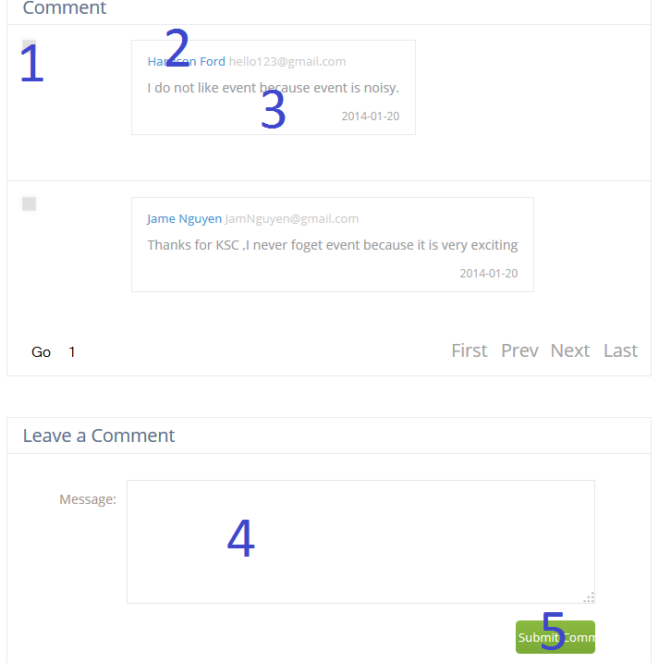

|  |  |  |  |  |  |  |
| --- | --- | --- | --- | --- | --- | --- |
| **No.** | **Name** | **Type** | **Validation** | **Event** | **Description** | **Status** |
| 1 | imgUser | Image |  |  | Represent User Image |  |
| 2 | txtUsername | Text |  |  | Represent Username |  |
| 3 | txtComment | Text |  |  | Represent User Comment |  |
| 4 | txtMess | Textfield | Length<=500 |  | Represent User Comment |  |
| 5 | btnSubmit | Button |  | Click | Submit User Comment to Server |  |

* + 1. Feedback Page

This is Feedback Page. Users can access this page via navigation bar. In this page, Users can see what others think about our site and how we response to those opinions and send feedback for system.

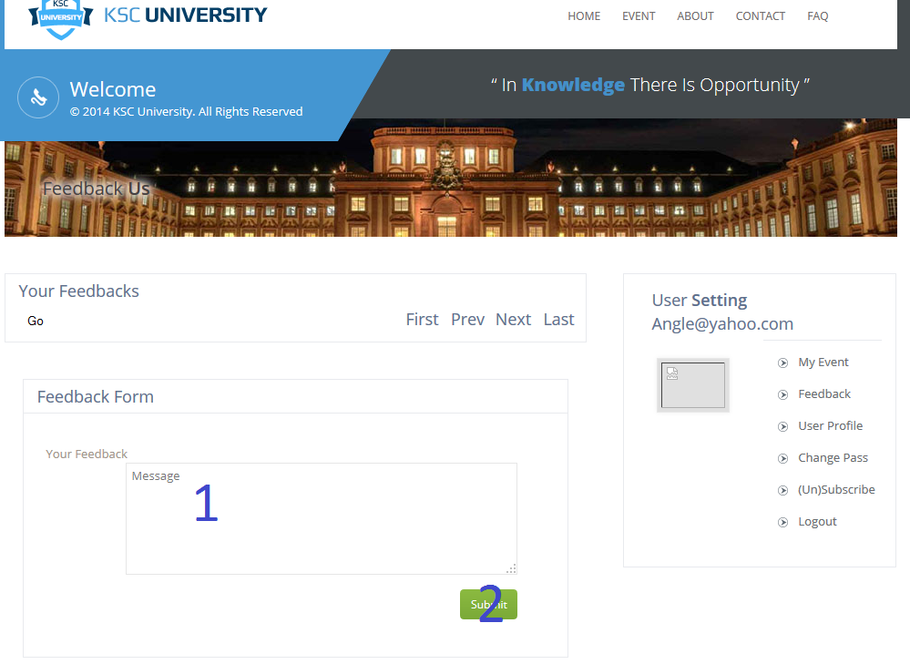

|  |  |  |  |  |  |  |
| --- | --- | --- | --- | --- | --- | --- |
| **No.** | **Name** | **Type** | **Validation** | **Event** | **Description** | **Status** |
| 1 | txtMessage | Text | Length<=500 |  | Represent User’s Feedback |  |
| 2 | btnSubmit | Button |  | Click | Submit User Feedback to Server |  |

* + 1. About Us Page

This is About Us Page. Users can access this page via navigation bar. In this page, Users can have a quick look about our University and our lead professors. This page also provide our address for further contacts.



* + 1. Login Page

This is Login page .In this page, User will input their Account Login Info to Log In.

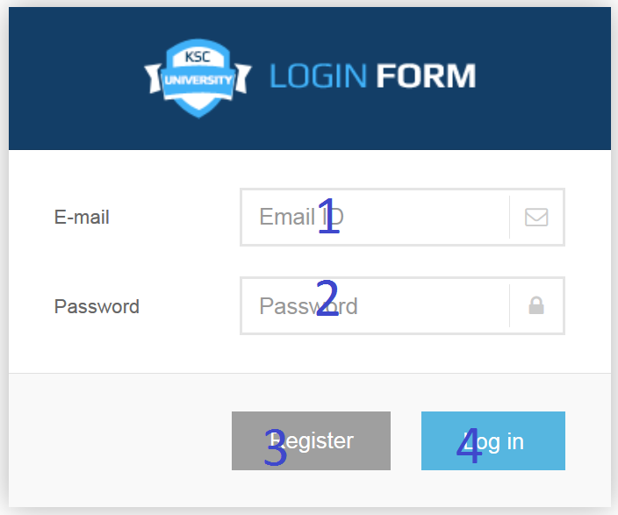

|  |  |  |  |  |  |  |
| --- | --- | --- | --- | --- | --- | --- |
| **No.** | **Name** | **Type** | **Validation** | **Event** | **Description** | **Status** |
| 1 | txtEmailID | Textfield | Length<=50 |  | Represent Username |  |
| 2 | txtPassword | Textfield | Length<=50 |  | Represent User’s Password |  |
| 3 | btnReg | Button |  | Click | Redirect to Registration page |  |
| 4 | btnLogin | Button |  | Click | Log User In using above login information |  |

* + 1. Registration Page

Through this page, Guest can register as User.

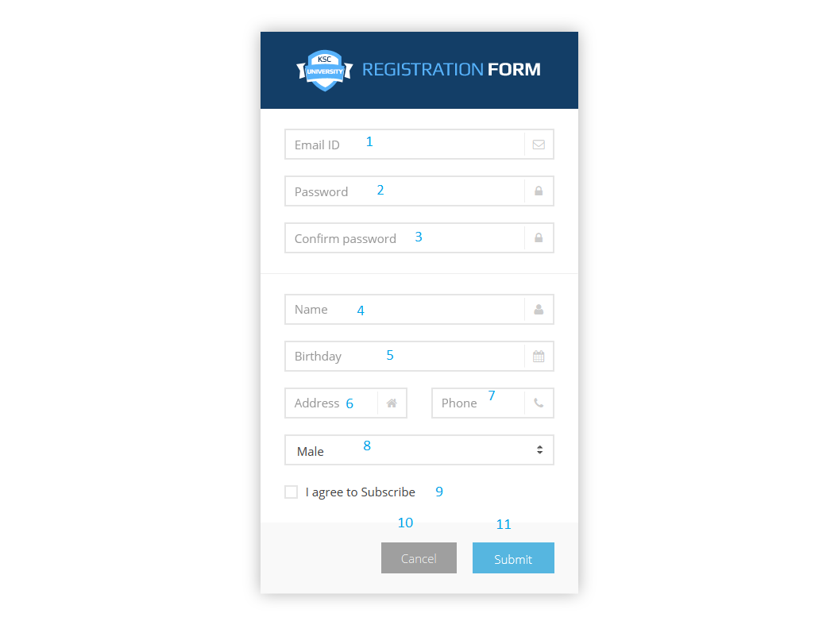

|  |  |  |  |  |  |  |
| --- | --- | --- | --- | --- | --- | --- |
| **No.** | **Name** | **Type** | **Validation** | **Event** | **Description** | **Status** |
| 1 | txtEmailID | Textfield | Length<=50 |  | Represent Username |  |
| 2 | txtPassword | Textfield | Length<=50 |  | Represent User’s Password |  |
| 3 | txtPasswordConfirm | Textfield | Length<=50 |  | Represent User’s Password Retype |  |
| 4 | txtName | Textfield | Length<=50 |  | Represent User’s Full name |  |
| 5 | txtDOB | Textfield | Date |  | Represent User’s DOB |  |
| 6 | txtAddress | Textfield | Length<=50 |  | Represent User Address |  |
| 7 | txtPhone | Textfield | Length<=50 |  | Represent User Phone Number |  |
| 8 | dropGender | Dropdownlist |  |  | Represent User’s Gender (Male/Female) |  |
| 9 | chkSubscribe | Checkbox |  |  | Indicate if User is subscribed to Website |  |
| 10 | btnCancel | Button |  | Click | Refuse to create account and redirect to Homepage |  |
| 11 | btnSubmit | Button |  | Click | Agree to create an account with above information |  |

* + 1. My event Page

This is my event page, through this page user can have an overall look at the events that they enrolled

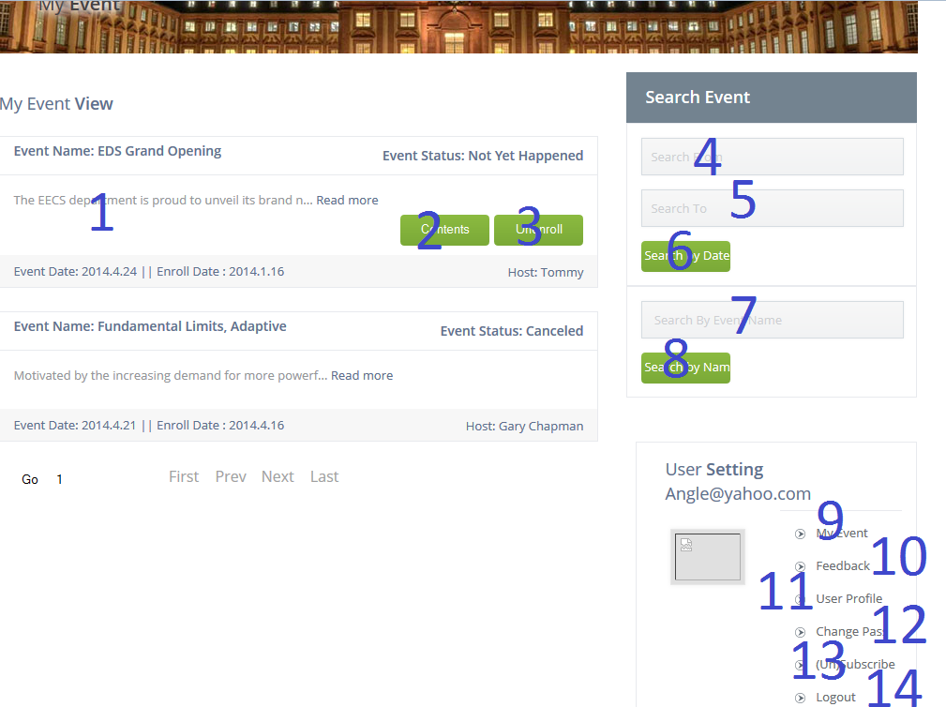

|  |  |  |  |  |  |  |
| --- | --- | --- | --- | --- | --- | --- |
| **No.** | **Name** | **Type** | **Validation** | **Event** | **Description** | **Status** |
| 1 | EventDes | Text |  |  | Represent Event Description |  |
| 2 | btnContent | Button |  | Click | Redirect to Content Upload/Download Page |  |
| 3 | btnUnenroll | Button |  | Click | Redirect to Unenroll Page |  |
| 4 | searchFrom | datepicker |  | Click | Represent Date search From | searchFrom |
| 5 | searchTo | datepicker |  | Click | Represent Date search To | searchTo |
| 6 | btnSearch | Button |  | Click | Redirect to Search method of Events Page | btnSearch |
| 7 | searchName | Text |  | Click | Represent Event name |  |
| 8 | btnSearchName | Button |  | Click | Redirect to Search method of Events Page | btnSearch |
| 9 | lnkMyEvent | Hyperlink |  | Click | Redirect to My Event Page |  |
| 10 | lnkFeedback | Hyperlink |  | Click | Redirect to User Feedback Page |  |
| 11 | lnkUserProfile | Hyperlink |  | Click | Redirect to User Profile edit page |  |
| 12 | lnkChangePass | Hyperlink |  | Click | Redirect to User Change Password page |  |
| 13 | lnkSubscribe | Hyperlink |  | Click | Redirect to Subscribe(Unsubscribe) Page |  |
| 14 | lnkLogout | Hyperlink |  | Click | Log User out of system then redirect to Homepage |  |

* + 1. User Profile

-This is a page user change information and avatar.

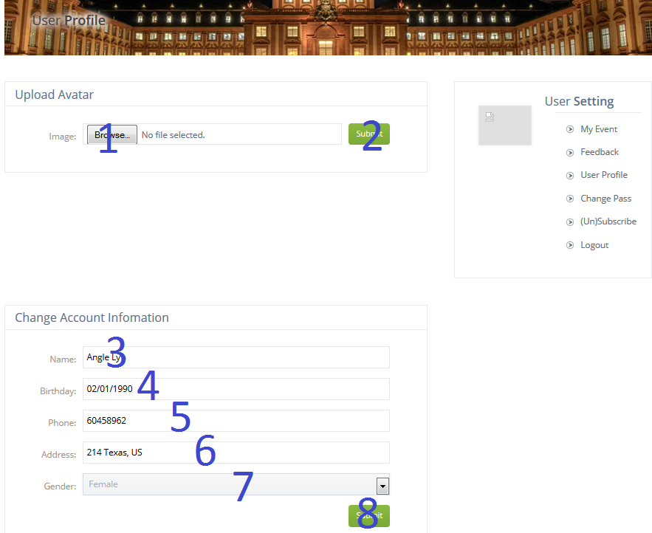

|  |  |  |  |  |  |  |
| --- | --- | --- | --- | --- | --- | --- |
| **No.** | **Name** | **Type** | **Validation** | **Event** | **Description** | **Status** |
| 1 | txtUpload | File |  | Click | Represent User Image |  |
| 2 | btnUpload | Button |  | Click | Upload User Image to server and update current user image |  |
| 3 | txtName | Text | Length<=50 |  | Represent User Full name |  |
| 4 | txtDOB | Text |  |  | Represent User DOB |  |
| 5 | txtPhone | Text |  |  | Represent User Phone Number |  |
| 6 | txtAddress | Text |  |  | Represent User Home Address |  |
| 7 | dropGender | Dropdownlist |  | Click | Indicate User Gender (Male/Female) |  |
| 8 | btnSubmit | Button |  | Click | Process to update current user profile |  |

* + 1. User Change Password

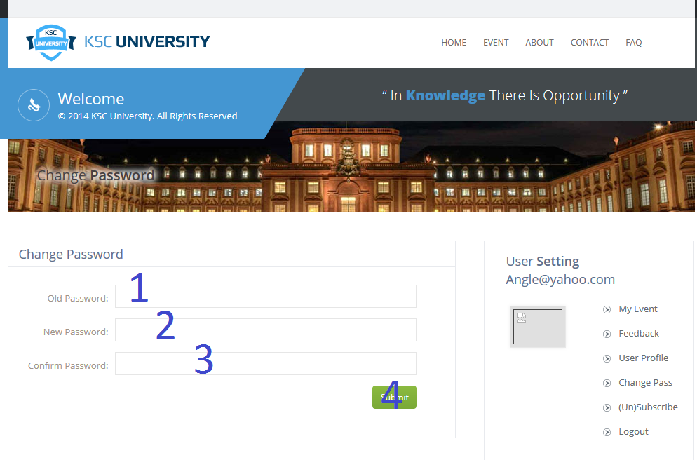

|  |  |  |  |  |  |  |
| --- | --- | --- | --- | --- | --- | --- |
| **No.** | **Name** | **Type** | **Validation** | **Event** | **Description** | **Status** |
| 1 | txtOldPass | Textfield | Length<=50 |  | Represent User Old Password |  |
| 2 | txtPassword | Textfield | Length<=50 |  | Represent User’s Password |  |
| 3 | txtPasswordConfirm | Textfield | Length<=50 |  | Represent User’s Password Retype |  |
| 4 | btnSubmit | Button |  | Click | Process to update current user password |  |

* + 1. User Subscribe – Unsubscribe

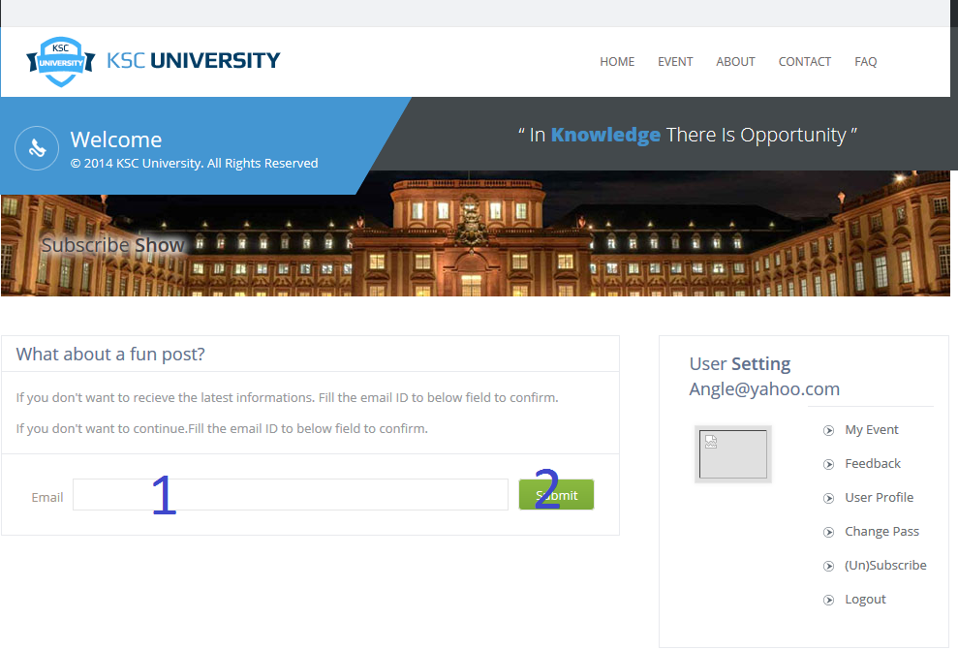

|  |  |  |  |  |  |  |
| --- | --- | --- | --- | --- | --- | --- |
| **No.** | **Name** | **Type** | **Validation** | **Event** | **Description** | **Status** |
| 1 | txtEmail | Textfield |  |  | Represent Username to subscribe |  |
| 2 | btnSubmit | Button |  | Click | Submit information to server |  |

* + 1. User Enroll/Unenroll Event
       1. This is Enroll Show Page. Users should be able to see this page by clicking Enroll Button in Event Page. In this page, Users can have a look at an event, which they decided to take part in.

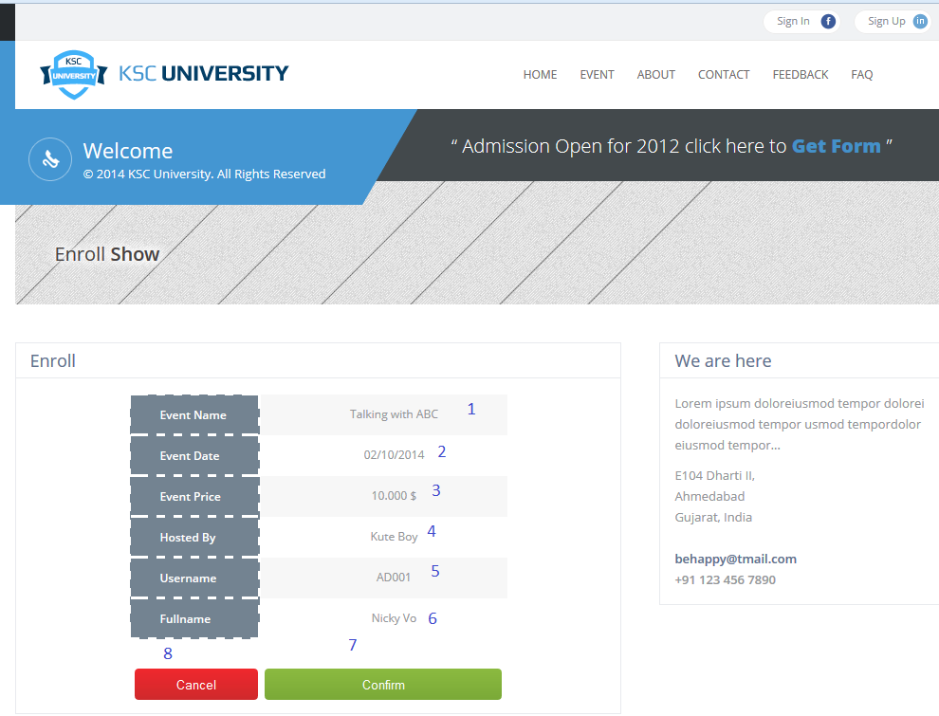

* + - 1. This is Unenroll Show Page. Users should be able to see this page by clicking Unenroll Button in My Event Page.

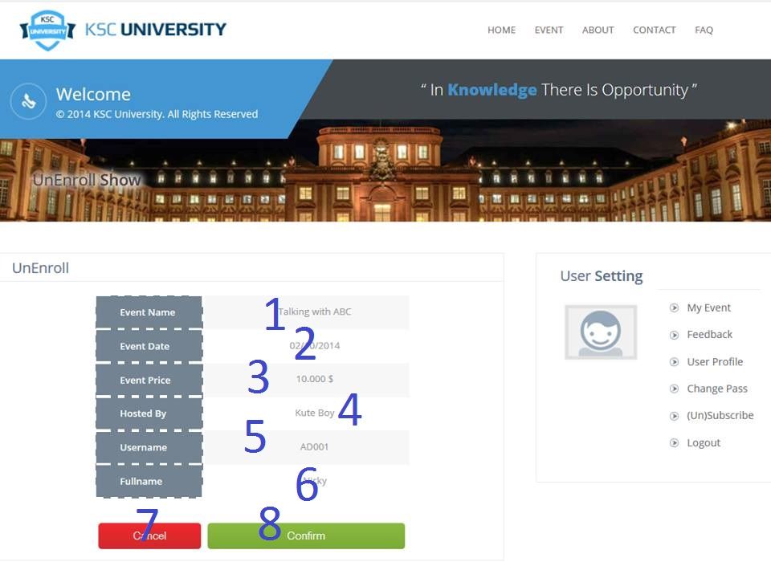

|  |  |  |  |  |  |  |
| --- | --- | --- | --- | --- | --- | --- |
| **No.** | **Name** | **Type** | **Validation** | **Event** | **Description** | **Status** |
| 1 | txtEventName | Text |  |  | Displays Event Name |  |
| 2 | txtEventDate | Text |  |  | Displays Event Occur Date |  |
| 3 | txtEventFee | Text |  |  | Displays Event Fee (Price)for specific User |  |
| 4 | txtEventHost | Text |  |  | Displays Event’s Host |  |
| 5 | txtUsername | Text |  |  | Displays current Username |  |
| 6 | txtFullName | Text |  |  | Displays current Username’s Fullname |  |
| 7 | btnConfirm | Button |  | Click | Confirm a participation and redirect to Home page |  |
| 8 | btnCancel | Button |  | Click | Reject a participation and redirect to Event Page |  |

* + 1. User Confirm Payment

This is Payment Page. Only Users who are not a student from KSC University should be able to see this page by clicking Confirm button in Enroll Page after Clicking Enroll an Event. In this page, Users can have a look at a payment, which they have to make before their enrollment is activated.

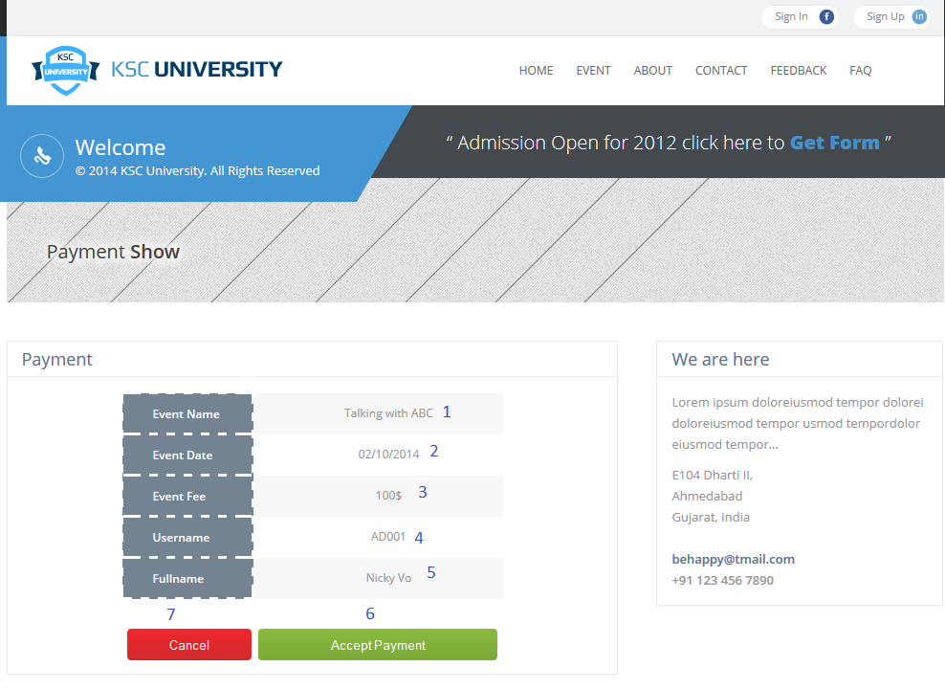

|  |  |  |  |  |  |  |
| --- | --- | --- | --- | --- | --- | --- |
| **No.** | **Name** | **Type** | **Validation** | **Event** | **Description** | **Status** |
| 1 | txtEventName | Text |  |  | Displays Event Name |  |
| 2 | txtEventDate | Text |  |  | Displays Event Occur Date |  |
| 3 | txtEventFee | Text |  |  | Displays Event Fee for specific User |  |
| 4 | txtUsername | Text |  |  | Displays current Username |  |
| 5 | txtFullName | Text |  |  | Displays current Username’s Fullname |  |
| 6 | btnAcceptPayment | Button |  | Click | Accept to make a payment and redirect to Home page |  |
| 7 | btnCancel | Button |  | Click | Refuse to make a payment and redirect to Event Page |  |

* + 1. User Upload Content

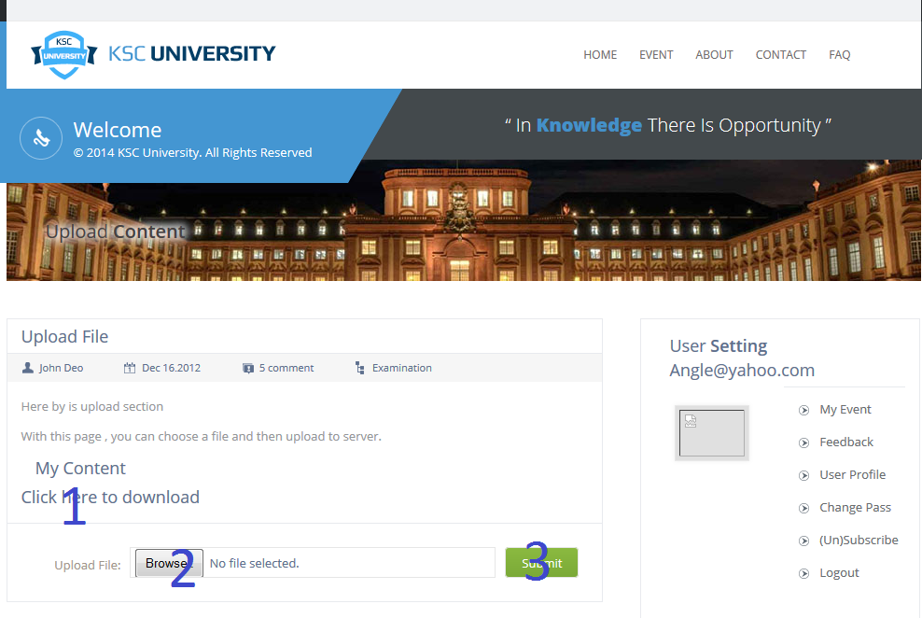

|  |  |  |  |  |  |  |
| --- | --- | --- | --- | --- | --- | --- |
| **No.** | **Name** | **Type** | **Validation** | **Event** | **Description** | **Status** |
| 1 | lnkDownload | Link |  | Click | Represent download file. |  |
| 2 | txtFile | File |  |  | Represent URL to Content File |  |
| 3 | btnSubmit | Button |  | Click | Submit content to server |  |

* 1. Admin Side
     1. Admin Home Page

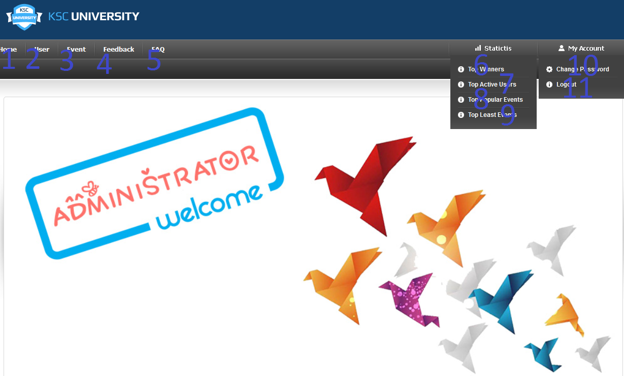

|  |  |  |  |  |  |  |
| --- | --- | --- | --- | --- | --- | --- |
| **No.** | **Name** | **Type** | **Validation** | **Event** | **Description** | **Status** |
| 1 | btnHome | Button |  | Click | Redirect to Admin Home Page |  |
| 2 | btnUser | Button |  | Click | Redirect to User Management Page |  |
| 3 | btnEvent | Button |  | Click | Redirect to Event Management Page |  |
| 4 | btnFeedback | Button |  | Click | Redirect to Feedback Management Page |  |
| 5 | btnFAQ | Button |  | Click | Redirect to FAQ Management Page |  |
| 6 | btnTopWinner | Button |  | Click | Redirect to Top Winner Report Page |  |
| 7 | btnTopActive | Button |  | Click | Redirect to Top Active User Report Page |  |
| 8 | btnPopEvent | Button |  | Click | Redirect to Popular Event Report Page |  |
| 9 | btnLeastEvent | Button |  | Click | Redirect to Least Event Page |  |
| 10 | btnChangePass | Button |  | Click | Redirect to Change Admin Password Page |  |
| 11 | btnLogout | Button |  | Click | Process to Log Admin out of system |  |

* + 1. Admin Change Password

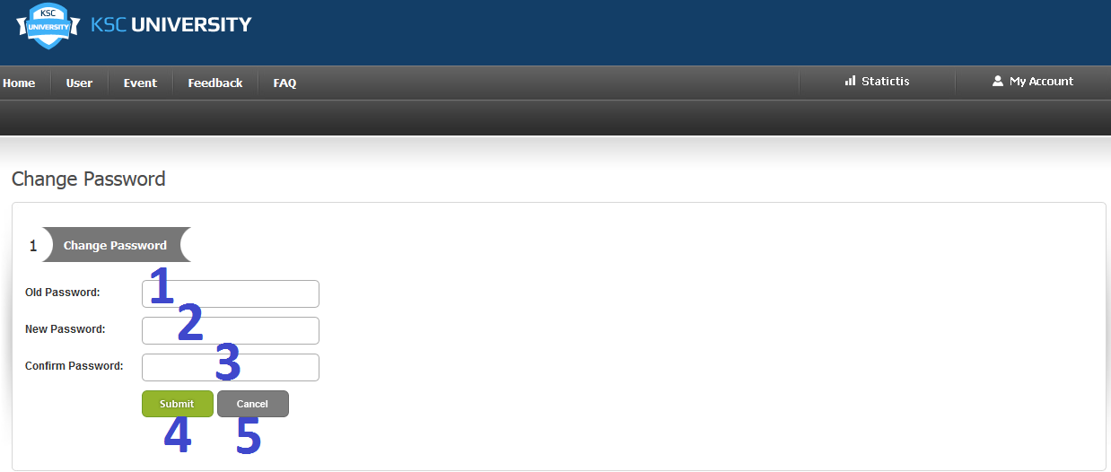

|  |  |  |  |  |  |  |
| --- | --- | --- | --- | --- | --- | --- |
| **No.** | **Name** | **Type** | **Validation** | **Event** | **Description** | **Status** |
| 1 | txtOldPass | Textfield | Length<=50 |  | Represent Admin Old Password |  |
| 2 | txtPassword | Textfield | Length<=50 |  | Represent Admin’s Password |  |
| 3 | txtPasswordConfirm | Textfield | Length<=50 |  | Represent Admin ‘s Password Retype |  |
| 4 | btnSubmit | Button |  | Click | Process to update current user password |  |
| 5 | btnCancel | Button |  | Click | Cancel all changes and redirect to Admin Home Page |  |

* + 1. User Management Page

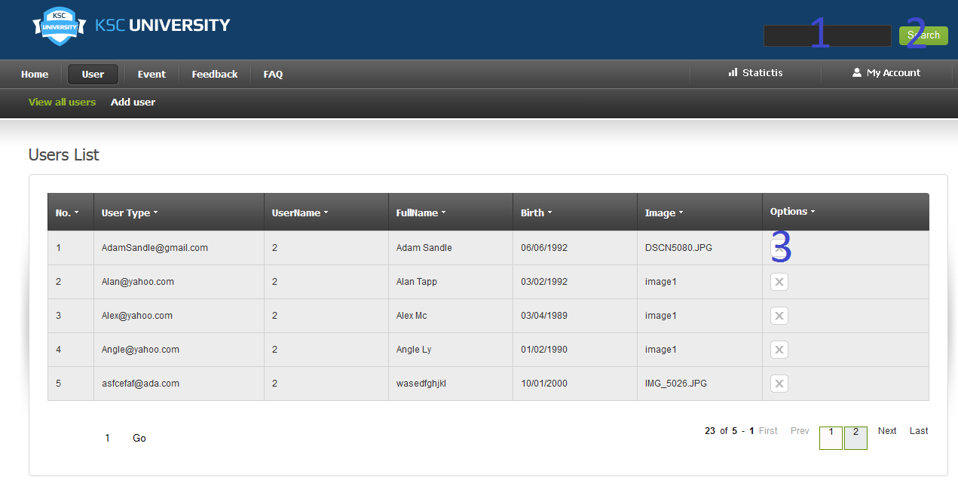

|  |  |  |  |  |  |  |
| --- | --- | --- | --- | --- | --- | --- |
| **No.** | **Name** | **Type** | **Validation** | **Event** | **Description** | **Status** |
| 1 | txtSearch | Textfield | Length<=50 |  | Keyword for searching username method |  |
| 2 | btnSearch | Button |  | Click | Process to Search User |  |
| 3 | btnDelete | Button |  | Click | Process to delete current record |  |

* + 1. User Create user Page

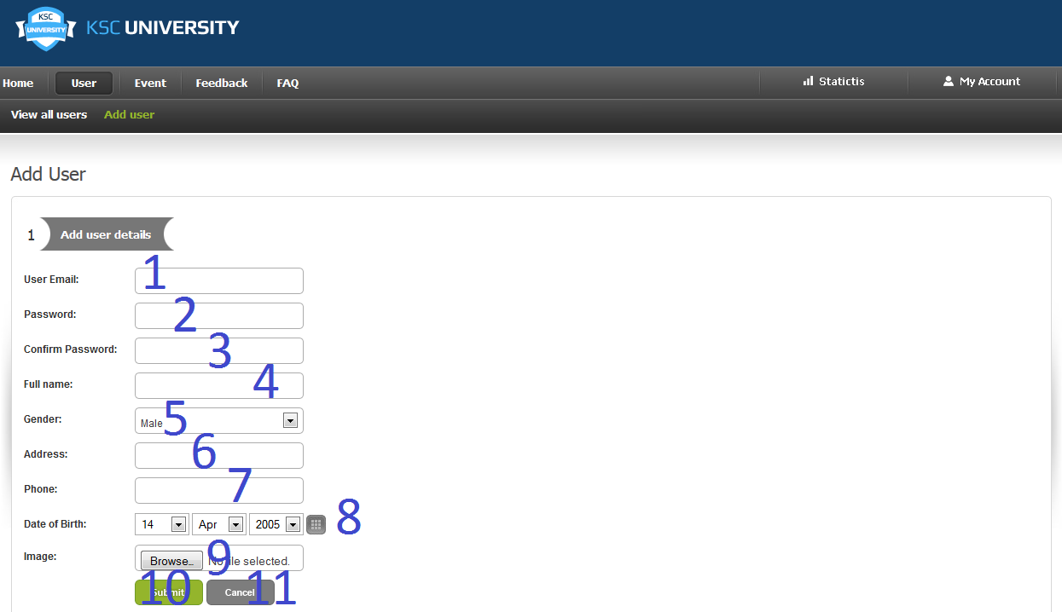

|  |  |  |  |  |  |  |
| --- | --- | --- | --- | --- | --- | --- |
| **No.** | **Name** | **Type** | **Validation** | **Event** | **Description** | **Status** |
| 1 | txtUsername | Textfield | Length<=50 |  | Represent Username |  |
| 2 | txtPassword | Textfield | Length<=50 |  | Represent User’s Password |  |
| 3 | txtPasswordConfirm | Textfield | Length<=50 |  | Represent User’s Password Retype |  |
| 4 | txtName | Textfield | Length<=50 |  | Represent User’s Fullname |  |
| 5 | dropGender | Dropdownlist |  |  | Represent User’s Gender (Male/Female) |  |
| 6 | txtAddress | Textfield | Length<=50 |  | Represent User Address |  |
| 7 | txtPhone | Textfield | Length<=50 |  | Represent User Phone Number |  |
| 8 | dropDOB | Dropdownlist |  |  | Represent User’s DOB |  |
| 9 | txtUpload | File |  | Click | Represent a file that will becomes user image |  |
| 10 | btnSubmit | Button |  | Click | Agree to create an account with above information |  |
| 11 | btnCancel | Button |  | Click | Refuse to create account and redirect to Homepage |  |

* + 1. Event Management Page

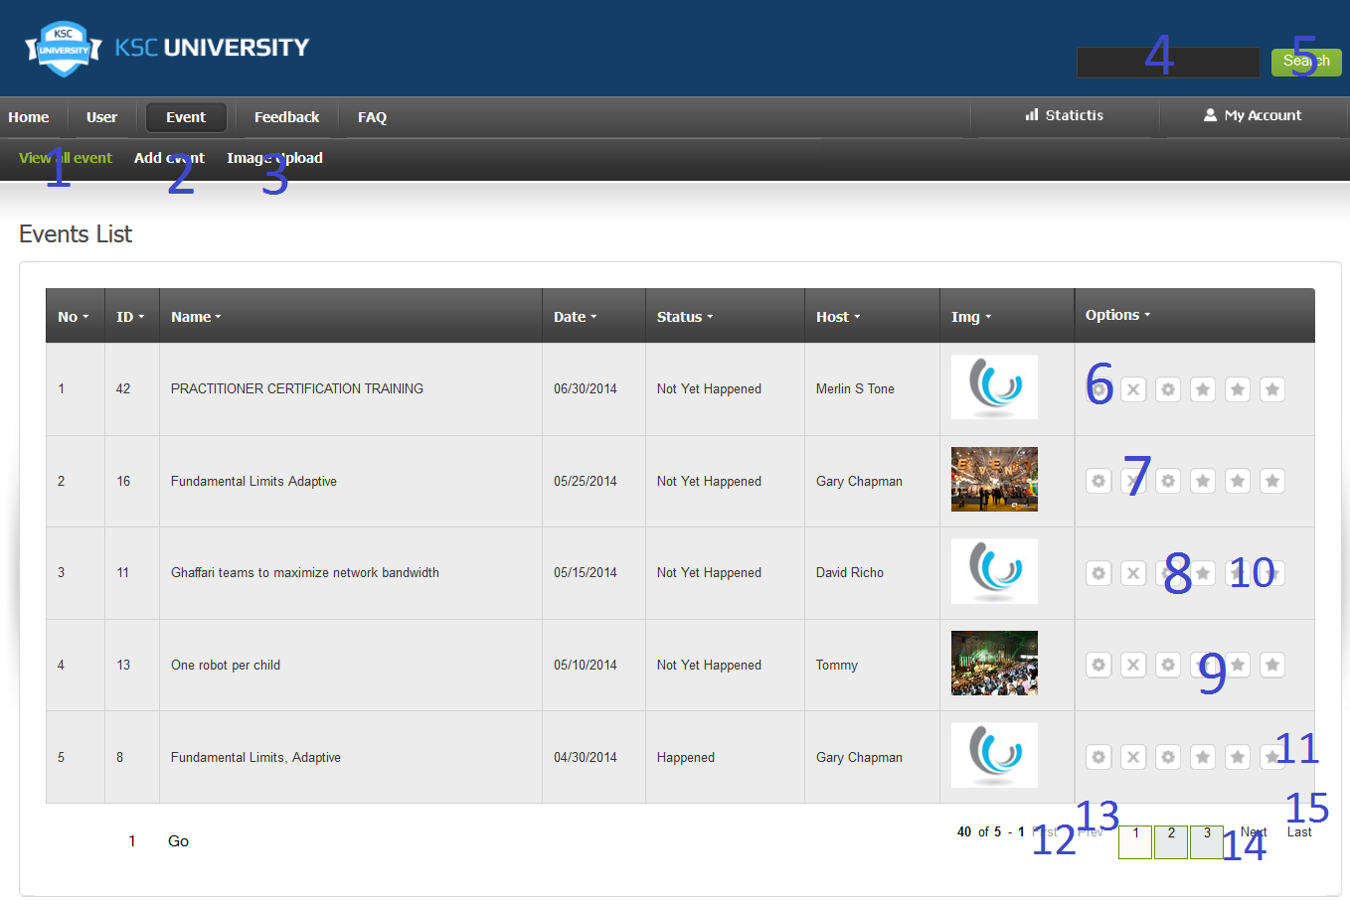

|  |  |  |  |  |  |  |
| --- | --- | --- | --- | --- | --- | --- |
| **No.** | **Name** | **Type** | **Validation** | **Event** | **Description** | **Status** |
| 1 | btnViewEvent | Button |  | Click | Redirect to Event Show Page |  |
| 2 | btnAddEvent | Button |  | Click | Redirect to Event Creation Page |  |
| 3 | btnImageUpload | Button |  | Click | Redirect to AdminEventUploadImage Page |  |
| 4 | txtSearch | Textfield | Length<=50 |  | Keyword for search Event |  |
| 5 | btnSearch | Button |  | Click | Process to search Event depends on selected method |  |
| 6 | btnEdit | Button |  | Click | Process to edit information of current record |  |
| 7 | btnDelete | Button |  | Click | Process to Update current record |  |
| 8 | btnUploadContent | Button |  | Click | Redirect to current event AdminUploadEventContent Page |  |
| 9 | btnParticipant | Button |  | Click | Redirect to current event Participant Management Page |  |
| 10 | btnContent | Button |  | Click | Redirect to current event Content Management Page |  |
| 11 | btnComment | Button |  | Click | Redirect to current event Management |  |
| 12 | btnFirst | Button |  | Click | Process to first page |  |
| 13 | btnPrev | Button |  | Click | Process to previous page |  |
| 14 | btnNext | Button |  | Click | Process to next page |  |
| 15 | btnLast | Button |  | Click | Process to last page |  |

* + 1. Event Update Info Page

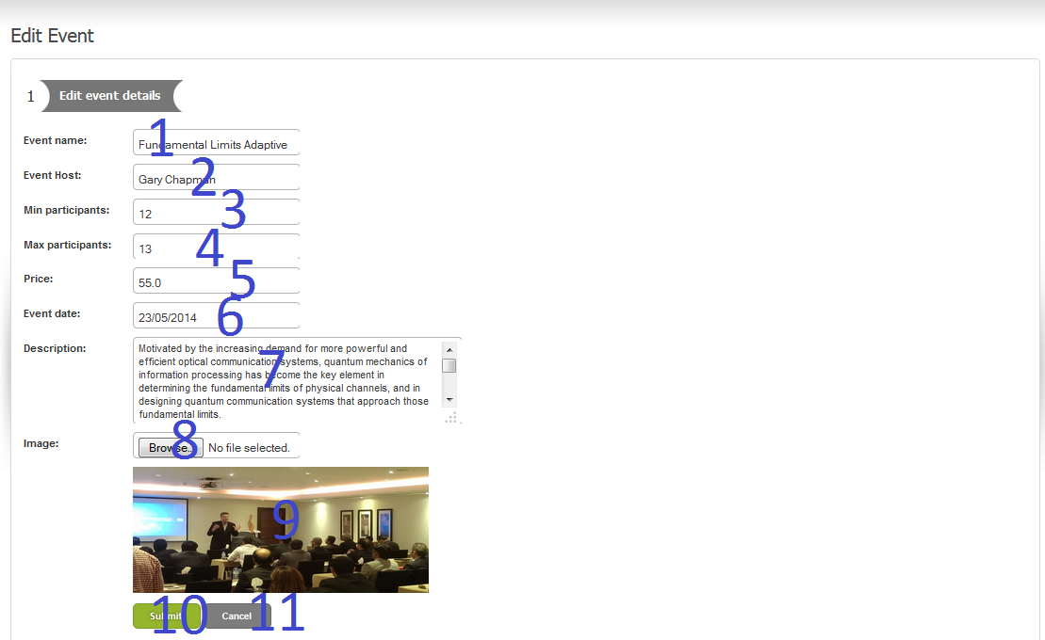

|  |  |  |  |  |  |  |
| --- | --- | --- | --- | --- | --- | --- |
| **No.** | **Name** | **Type** | **Validation** | **Event** | **Description** | **Status** |
| 1 | txtEventName | Textfield | Length<=50 |  | Represent Event Name |  |
| 2 | txtEventHost | Textfield | Length<=50 |  | Represent Event Host |  |
| 3 | txtMin | Textfield | Number only |  | Indicate minimum participant that required for an event to be held |  |
| 4 | txtMax | Textfield | Number only |  | Indicate maximum participant that an event can have |  |
| 5 | txtPrice | Textfield | Length<=50 |  | Indicate Event Price |  |
| 6 | cmbDate(1,2,3) | Dropdownlist | Must not before current Event Date |  | Represent Event Date |  |
| 7 | txtEventDes | Textfield | Length<=Varchar(Max) |  | Represent Event Description |  |
| 8 | ImageEvent | Image |  |  | Represent Event Image current before update. |  |
| 9 | txtFile | File |  | Click | Represent Event Image |  |
| 10 | btnSubmit | Button |  | Click | Process to create a new event with information above |  |
| 11 | btnCancel | Button |  | Click | Cancel all changes and redirect to Event Management Page |  |

* + 1. Event Create Page

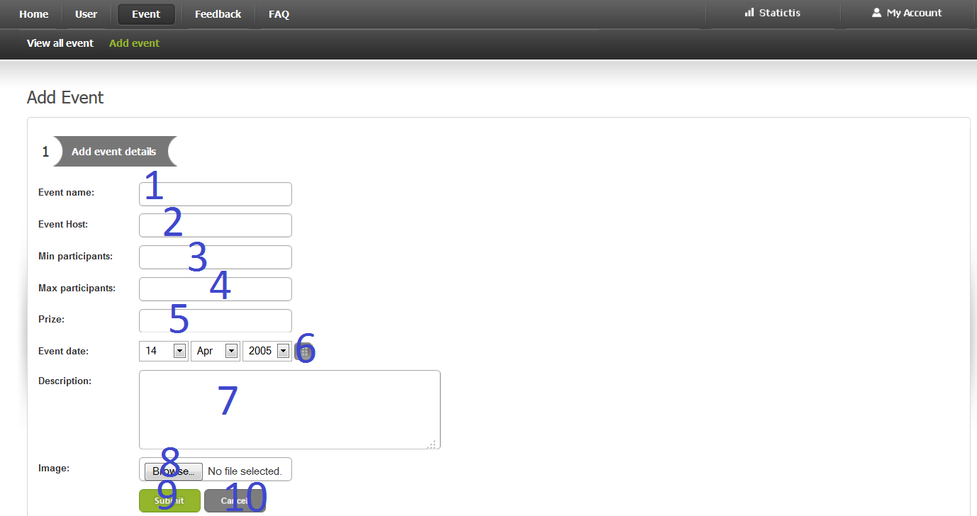

|  |  |  |  |  |  |  |
| --- | --- | --- | --- | --- | --- | --- |
| **No.** | **Name** | **Type** | **Validation** | **Event** | **Description** | **Status** |
| 1 | txtEventName | Textfield | Length<=50 |  | Represent Event Name |  |
| 2 | txtEventHost | Textfield | Length<=50 |  | Represent Event Host |  |
| 3 | txtMin | Textfield | Number only |  | Indicate minimum participant that required for an event to be held |  |
| 4 | txtMax | Textfield | Number only |  | Indicate maximum participant that an event can have |  |
| 5 | txtPrice | Textfield | Length<=50 |  | Indicate Event Price |  |
| 6 | cmbDate(1,2,3) | Dropdownlist |  |  | Represent Event Date |  |
| 7 | cmbRegDate(1,2,3) | Dropdownlist |  |  | Represent that date from which users will be able to enroll |  |
| 7 | txtEventDes | Textfield | Length<=Varchar(Max) |  | Represent Event Description |  |
| 8 | txtFile | File |  | Click | Represent Event Image |  |
| 9 | btnSubmit | Button |  | Click | Process to create a new event with information above |  |
| 10 | btnCancel | Button |  | Click | Cancel all changes and redirect to Event Management Page |  |

* + 1. Upload Image Event Page

-This is a page upload image for event.

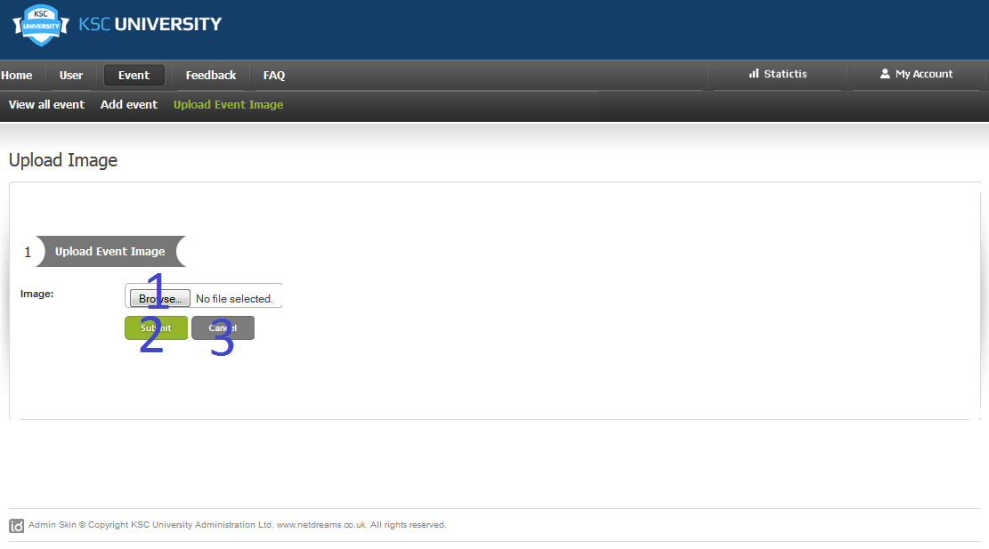

|  |  |  |  |  |  |  |
| --- | --- | --- | --- | --- | --- | --- |
| **No.** | **Name** | **Type** | **Validation** | **Event** | **Description** | **Status** |
| 1 | txtImgae | File |  |  | Represent Event Image |  |
| 2 | btnSubmit | Button |  | Click | Process to upload a new event with information above |  |
| 3 | btnCancel | Button |  | Click | Cancel all changes and redirect to Event Management Page |  |

* + 1. Event Participants Management Page

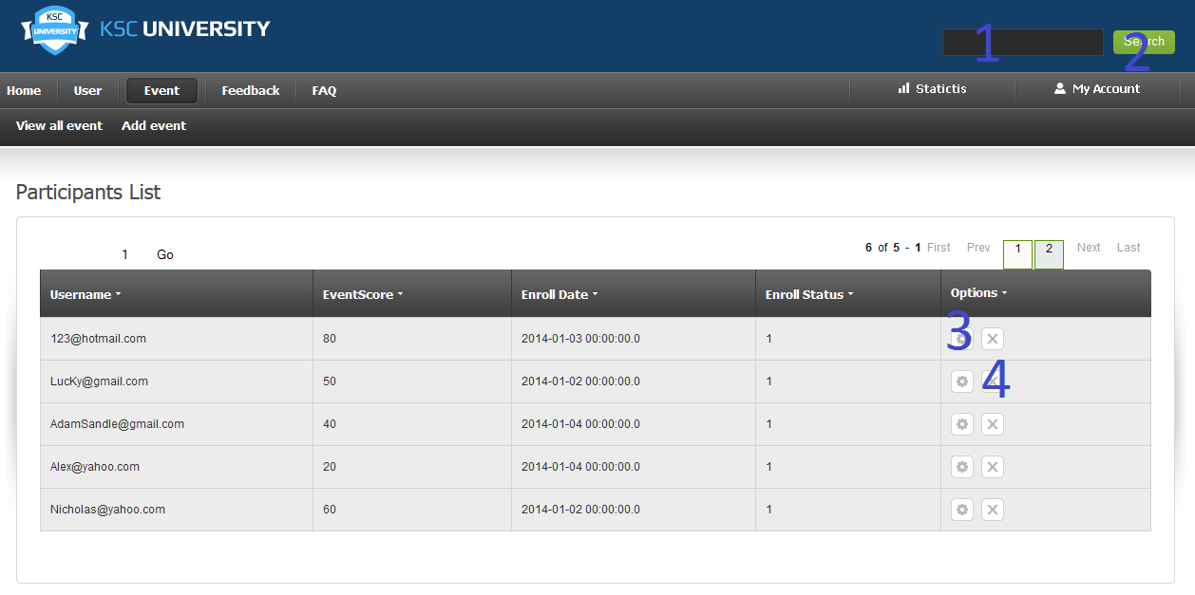

|  |  |  |  |  |  |  |
| --- | --- | --- | --- | --- | --- | --- |
| **No.** | **Name** | **Type** | **Validation** | **Event** | **Description** | **Status** |
| 1 | txtSearch | Textfield | Length<=50 |  | Keyword for searching participants |  |
| 2 | btnSearch | Button |  | Click | Process to search paticipants |  |
| 3 | btnEdit | Button |  | Click | Process to edit current record |  |
| 4 | btnDelete | Button |  | Click | Process to delete current record |  |

* + 1. Event Participant Update Info Page

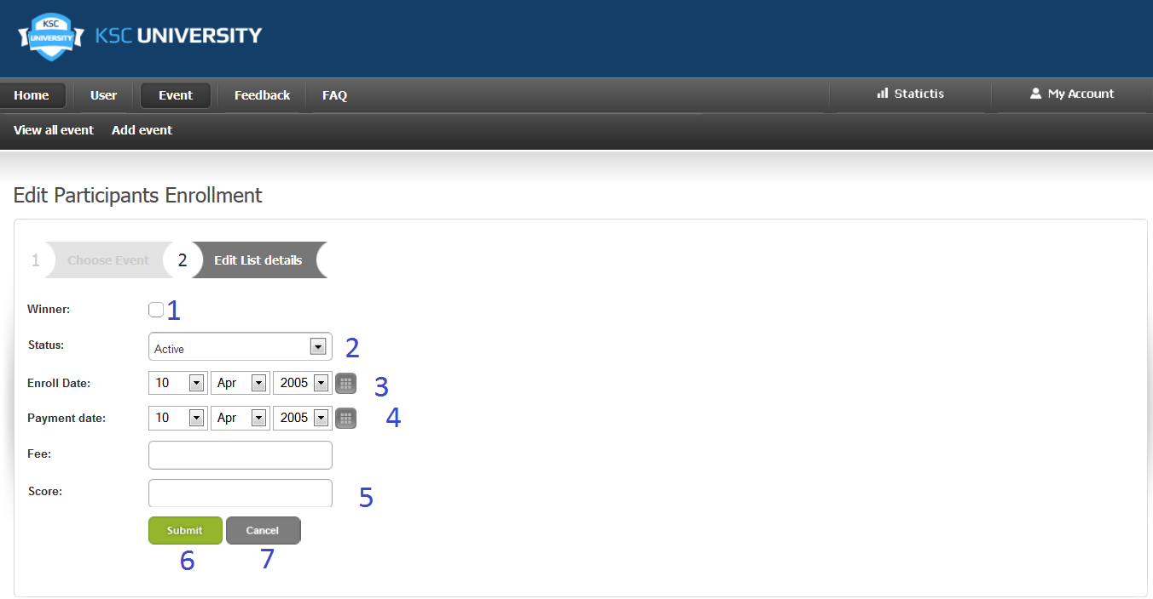

|  |  |  |  |  |  |  |
| --- | --- | --- | --- | --- | --- | --- |
| **No.** | **Name** | **Type** | **Validation** | **Event** | **Description** | **Status** |
| 1 | chkWinner | Checkbox |  | Click | Indicate if current user is winner of current event |  |
| 2 | cmbStt | Dropdownlist |  | Click | Indicate current enrollment status |  |
| 3 | cmbDate | Dropdownlist |  | Click | Represent the date that user enrolled in an event |  |
| 4 | cmbPayment | Dropdownlist |  | Click | Represent the date that user made their payment(if user is not belonged to this university then this field will be the same as enroll Date) |  |
| 5 | txtScore | Textfield | Number Only |  | Represent current user score in current event |  |
| 6 | btnSubmit | Button |  | Click | Process to update current user enrollment info |  |
| 7 | btnCancel | Button |  | Click | Cancel all changes and redirect to Paticipant Management page |  |

* + 1. Event Content Management Page

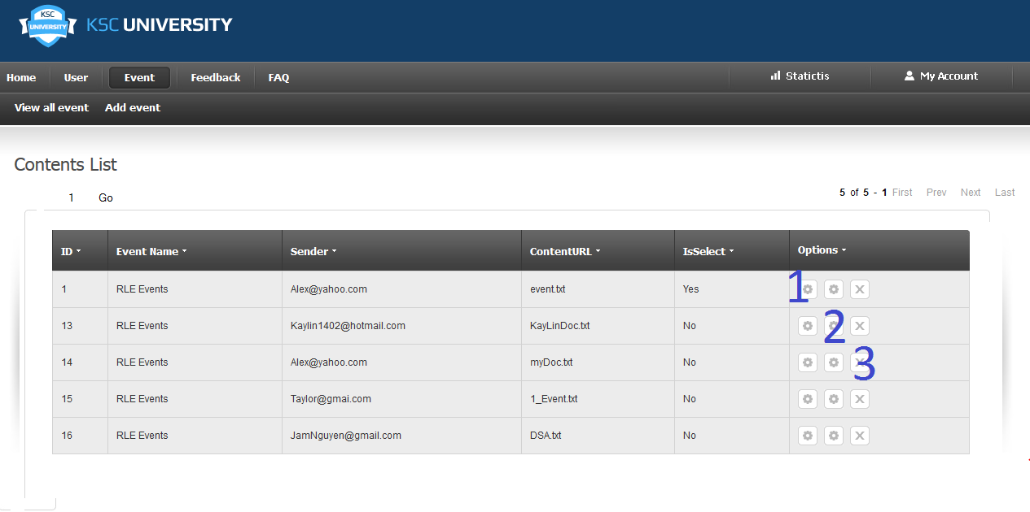

|  |  |  |  |  |  |  |
| --- | --- | --- | --- | --- | --- | --- |
| **No.** | **Name** | **Type** | **Validation** | **Event** | **Description** | **Status** |
| 1 | btnDownload | Button |  | Click | Process to download current content |  |
| 2 | btnEdit | Button |  | Click | Process to edit information of current record |  |
| 3 | btnDelete |  |  | Click | Process to Update current record |  |

* + 1. Event Upload Content Page

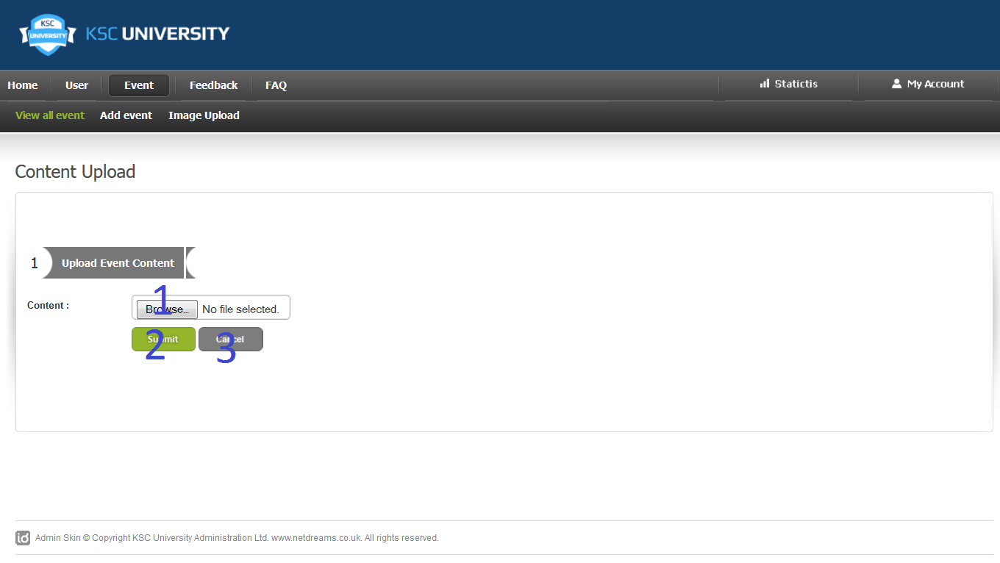

|  |  |  |  |  |  |  |
| --- | --- | --- | --- | --- | --- | --- |
| **No.** | **Name** | **Type** | **Validation** | **Event** | **Description** | **Status** |
| 1 | txtContent | File |  |  | Represent Content URL |  |
| 2 | btnSubmit | Button |  | Click | Process to upload a content to specific event with information above |  |
| 3 | btnCancel | Button |  | Click | Cancel all changes and redirect to Event Management Page |  |

* + 1. Event Content Approve Page

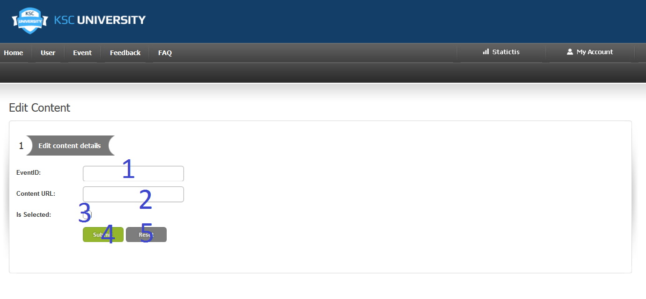

|  |  |  |  |  |  |  |
| --- | --- | --- | --- | --- | --- | --- |
| **No.** | **Name** | **Type** | **Validation** | **Event** | **Description** | **Status** |
| 1 | chkSelected | Checkbox |  | Click | Indicate if current content is selected |  |
| 2 | btnSubmit | Button |  | Click | Process to update current record and then redirect to Content Management Page |  |
| 3 | btnCancel | Button |  | Click | Cancel all action and redirect to Content Management Page |  |

* + 1. Event Comment Management Page

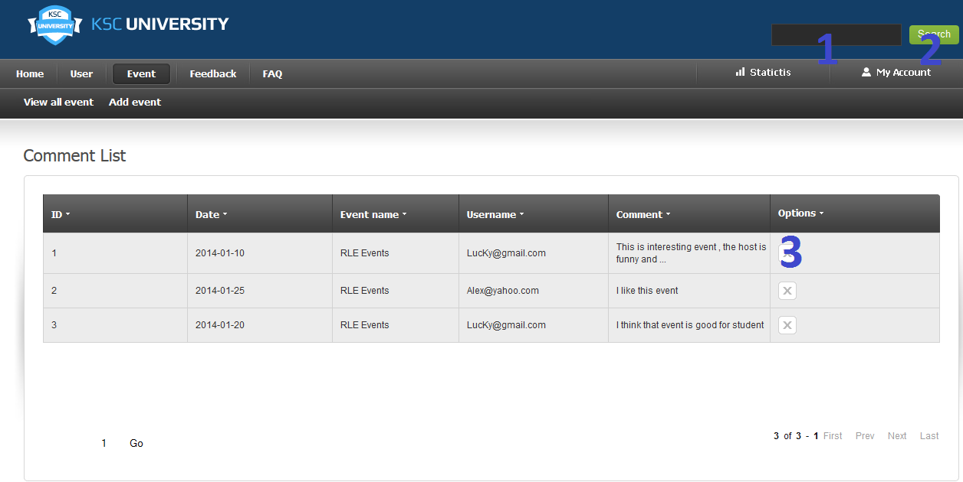

|  |  |  |  |  |  |  |
| --- | --- | --- | --- | --- | --- | --- |
| **No.** | **Name** | **Type** | **Validation** | **Event** | **Description** | **Status** |
| 1 | txtSearch | Textfield | Length<=50 |  | Keyword for searching comment by Username method |  |
| 2 | btnSearch | Button |  | Click | Process to Search Commnet |  |
| 3 | btnDelete | Button |  | Click | Process to delete current record |  |

* + 1. Feedback Management Page

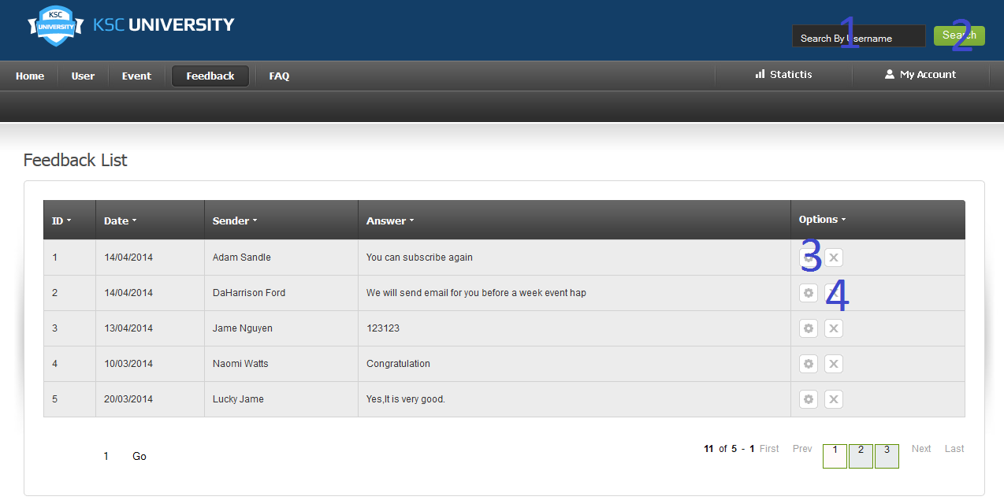

|  |  |  |  |  |  |  |
| --- | --- | --- | --- | --- | --- | --- |
| **No.** | **Name** | **Type** | **Validation** | **Event** | **Description** | **Status** |
| 1 | txtSearch | Textfield | Length<=50 |  | Keyword for searching Feedback by Username method |  |
| 2 | btnSearch | Button |  | Click | Process to Search Feedback |  |
| 3 | btnEdit | Button |  | Click | Process to edit current record |  |
| 4 | btnDelete | Button |  | Click | Process to delete current record |  |

* + 1. Feedback Update ( Reply) Page

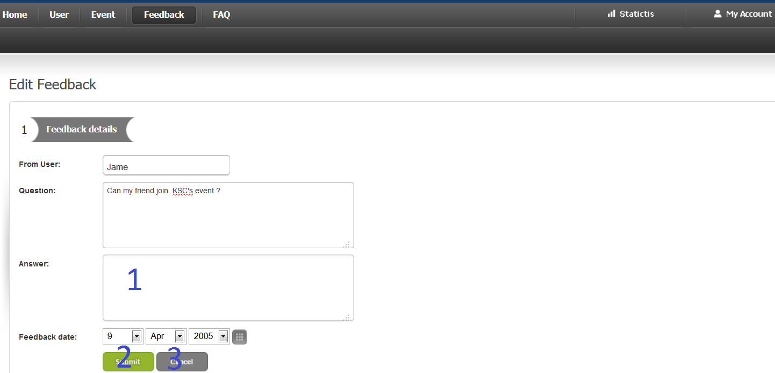

|  |  |  |  |  |  |  |
| --- | --- | --- | --- | --- | --- | --- |
| **No.** | **Name** | **Type** | **Validation** | **Event** | **Description** | **Status** |
| 1 | txtAnswer | Textfield | Length<=Varchar(Max) |  | Represent an appropriate answer |  |
| 2 | btnSubmit | Button |  | Click | Process to update a Feedback by using information above |  |
| 3 | btnCancel | Buton |  | Click | Cancel all changes and redirect to Feedback Management Page |  |

* + 1. FAQ Management Page

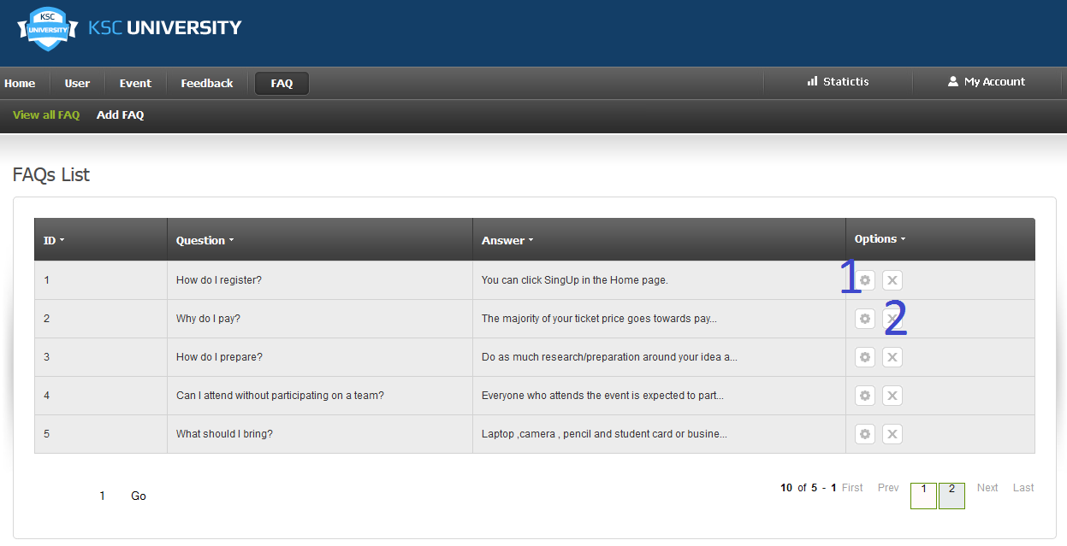

|  |  |  |  |  |  |  |
| --- | --- | --- | --- | --- | --- | --- |
| **No.** | **Name** | **Type** | **Validation** | **Event** | **Description** | **Status** |
| 1 | btnEdit | Button |  | Click | Process to edit current record |  |
| 2 | btnDelete | Button |  | Click | Process to delete current record |  |

* + 1. FAQ Update Page

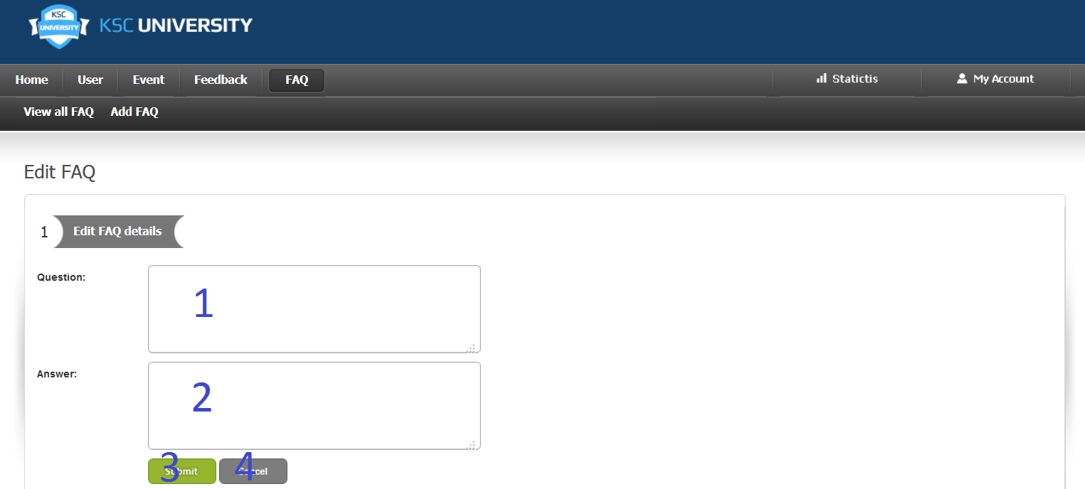

|  |  |  |  |  |  |  |
| --- | --- | --- | --- | --- | --- | --- |
| **No.** | **Name** | **Type** | **Validation** | **Event** | **Description** | **Status** |
| 1 | txtQuestion | Textfield | Length<=Varchar500 |  | Represent a question |  |
| 2 | txtAnswer | Textfield | Length<=Varchar500 |  | Represent an appropriate answer |  |
| 3 | btnSubmit | Button |  | Click | Process to update an FAQ Topic by using information above |  |
| 4 | btnCancel | Buton |  | Click | Cancel all changes and redirect to FAQ Management Page |  |

* + 1. FAQ Create Page

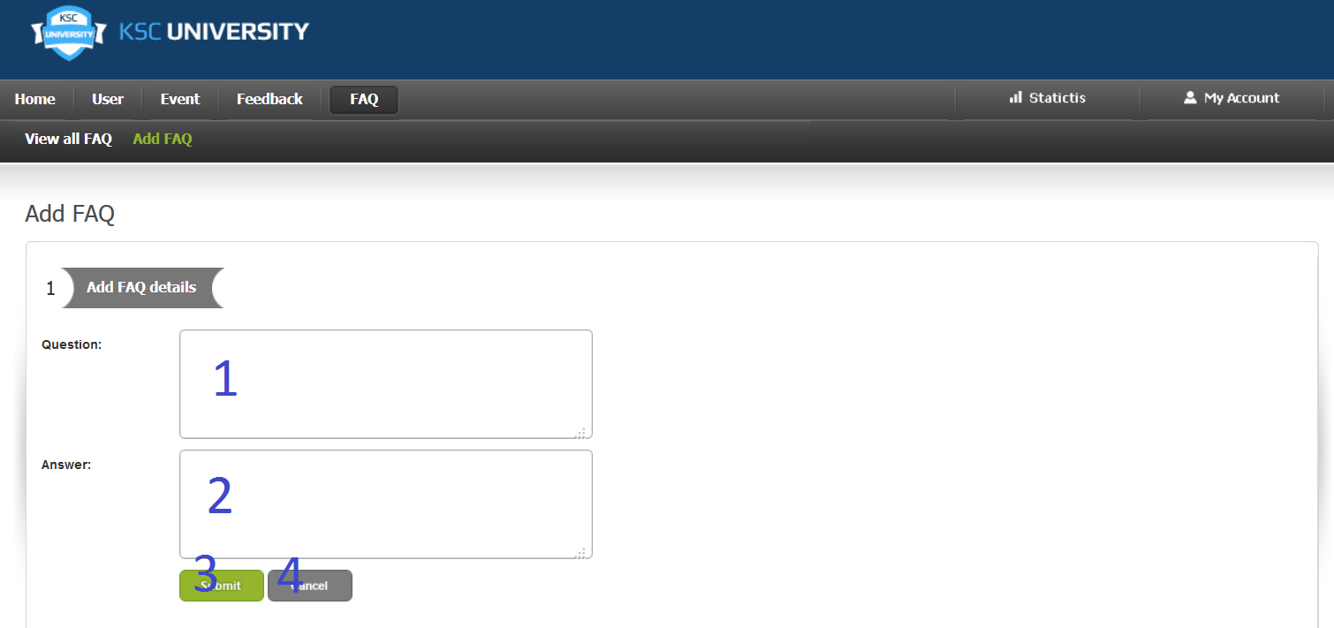

|  |  |  |  |  |  |  |
| --- | --- | --- | --- | --- | --- | --- |
| **No.** | **Name** | **Type** | **Validation** | **Event** | **Description** | **Status** |
| 1 | txtQuestion | Textfield | Length<=Varchar500 |  | Represent a question |  |
| 2 | txtAnswer | Textfield | Length<=Varchar500 |  | Represent an appropriate answer |  |
| 3 | btnSubmit | Button |  | Click | Process to create an FAQ Topic by using information above |  |
| 4 | btnCancel | Buton |  | Click | Cancel all changes and redirect to FAQ Management Page |  |

* 1. REPORT
     1. Report Top Winner Page

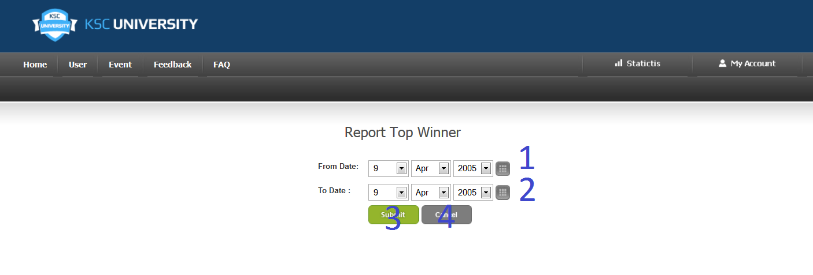

-When administrator click “Submit” ,system redirect to this page.

|  |  |  |  |  |  |  |
| --- | --- | --- | --- | --- | --- | --- |
| **No.** | **Name** | **Type** | **Validation** | **Event** | **Description** | **Status** |
| 1 | cmbFrom | Dropdownlist |  |  | Represent the date that report will be searched from |  |
| 2 | cmbTo | Dropdownlist |  |  | Represent the date that report will be searched to |  |
| 3 | btnSubmit | Button |  | Click | Process to create a report |  |
| 4 | btnCancel | Buton |  | Click | Cancel all changes and redirect to Admin Home Page |  |

* + 1. Report Top Active User Page

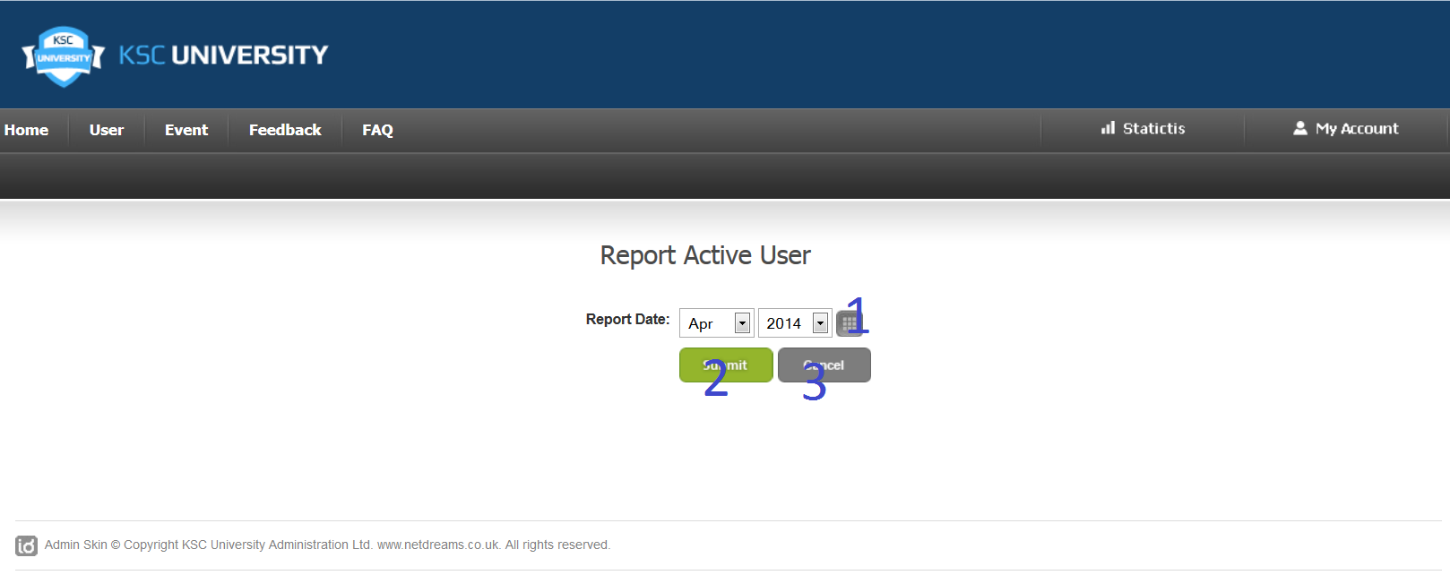

-When administrator click “Submit” ,system redirect to this page.

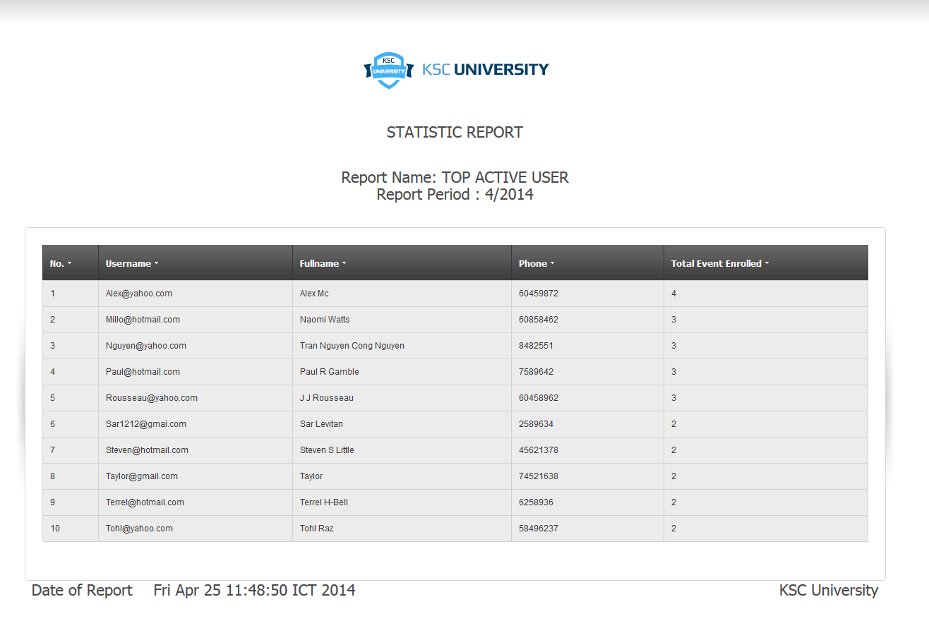

|  |  |  |  |  |  |  |
| --- | --- | --- | --- | --- | --- | --- |
| **No.** | **Name** | **Type** | **Validation** | **Event** | **Description** | **Status** |
| 1 | cmbDate | Dropdownlist |  |  | Represent the date that report will be searched |  |
| 2 | btnSubmit | Button |  | Click | Process to create a report |  |
| 3 | btnCancel | Buton |  | Click | Cancel all changes and redirect to Admin Home Page |  |

* + 1. Report Top Popular Event

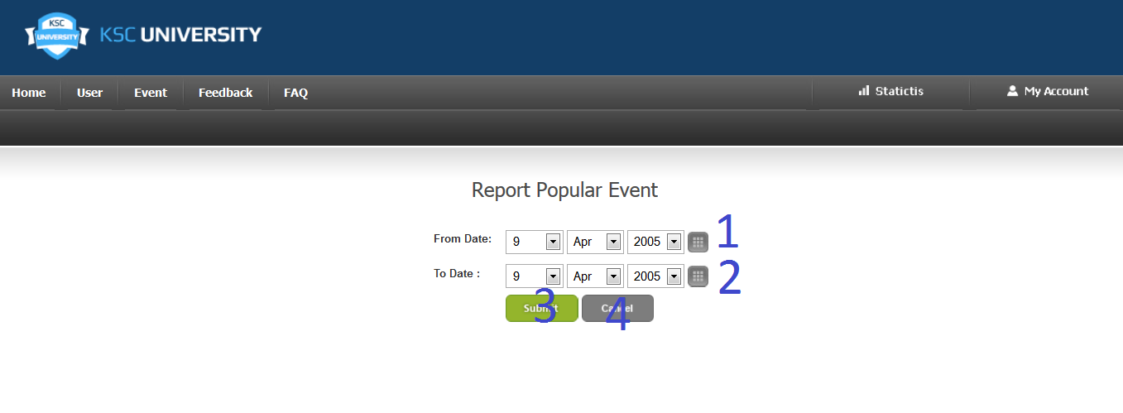

-When administrator click “Submit” ,system redirect to this page.

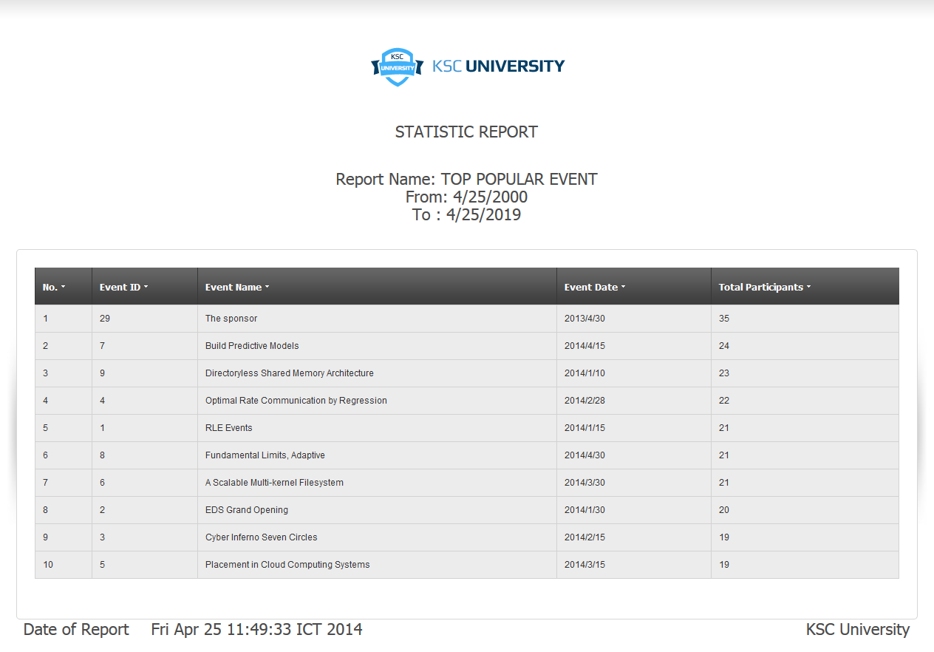

|  |  |  |  |  |  |  |
| --- | --- | --- | --- | --- | --- | --- |
| **No.** | **Name** | **Type** | **Validation** | **Event** | **Description** | **Status** |
| 1 | cmbFrom | Dropdownlist |  |  | Represent the date that events will be searched from |  |
| 2 | cmbTo | Dropdownlist |  |  | Represent the date that events will be searched to |  |
| 3 | btnSubmit | Button |  | Click | Process to create a report |  |
| 4 | btnCancel | Buton |  | Click | Cancel all changes and redirect to Admin Home Page |  |

* + 1. Report Top Least( Unpopular) Event

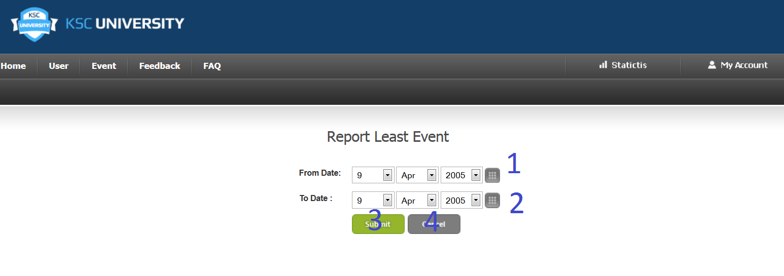

-When administrator click “Submit” ,system redirect to this page.

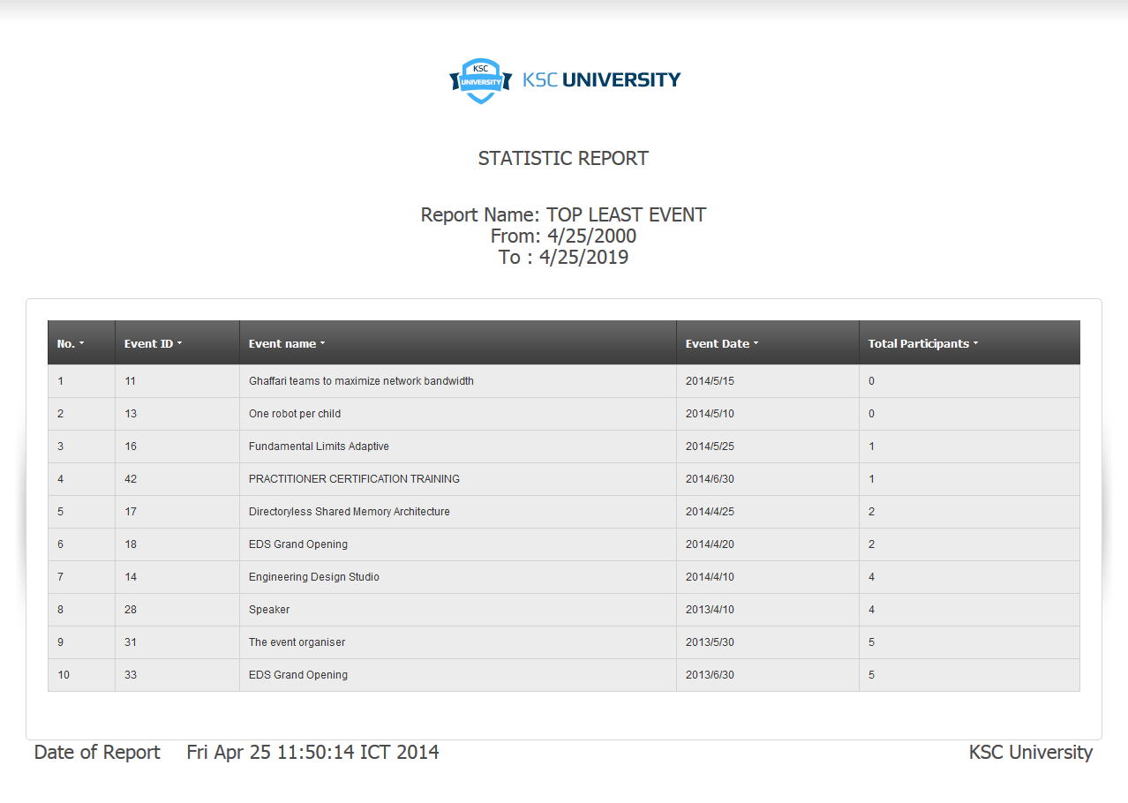

|  |  |  |  |  |  |  |
| --- | --- | --- | --- | --- | --- | --- |
| **No.** | **Name** | **Type** | **Validation** | **Event** | **Description** | **Status** |
| 1 | cmbFrom | Dropdownlist |  |  | Represent the date that events will be searched from |  |
| 2 | cmbTo | Dropdownlist |  |  | Represent the date that events will be searched to |  |
| 3 | btnSubmit | Button |  | Click | Process to create a report |  |
| 4 | btnCancel | Buton |  | Click | Cancel all changes and redirect to Admin Home Page |  |

|  |  |  |
| --- | --- | --- |
|  | **Prepared by (Student)** | **Approved by (Faculty)** |
| **Signature** | Team leader  **Vo Minh Nhut** | **Pham Cong Thanh** |
| **Date** |  |  |

TASK SHEET

|  |  |  |  |  |  |  |  |  |
| --- | --- | --- | --- | --- | --- | --- | --- | --- |
| **Project Ref. No 1** | | **Project Title** | **Activity Plan Prepared By** | **Date of Preparation of Activity Plan** | | | | |
| **Sr. No** | **Task** | **Start Date** | **End Date** | **Actual Days** | **Member’s name** | **Status** |
| **CRS document** | | | | | | | | |
| 1 | Introduction | KSC Technology and Science | Vo Minh Nhut | 23/03/2014 | 24/03/2014 | 2 | All of Team | DONE |
| 2 | Existing Scenario | KSC Technology and Science | Vo Minh Nhut | 23/03/2014 | 24/03/2014 | 2 | All of Team | DONE |
| 3 | Customer Requirement Specification | KSC Technology and Science | Vo Minh Nhut | 23/03/2014 | 24/03/2014 | 2 | All of Team | DONE |
| 4 | Functional Requirement Specification | KSC Technology and Science | Vo Minh Nhut | 23/03/2014 | 24/03/2014 | 2 | All of Team | DONE |
| 5 | System Requirements | KSC Technology and Science | Vo Minh Nhut | 23/03/2014 | 24/03/2014 | 2 | All of Team | DONE |
| 6 | Development Software | KSC Technology and Science | Vo Minh Nhut | 23/03/2014 | 24/03/2014 | 2 | All of Team | DONE |
| **Use Case and Sequence Diagrams** | | | | | | | | |
| 7 | Register as user(Guest) | KSC Technology and Science | Vo Minh Nhut | 25/03/2014 | 02/04/2014 | 9 | Nguyen Ngoc Kieu Trinh | DONE |
| 8 | FAQs Show (Guest) | KSC Technology and Science | Vo Minh Nhut | 25/03/2014 | 02/04/2014 | 9 | Nguyen Ngoc Kieu Trinh | DONE |
| 9 | View AboutUs (Guest) | KSC Technology and Science | Vo Minh Nhut | 25/03/2014 | 02/04/2014 | 9 | Nguyen Ngoc Kieu Trinh | DONE |
| 10 | View ContactUs(Guest) | KSC Technology and Science | Vo Minh Nhut | 25/03/2014 | 02/04/2014 | 9 | Nguyen Ngoc Kieu Trinh | DONE |
| 11 | Property for event(Guest) | KSC Technology and Science | Vo Minh Nhut | 25/03/2014 | 02/04/2014 | 9 | Nguyen Ngoc Kieu Trinh | DONE |
| 12 | Login(User) | KSC Technology and Science | Vo Minh Nhut | 25/03/2014 | 02/04/2014 | 9 | Nguyen Ngoc Kieu Trinh | DONE |
| 13 | Logout(User) | KSC Technology and Science | Vo Minh Nhut | 25/03/2014 | 02/04/2014 | 9 | Nguyen Ngoc Kieu Trinh | DONE |
| 14 | Change Password(User) | KSC Technology and Science | Vo Minh Nhut | 25/03/2014 | 02/04/2014 | 9 | Nguyen Ngoc Kieu Trinh | DONE |
| 15 | Update Profile(User) | KSC Technology and Science | Vo Minh Nhut | 25/03/2014 | 02/04/2014 | 9 | Vo Minh Nhut | DONE |
| 16 | View List of Feedback(User) | KSC Technology and Science | Vo Minh Nhut | 25/03/2014 | 02/04/2014 | 9 | Vo Minh Nhut | DONE |
| 17 | Create Feedback(User) | KSC Technology and Science | Vo Minh Nhut | 25/03/2014 | 02/04/2014 | 9 | Vo Minh Nhut | DONE |
| 18 | User Search Event  (User) | KSC Technology and Science | Vo Minh Nhut | 25/03/2014 | 02/04/2014 | 9 | Vo Minh Nhut | DONE |
| 19 | Write comment about event that they participated. (User) | KSC Technology and Science | Vo Minh Nhut | 25/03/2014 | 02/04/2014 | 9 | Vo Minh Nhut | DONE |
| 20 | User Enroll Event | KSC Technology and Science | Vo Minh Nhut | 25/03/2014 | 02/04/2014 | 9 | Vo Minh Nhut | DONE |
| 21 | User Unenroll Event | KSC Technology and Science | Vo Minh Nhut | 25/03/2014 | 02/04/2014 | 9 | Vo Minh Nhut | DONE |
| 22 | Subscribe | KSC Technology and Science | Vo Minh Nhut | 25/03/2014 | 02/04/2014 | 9 | Vo Minh Nhut | DONE |
| 22 | Unsubscribe | KSC Technology and Science | Vo Minh Nhut | 25/03/2014 | 02/04/2014 | 9 | Vo Minh Nhut | DONE |
| 23 | User upload contents | KSC Technology and Science | Vo Minh Nhut | 25/03/2014 | 02/04/2014 | 9 | Do Ngoc Quy | DONE |
| 24 | User confirm payment | KSC Technology and Science | Vo Minh Nhut | 25/03/2014 | 02/04/2014 | 9 | Do Ngoc Quy | DONE |
| 25 | Login(Admin) | KSC Technology and Science | Vo Minh Nhut | 25/03/2014 | 02/04/2014 | 9 | Do Ngoc Quy | DONE |
| 26 | Change Password | KSC Technology and Science | Vo Minh Nhut | 25/03/2014 | 02/04/2014 | 9 | Do Ngoc Quy | DONE |
| 27 | Approve Contents | KSC Technology and Science | Vo Minh Nhut | 25/03/2014 | 02/04/2014 | 9 | Do Ngoc Quy | DONE |
| 28 | View List of Feedback | KSC Technology and Science | Vo Minh Nhut | 25/03/2014 | 02/04/2014 | 9 | Do Ngoc Quy | DONE |
| 29 | Update Feedback | KSC Technology and Science | Vo Minh Nhut | 25/03/2014 | 02/04/2014 | 9 | Do Ngoc Quy | DONE |
| 30 | Property for feedback | KSC Technology and Science | Vo Minh Nhut | 25/03/2014 | 02/04/2014 | 9 | Do Ngoc Quy | DONE |
| 31 | View List of FAQs | KSC Technology and Science | Vo Minh Nhut | 25/03/2014 | 02/04/2014 | 9 | Do Ngoc Quy | DONE |
| 32 | Update FAQs | KSC Technology and Science | Vo Minh Nhut | 25/03/2014 | 02/04/2014 | 9 | Tran Nguyen Cong Nguyen | DONE |
| 33 | Change status FAQs | KSC Technology and Science | Vo Minh Nhut | 25/03/2014 | 02/04/2014 | 9 | Tran Nguyen Cong Nguyen | DONE |
| 34 | View List of Participants | KSC Technology and Science | Vo Minh Nhut | 25/03/2014 | 02/04/2014 | 9 | Tran Nguyen Cong Nguyen | DONE |
| 35 | Update Participant List | KSC Technology and Science | Vo Minh Nhut | 25/03/2014 | 02/04/2014 | 9 | Tran Nguyen Cong Nguyen | DONE |
| 36 | View List of Users | KSC Technology and Science | Vo Minh Nhut | 25/03/2014 | 02/04/2014 | 9 | Tran Nguyen Cong Nguyen | DONE |
| 37 | Add User Account for Student | KSC Technology and Science | Vo Minh Nhut | 25/03/2014 | 02/04/2014 | 9 | Tran Nguyen Cong Nguyen | DONE |
| 38 | Change Status User Account | KSC Technology and Science | Vo Minh Nhut | 25/03/2014 | 02/04/2014 | 9 | Tran Nguyen Cong Nguyen | DONE |
| 39 | Search User | KSC Technology and Science | Vo Minh Nhut | 25/03/2014 | 02/04/2014 | 9 | Tran Nguyen Cong Nguyen | DONE |
| 40 | View List of events | KSC Technology and Science | Vo Minh Nhut | 25/03/2014 | 02/04/2014 | 9 | Tran Nguyen Cong Nguyen | DONE |
| 41 | Add an event | KSC Technology and Science | Vo Minh Nhut | 25/03/2014 | 02/04/2014 | 9 | Tran Nguyen Cong Nguyen | DONE |
| 42 | Update an event | KSC Technology and Science | Vo Minh Nhut | 25/03/2014 | 02/04/2014 | 9 | Nguyen Ngoc Kieu Trinh | DONE |
| 43 | Change event status | KSC Technology and Science | Vo Minh Nhut | 25/03/2014 | 02/04/2014 | 9 | Vo Minh Nhut | DONE |
| 44 | Search Event | KSC Technology and Science | Vo Minh Nhut | 25/03/2014 | 02/04/2014 | 9 | Do Ngoc Quy | DONE |
| **ERD** | | | | | | | | |
| 45 | Conceptual | KSC Technology and Science | Vo Minh Nhut | 25/03/2014 | 02/04/2014 | 9 | All of Team | DONE |
| 46 | Table | KSC Technology and Science | Vo Minh Nhut | 25/03/2014 | 02/04/2014 | 9 | All of Team | DONE |
| 47 | Database Relationship | KSC Technology and Science | Vo Minh Nhut | 25/03/2014 | 02/04/2014 | 9 | All of Team | DONE |
| 48 | Table Definition | KSC Technology and Science | Vo Minh Nhut | 25/03/2014 | 02/04/2014 | 9 | All of Team | DONE |
| **GUI** | | | | | | | | |
| 49 | Homepage | KSC Technology and Science | Vo Minh Nhut | 25/03/2014 | 09/04/2014 | 16 | Vo Minh Nhut & Do Ngoc Quy | DONE |
| 50 | Event Page | KSC Technology and Science | Vo Minh Nhut | 25/03/2014 | 09/04/2014 | 16 | Tran Nguyen Cong Nguyen | DONE |
| 51 | Event Details | KSC Technology and Science | Vo Minh Nhut | 25/03/2014 | 09/04/2014 | 16 | Nguyen Ngoc Kieu Trinh | DONE |
| 52 | Feedback Page | KSC Technology and Science | Vo Minh Nhut | 25/03/2014 | 09/04/2014 | 16 | Do Ngoc Quy | DONE |
| 53 | About Us | KSC Technology and Science | Vo Minh Nhut | 25/03/2014 | 09/04/2014 | 16 | Vo Minh Nhut | DONE |
| 54 | Contact Us | KSC Technology and Science | Vo Minh Nhut | 25/03/2014 | 09/04/2014 | 16 | Tran Nguyen Cong Nguyen | DONE |
| 55 | FAQ Page | KSC Technology and Science | Vo Minh Nhut | 25/03/2014 | 09/04/2014 | 16 | Nguyen Ngoc Kieu Trinh | DONE |
| 56 | Login Page | KSC Technology and Science | Vo Minh Nhut | 25/03/2014 | 09/04/2014 | 16 | Do Ngoc Quy | DONE |
| 57 | Registration Page | KSC Technology and Science | Vo Minh Nhut | 25/03/2014 | 09/04/2014 | 16 | Vo Minh Nhut | DONE |
| 58 | My Event Page | KSC Technology and Science | Vo Minh Nhut | 25/03/2014 | 09/04/2014 | 16 | Tran Nguyen Cong Nguyen | DONE |
| 59 | User Profile Page | KSC Technology and Science | Vo Minh Nhut | 25/03/2014 | 09/04/2014 | 16 | Nguyen Ngoc Kieu Trinh | DONE |
| 60 | User Change Password | KSC Technology and Science | Vo Minh Nhut | 25/03/2014 | 09/04/2014 | 16 | Do Ngoc Quy | DONE |
| 61 | User Subscribe/ Unsubscribe | KSC Technology and Science | Vo Minh Nhut | 25/03/2014 | 09/04/2014 | 16 | Vo Minh Nhut | DONE |
| 62 | User Enroll Page | KSC Technology and Science | Vo Minh Nhut | 25/03/2014 | 09/04/2014 | 16 | Tran Nguyen Cong Nguyen | DONE |
| 63 | User Unenroll Page | KSC Technology and Science | Vo Minh Nhut | 25/03/2014 | 09/04/2014 | 16 | Nguyen Ngoc Kieu Trinh | DONE |
| 64 | User Confirm Payment | KSC Technology and Science | Vo Minh Nhut | 25/03/2014 | 09/04/2014 | 16 | Do Ngoc Quy | DONE |
| 65 | User Upload Content | KSC Technology and Science | Vo Minh Nhut | 25/03/2014 | 09/04/2014 | 16 | Vo Minh Nhut | DONE |
| 66 | Admin Home Page | KSC Technology and Science | Vo Minh Nhut | 25/03/2014 | 09/04/2014 | 16 | Tran Nguyen Cong Nguyen | DONE |
| 67 | Admin Change Pasword | KSC Technology and Science | Vo Minh Nhut | 25/03/2014 | 09/04/2014 | 16 | Nguyen Ngoc Kieu Trinh | DONE |
| 68 | User Management Page | KSC Technology and Science | Vo Minh Nhut | 25/03/2014 | 09/04/2014 | 16 | Do Ngoc Quy | DONE |
| 69 | User Create Page | KSC Technology and Science | Vo Minh Nhut | 25/03/2014 | 09/04/2014 | 16 | Tran Nguyen Cong Nguyen | DONE |
| 70 | Event Management Page | KSC Technology and Science | Vo Minh Nhut | 25/03/2014 | 09/04/2014 | 16 | Nguyen Ngoc Kieu Trinh | DONE |
| 71 | Event Update Info Page | KSC Technology and Science | Vo Minh Nhut | 25/03/2014 | 09/04/2014 | 16 | Do Ngoc Quy | DONE |
| 72 | Event Create Page | KSC Technology and Science | Vo Minh Nhut | 25/03/2014 | 09/04/2014 | 16 | Vo Minh Nhut | DONE |
| 73 | Event Participant Management | KSC Technology and Science | Vo Minh Nhut | 25/03/2014 | 09/04/2014 | 16 | Tran Nguyen Cong Nguyen | DONE |
| 74 | Event Participant Update Info Page | KSC Technology and Science | Vo Minh Nhut | 25/03/2014 | 09/04/2014 | 16 | Nguyen Ngoc Kieu Trinh | DONE |
| 75 | Event Content Management Page | KSC Technology and Science | Vo Minh Nhut | 25/03/2014 | 09/04/2014 | 16 | Do Ngoc Quy | DONE |
| 76 | Event Content Approve Page | KSC Technology and Science | Vo Minh Nhut | 25/03/2014 | 09/04/2014 | 16 | Vo Minh Nhut | DONE |
| 77 | Event Comment Management Page | KSC Technology and Science | Vo Minh Nhut | 25/03/2014 | 09/04/2014 | 16 | Tran Nguyen Cong Nguyen | DONE |
| 78 | Feedback Management Page | KSC Technology and Science | Vo Minh Nhut | 25/03/2014 | 09/04/2014 | 16 | Nguyen Ngoc Kieu Trinh | DONE |
| 79 | Feedback Update(Reply) Page | KSC Technology and Science | Vo Minh Nhut | 25/03/2014 | 09/04/2014 | 16 | Do Ngoc Quy | DONE |
| 80 | FAQ Management Page | KSC Technology and Science | Vo Minh Nhut | 25/03/2014 | 09/04/2014 | 16 | Vo Minh Nhut | DONE |
| 81 | FAQ Update Page | KSC Technology and Science | Vo Minh Nhut | 25/03/2014 | 09/04/2014 | 16 | Tran Nguyen Cong Nguyen | DONE |
| 82 | FAQ Create Page | KSC Technology and Science | Vo Minh Nhut | 25/03/2014 | 09/04/2014 | 16 | Nguyen Ngoc Kieu Trinh | DONE |
| 83 | Period Top Winner | KSC Technology and Science | Vo Minh Nhut | 25/03/2014 | 09/04/2014 | 16 | Do Ngoc Quy | DONE |
| 84 | Period Top Active User | KSC Technology and Science | Vo Minh Nhut | 25/03/2014 | 09/04/2014 | 16 | Vo Minh Nhut | DONE |
| 85 | Period Top Popular Event | KSC Technology and Science | Vo Minh Nhut | 25/03/2014 | 09/04/2014 | 16 | Tran Nguyen Cong Nguyen | DONE |
| 86 | Period Top Lease (Unpopular) Event | KSC Technology and Science | Vo Minh Nhut | 25/03/2014 | 09/04/2014 | 16 | Nguyen Ngoc Kieu Trinh | DONE |
| 87 | Error Page | KSC Technology and Science | Vo Minh Nhut | 25/03/2014 | 09/04/2014 | 16 | Do Ngoc Quy | DONE |
| **Report** | | | | | | | | |
| 88 | Report Top Winner | KSC Technology and Science | Vo Minh Nhut | 25/03/2014 | 09/04/2014 | 16 | Vo Minh Nhut | DONE |
| 89 | Report Top Active User | KSC Technology and Science | Vo Minh Nhut | 25/03/2014 | 09/04/2014 | 16 | Tran Nguyen Cong Nguyen | DONE |
| 90 | Report Top Popular Event | KSC Technology and Science | Vo Minh Nhut | 25/03/2014 | 09/04/2014 | 16 | Nguyen Ngoc Kieu Trinh | DONE |
| 91 | Report Top Lease (Unpopular) Event | KSC Technology and Science | Vo Minh Nhut | 25/03/2014 | 09/04/2014 | 16 | Do Ngoc Quy | DONE |
| **Permission Security** | | | | | | | | |
| 92 | Homepage | KSC Technology and Science | Vo Minh Nhut | 25/03/2014 | 09/04/2014 | 16 | Vo Minh Nhut | DONE |
| 93 | Admin Page | KSC Technology and Science | Vo Minh Nhut | 25/03/2014 | 09/04/2014 | 16 | Do Ngoc Quy | DONE |
| **Task sheet** | | | | | | | | |
| 94 | Task sheet | KSC Technology and Science | Vo Minh Nhut | 25/03/2014 | 09/04/2014 | 16 | Vo Minh Nhut | DONE |

**MONITORING REPORT**

Unit Test

# Login

|  |  |  |  |  |  |  |
| --- | --- | --- | --- | --- | --- | --- |
| **Author** | Vo Minh Nhut | | | | | |
| **Test case name** | Login | | | | | |
| **Actor** | User | | | | | |
| **Pre-requisite** |  | | | | | |
| **Process** | **Step No.** | **Action/Description** | **Input Data** | **Expected Result** | **Actual Result** | **Pass/Fail** |
| Login | 1 | From ‘Login’ page, left all textfield blank and then click on to the ‘Login’ button. |  | A message box appears with content: “UserName and Password is invalid” |  | DONE |
| 2 | Input UserName in ‘UserName’ textfield and then click ‘Login’ button. | Abcdef | A message box appears with content: “Password shouldn’t be blank. Please input password.” |  | DONE |
| 3 | Input Password in ‘Password’ textfield and then click ‘Login’ button. | Abcdef | A message box appears with content: “UserName or Password is invalid” |  | DONE |
| 4 | Input UserName in ‘UserName’ textfield, input Password in ‘Password’ textfield (with UserName and Password of an user account) and then click ‘Login’ button. | UserName: abc@yahoo.com  Password: 123456 | Redirect to ‘Home’ page of User. |  | DONE |

# Register

|  |  |  |  |  |  |  |
| --- | --- | --- | --- | --- | --- | --- |
| **Author** | Nguyen Ngoc Kieu Trinh | | | | | |
| **Test case name** | Register | | | | | |
| **Actor** | Guest | | | | | |
| **Pre-requisite** |  | | | | | |
| **Process** | **Step No.** | **Action/Description** | **Input Data** | **Expected Result** | **Actual Result** | **Pass/Fail** |
| Register | 1 | From ‘Home’ page, click on to the ‘Sign Up’ button. |  | Redirect to ‘Registration’ page. |  | DONE |
| 2 | From ‘Registration‘ page, left all textfield blank and then click on to the ‘Submit’ button. |  | A message box appears with content: “EmailID shouldn’t be blank.Please input EmailID.” |  | DONE |
| 3 | Input EmailID in ‘EmailID’ textfield and then click ‘Submit’ button. | Hello12@yahoo.com | A message box appears with content: “Password shouldn’t be blank. Please input password.” |  | DONE |
| 4 | Input Password in ‘Password’ textfield and then click ‘Submit’ button. | 123 | A message box appears with content: “Password shouldn’t be less than 6 characters.” |  | DONE |
| 5 | Input Password in ‘Password’ textfield and then click ‘Submit’ button. | 123456 | A message box appears with content: ‘ “Confirm Password shouldn’t be blank. Please input Confirm password.” |  | DONE |
| 6 | Input Confirm Password in ‘Confirm Password’ textfield and then click ‘Submit’ button. | 123456 | A validation message point to ‘‘Name’ text field with content: “Invalid Fullname” |  | DONE |
| 7 | Input Name in ‘Name’ textfield and then click ‘Submit’ button. | ABC | A validation message point to ‘Birthday’ datepicker with content: “Invalid Birthday” |  | DONE |
| 8 | Select current date from the ‘Birthday’ datepicker and then click ‘Submit’ button. | 10/10/1994 | A validation message point to ‘Address’ text field with content: “Invalid Address” |  | DONE |
| 9 | Input Address in ‘Address’ textfield and then click ‘Submit’ button. | 02VP, Chau Thoi street, 10 Dist, HCM City | A validation message point to ‘Phone’ int box with content: “Invalid Phone” |  | DONE |
| 10 | Input Phone in ‘Phone’ int box and then click ‘Submit’ button. | aaaa | A validation message point to ‘Phone’ int box with content: “Invalid Phone” |  | DONE |
| 11 | Input Phone in ‘Phone’ int box and then click ‘Submit’ button. | 00000000 or 123 | A validation message point to ‘Phone’ int box with content: “Phone should be 8-11 number.” |  | DONE |
| 12 | Input Phone in ‘Phone’ int box and then click ‘Submit’ button. | 123456789 | The new User account, as a foreign user, and Gender is Male (default Gender when not select Gender in Gender Drop down list) is added into the database. Then redirect to ‘Home’ page. |  | DONE |

# Update Profile

|  |  |  |  |  |  |  |
| --- | --- | --- | --- | --- | --- | --- |
| **Author** | Tran Nguyen Cong Nguyen | | | | | |
| **Test case name** | Update Profile | | | | | |
| **Actor** | User | | | | | |
| **Pre-requisite** | Actor has already logged into the System as a User | | | | | |
| **Process** | **Step No.** | **Action/Description** | **Input Data** | **Expected Result** | **Actual Result** | **Pass/Fail** |
| Update Profile | 1 | From ‘Home’ page, click on to the ‘User Profle button. |  | Redirect to ‘UserProfile’ page, load all User profile information, and fill onto the form. |  | DONE |
| 2 | Clear the ‘Name’ text field and then click on to the ‘Submit’ button. |  | A validation message point to ‘Name’ text field with content: “Name shouldn’t be blank.Please input name.” |  | DONE |
| 3 | Input Name and clear the birthday’ text field and then click on to the ‘Submit’ button. | Nicky | A validation message point to ‘birthday text field with content: “Birthday shouldn’t be blank.Please input birthday.” |  | DONE |
| 4 | Input birthday and clear phone then click on to the ‘Submit’ button. | 10/101/1994 | A validation message point to ‘Phone’ text field with content: “Phone shouldn’t be blank.Please input phone.” |  | DONE |
| 5 | Input Phone in ‘Phone’ int box and then click ‘Submit’ button. | aaaa | A validation message point to ‘Phone’ int box with content: “Invalid Phone” |  | DONE |
| 6 | Input Phone in ‘Phone’ int box and then click ‘Submit’ button. | 00000000 or 123 | A validation message point to ‘Phone’ int box with content: “Phone should be 8-11 number.” |  | DONE |
| 7 | Input Phone in ‘Phone’ textfield, and clear the ‘Address’ text field, and then click ‘Submit’ button. | 0989330599 | A validation message point to ‘Address ‘ text field with content: “Address shouldn’t be blank.Please input address.” |  | DONE |
| 8 | Input Address in ‘Address’text field and then click ‘Submit’ button. | 12 Hung Thuan Dong , 12 Dist,HCM city. | The User account is updated into the database, with the new fields:  - Gender is male.  - Name is “Nicky”.  - Address is “12 Hung Thuan Dong , 12 Dist,HCM city  .- Phone is “0989330599”.  - Birthday is “10/10/1994”  And then a message box appears with content: “Your account has been updated!”. Then redirect to ‘Login’ page. |  | DONE |

# User Change Password

|  |  |  |  |  |  |  |
| --- | --- | --- | --- | --- | --- | --- |
| **Author** | Vo Minh Nhut | | | | | |
| **Test case name** | Change Password | | | | | |
| **Actor** | User | | | | | |
| **Pre-requisite** | Actor has already logged into the System as user | | | | | |
| **Process** | **Step No.** | **Action/Description** | **Input Data** | **Expected Result** | **Actual Result** | **Pass/Fail** |
| Change Password | 1 | From ‘Home’ page, click on to the ‘Change Pass’ menu button. ‘Change Password’ form appears. |  |  |  | DONE |
| 2 | Left ‘Old Password’ text field and then click Submit button. |  | A message box appears with content: “The Old Password shouldn’t be blank. Please input an Old Password.” |  | DONE |
| 3 | Input Old password and then click Submit button. | 123456 | A message box appears with content: “The New Password shouldn’t be blank. Please input a New Password.” |  | DONE |
| 4 | Input New password and then click Submit button. | 1234 | A message box appears with content: “Password should be less than 6 characters.” |  | DONE |
| 5 | Input New password and then click Submit button. | 123456 | A message box appears with content: “New Password the same Old password.” |  |  |
| 6 | Input New password and then click Submit button. | 12345678 | A message box appears with content: “The Confirm New Password shouldn’t be blank. Please input a Confirm New Password.” |  | DONE |
|  | 7 | Input “Confirm new password” text field  And then click Submit button | 123 | A message box appears with content: “The Confirm New Password should be same with new password.” |  | DONE |
|  | 8 | Input “Confirm new password” text field  And then click Submit button | 12345678 | The pasword of user is updated into the database, with the new password:  12345678  And then a message box appears with content: “Your account has been updated!”. Then redirect to ‘Login’ page. |  |  |

1. **User Search Event name**

|  |  |  |  |  |  |  |
| --- | --- | --- | --- | --- | --- | --- |
| **Author** | Tran Nguyen Cong Nguyen | | | | | |
| **Test case name** | User search Event name | | | | | |
| **Actor** | User | | | | | |
| **Pre-requisite** | Actor has already logged into the System as user | | | | | |
| **Process** | **Step No.** | **Action/Description** | **Input Data** | **Expected Result** | **Actual Result** | **Pass/Fail** |
| User search Event name | 1 | In the ‘Home’ page user click Search button. |  | System redirect to ‘EventShow’ page and displays all event on the table in current page. |  | DONE |
| 2 | User input name of event in ‘SearchBy Event name’ text field and then click Search button. | Cy | System select the name of event begin with ‘Cy’ and displays the result in the table. |  | DONE |

1. **User Search Event date**

|  |  |  |  |  |  |  |
| --- | --- | --- | --- | --- | --- | --- |
| **Author** | Quy Ngoc Do | | | | | |
| **Test case name** | User search Event date | | | | | |
| **Actor** | User | | | | | |
| **Pre-requisite** | Actor has already logged into the System as user | | | | | |
| **Process** | **Step No.** | **Action/Description** | **Input Data** | **Expected Result** | **Actual Result** | **Pass/Fail** |
| User search Event date | 1 | From ‘Home’ page, User click Event button |  | System redirect to EventShow page. |  | DONE |
| 2 | Left ‘SearchFrom’ date picker and then click Search button. |  | System redirect to current page and displays all event. |  | DONE |
| 3 | Choose to the date from with begin to be search and then click Submit button. | 10/3/2014 | System will search from 10//3/2014 to current day. |  | DONE |
|  | 4 | Choose to the date from with end to be search and then click Submit button. | 14/4/2014 | System displays event name from 10/3/2014 to 14/4/2014 on current the page. |  | DONE |

1. **User Feedback**

|  |  |  |  |  |  |  |
| --- | --- | --- | --- | --- | --- | --- |
| **Author** | Nguyen Ngoc Kieu Trinh | | | | | |
| **Test case name** | User feedback | | | | | |
| **Actor** | User | | | | | |
| **Pre-requisite** | Actor has already logged into the System as user | | | | | |
| **Process** | **Step No.** | **Action/Description** | **Input Data** | **Expected Result** | **Actual Result** | **Pass/Fail** |
| User feedback | 1 | From ‘Home’ page, User input feedback information in Feedback form at the end of page. |  | System redirect to current page. |  | DONE |
| 2 | Left ‘Message’ text field and then click Submit button. |  | A message box appears with content: “Message shouldn’t be blank. Please input an Message.” |  | DONE |
| 3 | Input Message and then click Submit button. | I like KSC | The feedback of user is inserted into the database, with the feedback information:  -‘I like KSC’  appears with content: “Thank for you feedback” |  | DONE |

1. **User Enroll Event**

|  |  |  |  |  |  |  |
| --- | --- | --- | --- | --- | --- | --- |
| **Author** | Vo Minh Nhut | | | | | |
| **Test case name** | User enrll event | | | | | |
| **Actor** | User | | | | | |
| **Pre-requisite** | Actor has already logged into the System as a User | | | | | |
| **Process** | **Step No.** | **Action/Description** | **Input Data** | **Expected Result** | **Actual Result** | **Pass/Fail** |
| Enroll Event | 1 | From ‘Home’ page, click on to the ‘Event’ button. |  | Redirect to ‘EventShow’ page, load some event information. |  | DONE |
| 2 | User click ‘Enroll’ button on the ‘EventShow’ page. |  | Redirect to ‘EnrollShow’ page and load all event information. |  | DONE |
| 3 | User click’Confirm’ on ‘EnrollShow’ page. |  | If user belong to KSC university ,Redirect to ‘My Event’ page. |  | DONE |
| 4 | User don’t belong to KSC university. User click’Confirm’ on ‘EnrollShow’ page |  | Redirect to ‘PaymentShow’ page and load all event information. |  | DONE |
| 5 | User click ‘Accept Payment’ button on ‘PaymentShow’ page |  | Redirect to ‘MyEvent’ page . |  | DONE |
| 6 | Redirect to ‘MyEvent’ page and load all event information.. |  | The User event is insert into the database, with the fields:  -EventName  -Event date  -Event Price  -Event host  -Event price(if any)  -Username  -Fullname.  And then a message box appears with content: “Enroll successful”. Then redirect to ‘MyEvent’ page. |  | DONE |

1. **User subscribe**

|  |  |  |  |  |  |  |
| --- | --- | --- | --- | --- | --- | --- |
| **Author** | Tran Nguyen Cong Nguyen | | | | | |
| **Test case name** | User subscribe | | | | | |
| **Actor** | User | | | | | |
| **Pre-requisite** | Actor has already logged into the System as a User | | | | | |
| **Process** | **Step No.** | **Action/Description** | **Input Data** | **Expected Result** | **Actual Result** | **Pass/Fail** |
| User subscribe | 1 | From ‘Home’ page, click on to the ‘(Un)Subscribe button. |  | Redirect to ‘Subscribe’ page, and displays form subscribe. |  | DONE |
| 2 | Left’Email ’ textfield and click Submit button |  | A validation message point to ‘Email’ text field with content: “Email shouldn’t be blank.Please input email.” |  | DONE |
| 3 | Input Email text field and lick on to the ‘Submit’ button. | Boy1212@yahoo.com | The User subscribe is added into the database, with the fields:  -Email is : ’Boy1212@yahoo.com ’ |  | DONE |

1. **User unsubscribe**

|  |  |  |  |  |  |  |
| --- | --- | --- | --- | --- | --- | --- |
| **Author** | Quy Ngoc Do | | | | | |
| **Test case name** | User unsubscribe | | | | | |
| **Actor** | User | | | | | |
| **Pre-requisite** | Actor has already logged into the System as a User | | | | | |
| **Process** | **Step No.** | **Action/Description** | **Input Data** | **Expected Result** | **Actual Result** | **Pass/Fail** |
| User unsubscribe | 1 | From ‘Home’ page, click on to the ‘(Un)Subscribe button. |  | Redirect to ‘Subscribe’ page, and displays form unsubscribe. |  | DONE |
| 2 | Left’Email ’ textfield and click Submit button |  | A validation message point to ‘Email’ text field with content: “Email shouldn’t be blank.Please input email.” |  | DONE |
| 3 | Input Email text field and lick on to the ‘Submit’ button. | Boy1212@yahoo.com | The User unsubscribe is added into the database, with the fields:  -Email is : ’Boy1212@yahoo.com ’ |  | DONE |

1. **User unenroll**

|  |  |  |  |  |  |  |
| --- | --- | --- | --- | --- | --- | --- |
| **Author** | Nguyen Ngoc Kieu Trinh | | | | | |
| **Test case name** | User unenroll | | | | | |
| **Actor** | User | | | | | |
| **Pre-requisite** | Actor has already logged into the System as a User | | | | | |
| **Process** | **Step No.** | **Action/Description** | **Input Data** | **Expected Result** | **Actual Result** | **Pass/Fail** |
| User unenroll | 1 | From ‘Home’ page, click on to the ‘My Event’ button. |  | Redirect to ‘MyEvent’ page, displays all event that user enrolled and ‘Upload’ button ,’Unenroll’ button. |  | DONE |
| 2 | User click ‘Unenroll’ button on the MyEvent page |  | Redirect to ‘UnEnrollShow’ page and load all enroll information of event. |  | DONE |
| 3 | User click ‘Confirm’ button on the UnEnrollShow page |  | The User unenroll is added into the database with unenroll information of user. |  | DONE |
| Cancel unenroll | 4 | User click ‘Cancel’ button on the UnEnrollShow page |  | Redirect to ‘MyEvent’ page |  | DONE |

1. **User upload content**

|  |  |  |  |  |  |  |
| --- | --- | --- | --- | --- | --- | --- |
| **Author** | Vo Minh Nhut | | | | | |
| **Test case name** | User upload content | | | | | |
| **Actor** | User | | | | | |
| **Pre-requisite** | Actor has already logged into the System as a User | | | | | |
| **Process** | **Step No.** | **Action/Description** | **Input Data** | **Expected Result** | **Actual Result** | **Pass/Fail** |
| User upload content | 1 | From ‘Home’ page, click on to the ‘My Event’ button. |  | Redirect to ‘MyEvent’ page, displays all event that user enrolled and ‘Upload’ button ,’Unenroll’ button |  | DONE |
| 2 | User click ‘Upload’ button on the MyEvent page |  | Redirect to ‘UploadContent’ page and displays form upload |  | DONE |
| 3 | User click ‘Browser’ file | DocEvent.pdf | System browser file user want upload. |  | DONE |
| 4 | User click ‘Submit’ button on the UploadContent page |  | The User upload is added into the database with :  -Upload file is ’DocEvent.pdf .’ |  | DONE |

1. **View List of Comment**

|  |  |  |  |  |  |  |
| --- | --- | --- | --- | --- | --- | --- |
| **Author** | Tran Nguyen Cong nguyen | | | | | |
| **Test case name** | View List of Comment | | | | | |
| **Actor** | Asministrator | | | | | |
| **Pre-requisite** | Actor has logged in as Asministrator | | | | | |
| **Process** | **Step No.** | **Action/Description** | **Input Data** | **Expected Result** | **Actual Result** | **Pass/Fail** |
| View List of comment | 1 | Actor clicks ‘Comment’ button on AdminEventShow page |  | System redirects to AdminEventCommentShow page and displayss table for Actor with following :  -‘Search By Username’ text field  -‘ID’  -‘Date’  -‘Event name’  -‘Userlname’  -‘Comment’  -‘Delete button  -‘Search’ button |  | DONE |
| Delete Event | 1 | Actor clicks Delete button on AdminUserShow page |  | View in Delete comment usecase |  | DONE |
| Search  Comment |  | Actor input event name and clicks Search button on AdminUserShow page |  | System select the properties in database that match searching condition and displays the result in the table. |  | DONE |

1. **Search comment by username**

|  |  |  |  |  |  |  |
| --- | --- | --- | --- | --- | --- | --- |
| **Author** | Tran Nguyen Cong Nguyen | | | | | |
| **Test case name** | Administrator search comment by username | | | | | |
| **Actor** | Administrator | | | | | |
| **Pre-requisite** | Actor has already logged into the System as Administrator | | | | | |
| **Process** | **Step No.** | **Action/Description** | **Input Data** | **Expected Result** | **Actual Result** | **Pass/Fail** |
| Administrator search Comment by username | 1 | In the ‘AdminEventCommentShow’ page actor click Search button. |  | System redirect to current page and displays all comment on the table . |  | DONE |
| 2 | Actor input username of user in ‘SearchBy Username’ text field and then click Search button. | J | System select the username begin with ‘J’and displays the result in the table. |  | DONE |

1. **Delete comment**

|  |  |  |  |  |  |  |
| --- | --- | --- | --- | --- | --- | --- |
| **Author** | Quy Ngoc Do | | | | | |
| **Test case name** | Delete Comment | | | | | |
| **Actor** | Administrator | | | | | |
| **Pre-requisite** | Actor has logged in as Administrator | | | | | |
| **Process** | **Step No.** | **Action/Description** | **Input Data** | **Expected Result** | **Actual Result** | **Pass/Fail** |
| Delete Comment | 1 | Actor clicks Delete button on AdminUserShow page |  | System show popup message :”Do you want to Delete this comment. With Yes and No button |  | DONE |
| 2 | Actor click ‘Yes’ button  Actor click ‘No’ button. |  | System delete commnet from database then displays message ‘Delete comment successful’.  System returns to current page. |  | DONE |

1. **View List of Participant**

|  |  |  |  |  |  |  |
| --- | --- | --- | --- | --- | --- | --- |
| **Author** | Nguyen Ngoc Kieu Trinh | | | | | |
| **Test case name** | View List of Participant | | | | | |
| **Actor** | Asministrator | | | | | |
| **Pre-requisite** | Actor has logged in as Asministrator | | | | | |
| **Process** | **Step No.** | **Action/Description** | **Input Data** | **Expected Result** | **Actual Result** | **Pass/Fail** |
| Edit Participant | 1 | Actor clicks Edit button on AdminEventUserShow page |  | Redirect to AdminEventUserUpdate page. |  | DONE |
| Delete Participant | 1 | Actor clicks Delete button on AdminEventUserShow page |  | View in Delete user usecase |  | DONE |
| Search Participant | 1 | Actor click search button on AdminEventUserShow page |  | System select the properties in database that match searching condition and displays the result in the table. |  | DONE |

1. **Search Participant**

|  |  |  |  |  |  |  |
| --- | --- | --- | --- | --- | --- | --- |
| **Author** | Tran Nguyen Cong Nguyen | | | | | |
| **Test case name** | Administrator search participant by username | | | | | |
| **Actor** | Administrator | | | | | |
| **Pre-requisite** | Actor has already logged into the System as administrator | | | | | |
| **Process** | **Step No.** | **Action/Description** | **Input Data** | **Expected Result** | **Actual Result** | **Pass/Fail** |
| Administrator search participant | 1 | In the ‘AdminEventUserShow’ page user click Search button. |  | System displays all participant on the curent page. |  | DONE |
| 2 | Actor input username of user ‘SearchBy Username’ text field and then click Search button. | 123@yahoo.com | System displays information of username ‘123@yahoo.com.’ |  | DONE |

1. **Update Participant**

|  |  |  |  |  |  |  |
| --- | --- | --- | --- | --- | --- | --- |
| **Author** | Vo Minh Nhut | | | | | |
| **Test case name** | Update participant | | | | | |
| **Actor** | Administrator | | | | | |
| **Pre-requisite** | Actor has logged in as Administrator | | | | | |
| **Process** | **Step No.** | **Action/Description** | **Input Data** | **Expected Result** | **Actual Result** | **Pass/Fail** |
| Update participant | 1 | Actor clicks ‘Edit ‘ button on ‘AdminEventUserShow’ page |  | System redirects to ‘AdminEventUserUpdate’ and displayss form for Actor to input information with the following control  -‘Winner’ selected  -‘Status’ dropdownlist  -‘Enroll date’ date picker  -‘Payment date’ date picker  -‘Fee’ text field  -‘Score’text field  -‘Submit’ button  -‘Canl’ button |  | DONE |
|  | 2 | Delete‘Fee‘ in the form and then click Submit button. |  | A message box appears with content “Fee shouldn’t blank. Please input Fee .” |  | DONE |
|  | 3 | Input‘Fee‘ in the form and then click Submit button. | 100 | A message box appears with content “Score shouldn’t blank. Please input Score” |  | DONE |
|  | 4 | Input‘Score in the form and then click Submit button. | 0000 | A message box appears with content “Please match the requested format.” |  | DONE |
|  | 5 | Input‘Score in the form and then click Submit button. | 40 | System update participant into database . |  | DONE |
|  | 6 | Input Participant information:  -‘Fee ’ text field  -‘Score’ text field | 100 | System update participant into database with :  -Fee is “100”  - Score is “40” |  | DONE |
| Cancel update participant |  | Click on to Cancel button |  | System redirects to AdminEventUserShow page. |  | DONE |

1. **Delete Participant**

|  |  |  |  |  |  |  |
| --- | --- | --- | --- | --- | --- | --- |
| **Author** | Nguyen Ngoc Kieu Trinh | | | | | |
| **Test case name** | Delete Participant | | | | | |
| **Actor** | Administrator | | | | | |
| **Pre-requisite** | Actor has logged in as Administrator | | | | | |
| **Process** | **Step No.** | **Action/Description** | **Input Data** | **Expected Result** | **Actual Result** | **Pass/Fail** |
| Delete Participant | 1 | Actor clicks Delete button on AdminEventUserShow page |  | System show message : ”Do you want to Delete this enroll?”. With Yes and No button |  | DONE |
| 2 | Actor click ‘Yes’ button  Actor click ‘No’ button. |  | System delete enroll from database then displays message ‘Delete enroll successful’.  System returns to current page. |  | DONE |

1. **View List of Content**

|  |  |  |  |  |  |  |
| --- | --- | --- | --- | --- | --- | --- |
| **Author** | Tran Nguyen Cong Nguyen | | | | | |
| **Test case name** | View List of Content | | | | | |
| **Actor** | Asministrator | | | | | |
| **Pre-requisite** | Actor has logged in as Asministrator | | | | | |
| **Process** | **Step No.** | **Action/Description** | **Input Data** | **Expected Result** | **Actual Result** | **Pass/Fail** |
| Edit Content | 1 | Actor clicks Edit button on AdminEventContentShow page |  | Redirect to AdminEventContentUpdate page. |  | DONE |
| Delete Content | 1 | Actor clicks Delete button on AdminEventContentShow page |  | View in Delete content usecase |  | DONE |

1. **Administrator approve Content**

|  |  |  |  |  |  |  |
| --- | --- | --- | --- | --- | --- | --- |
| **Author** | Vo Minh Nhut | | | | | |
| **Test case name** | Approve content | | | | | |
| **Actor** | Administrator | | | | | |
| **Pre-requisite** | Actor has logged in as Administrator | | | | | |
| **Process** | **Step No.** | **Action/Description** | **Input Data** | **Expected Result** | **Actual Result** | **Pass/Fail** |
| Approve Content | 1 | Actor clicks ‘Edit ‘ button on ‘Admin EventContentShow’ page |  | System redirects to ’ AdminEventContent Update’ page and displayss form for Actor to input information with the following control  -‘Event ID’ text field.(read only)  -‘Content URL’ text field. (read only)  -‘Is selected’ check box  -‘Submit’ button  -‘Cancel’ button |  | DONE |
|  | 2 | Left ‘Is selected ‘check box click Submit button. | True | System add content into database then displays message ‘Content has been update successful’. |  | DONE |
| Cancel approve content |  | Click on to Cancel button |  | System redirects to AdminEventContentShow page. |  | DONE |

1. **Delete Content**

|  |  |  |  |  |  |  |
| --- | --- | --- | --- | --- | --- | --- |
| **Author** | Quy Ngoc Do | | | | | |
| **Test case name** | Delete Content | | | | | |
| **Actor** | Administrator | | | | | |
| **Pre-requisite** | Actor has logged in as Administrator | | | | | |
| **Process** | **Step No.** | **Action/Description** | **Input Data** | **Expected Result** | **Actual Result** | **Pass/Fail** |
| Delete Content | 1 | Actor clicks Delete button on AdminEventContentShow page |  | System show message : ”Do you want to Delete this content?”. With Yes and No button |  | DONE |
| 2 | Actor click ‘Yes’ button  Actor click ‘No’ button. |  | System delete content from database then displays message ‘Delete content successful’.  System returns to current page. |  | DONE |

1. **View list of FAQ**

|  |  |  |  |  |  |  |
| --- | --- | --- | --- | --- | --- | --- |
| **Author** | Nguyen Ngoc Kieu Trinh | | | | | |
| **Test case name** | View List of FAQ | | | | | |
| **Actor** | Asministrator | | | | | |
| **Pre-requisite** | Actor has logged in as Asministrator | | | | | |
| **Process** | **Step No.** | **Action/Description** | **Input Data** | **Expected Result** | **Actual Result** | **Pass/Fail** |
| Add FAQ | 1 | Actor clicks ‘Add FAQ’ button on Admin page |  | System redirects to AdminFAQInsert page |  | DONE |
| View All FAQ |  | Actor clicks ‘View All FAQ’ button on Admin page |  | System redirects to AdminFAQShow page |  | DONE |
| Edit FAQ |  | Actor clicks ‘Edit’ button on Admin page |  | System redirects to Admin FAQUpdate page |  | DONE |
| Delete FAQ | 1 | Actor clicks Delete button on Admin page |  | View in Delete event usecase |  | DONE |

1. **Add FAQ**

|  |  |  |  |  |  |  |
| --- | --- | --- | --- | --- | --- | --- |
| **Author** | Tran Nguyen Cong Nguyen | | | | | |
| **Test case name** | Add FAQ | | | | | |
| **Actor** | Administrator | | | | | |
| **Pre-requisite** | Actor has logged in as Administrator | | | | | |
| **Process** | **Step No.** | **Action/Description** | **Input Data** | **Expected Result** | **Actual Result** | **Pass/Fail** |
| Add FAQ | 1 | Actor clicks ‘Add FAQ’ button on AdminFAQShow page |  | System redirects to AdminFAQInsert page and displayss form for Actor to input information with the following control  -‘Question’ text field.  -‘Answer’ text field.  -‘Submit’ button  -‘Cancel’ button |  | DONE |
| 2 | Left ‘Question’ text field and then click Submit button. |  | A message box appears with content “Question shouldn’t blank. Please input Question .” |  | DONE |
| 3 | Input Question and then click Submit button. | Over 500 character | A message box appears with content:”Question shouldn’t be more than 500 character” |  | DONE |
| 4 | Input Question and then click Submit button. | What should I bring? | A message box appears with content:’ Answer shouldn’t blank. Please input Answer. |  | DONE |
| 5 | Input Answer and then click Submit button. | Over 500 character | A message box appears with content:” Answer shouldn’t be more than 500 character” |  | DONE |
| 6 | Input Answer and then click Submit button. | Laptop ,camera , pencil and student card or business card( if any) | A message box appears with content: ‘Add FAQ successful’ |  | DONE |
| 7 | Input FAQ information :  ‘Question ’text field  ‘Answer’ text field | What should I bring?  Laptop ,camera , pencil and student card or business card( if any) | System add FAQ into database with information :  - Question is ‘What should I bring?’  - Answer is ‘Laptop ,camera , pencil and student card or business card( if any).’ |  | DONE |
| Cancel add FAQ |  | Click on to Cancel button |  | System redirects to AdminFAQShow page. |  | DONE |

1. **Delete FAQ**

|  |  |  |  |  |  |  |
| --- | --- | --- | --- | --- | --- | --- |
| **Author** | Vo Minh Nhut | | | | | |
| **Test case name** | Delete FAQ | | | | | |
| **Actor** | Administrator | | | | | |
| **Pre-requisite** | Actor has logged in as Administrator | | | | | |
| **Process** | **Step No.** | **Action/Description** | **Input Data** | **Expected Result** | **Actual Result** | **Pass/Fail** |
| Delete FAQ | 1 | Actor clicks Delete button on AdminFAQShow page |  | System show message :”Do you want to Delete this FAQ?”. With Yes and No button |  | DONE |
| 2 | Actor click ‘Yes’ button  Actor click ‘No’ button. |  | System delete FAQ from database then displays message ‘Delete content successful’.  System returns to current page. |  | DONE |

1. **Update FAQ**

|  |  |  |  |  |  |  |
| --- | --- | --- | --- | --- | --- | --- |
| **Author** | Nguyen Ngoc Kieu Trinh | | | | | |
| **Test case name** | Update FAQ | | | | | |
| **Actor** | Administrator | | | | | |
| **Pre-requisite** | Actor has logged in as Administrator | | | | | |
| **Process** | **Step No.** | **Action/Description** | **Input Data** | **Expected Result** | **Actual Result** | **Pass/Fail** |
| Update FAQ | 1 | Actor clicks ‘Edit ‘ button on ‘Admin FAQShow’ page |  | System redirects to ‘AdminFAQUpdate’ and displayss form for Actor to input information with the following control  -‘Question’ text area  -‘Answer’ text area.  -‘Submit’ button  -‘Canl’ button |  | DONE |
|  | 2 | Delete‘Question‘ in the form and then click Submit button. |  | A message box appears with content “Question shouldn’t blank. Please input Question .” |  | DONE |
|  | 3 | Input Question and then click Submit button. | Over 500 character | A message box appears with content:”Question shouldn’t be more than 500 character” |  | DONE |
|  | 4 | Input Question and Delete ‘Answer’ in the form and then click Submit button. | How do I register? | A message box appears with content “Answer shouldn’t blank. Please input Answer.” |  | DONE |
|  | 5 | Input Answer and then click Submit button | Over 500 character | A message box appears with content:”Answer shouldn’t be more than 500 character” |  | DONE |
|  | 6 | Input Answer and then click Submit button.  . | You can click SingUp in the Home page. | System update FAQ into database then displays message ‘FAQ has been update successful’. |  | DONE |
|  | 7 | Input FAQ information:  -‘Question ’ text area  -‘Answer’ text area | How do I register?  You can click SingUp in the Home page. | System update FAQ into database with :  -Question : How do I register?  -Answer: You can click SingUp in the Home page. |  |  |
| Cancel update FAQ |  | Click on to Cancel button |  | System redirects to AdminFAQShow page. |  | DONE |

1. **View List of Feedback**

|  |  |  |  |  |  |  |
| --- | --- | --- | --- | --- | --- | --- |
| **Author** | Quy Ngoc Do | | | | | |
| **Test case name** | View List of Feedback | | | | | |
| **Actor** | Asministrator | | | | | |
| **Pre-requisite** | Actor has logged in as Asministrator | | | | | |
| **Process** | **Step No.** | **Action/Description** | **Input Data** | **Expected Result** | **Actual Result** | **Pass/Fail** |
| View All Feedback | 1 | Actor clicks ’Feedback’ button on Admin page |  | System redirects to AdminFeedbackShow page |  | DONE |
| Answer  Feedback |  | Actor clicks ‘Edit’ button on AdminFeedbackShow page |  | System redirects to Admin FeedbackUpdate page |  | DONE |
| Delete Feedback | 1 | Actor clicks Delete button on AdminFeedbackShow page |  | View in Delete feedback usecase |  | DONE |
| Search Feedback | 1 | Actor clicks Search button on AdminFeedbackShow page |  | System select the properties in database that match searching condition and displays the result in the table. |  | DONE |

1. **Search Feedback**

|  |  |  |  |  |  |  |
| --- | --- | --- | --- | --- | --- | --- |
| **Author** | Vo Minh Nhut | | | | | |
| **Test case name** | Administrator search feedback by username | | | | | |
| **Actor** | Administrator | | | | | |
| **Pre-requisite** | Actor has already logged into the System as administrator | | | | | |
| **Process** | **Step No.** | **Action/Description** | **Input Data** | **Expected Result** | **Actual Result** | **Pass/Fail** |
| Administrator search feedback | 1 | In the ‘AdminFeedbackShow’ page user click Search button. |  | System displays all feedback on the curent page. |  | DONE |
| 2 | Actor input username of user ‘SearchBy Username’ text field and then click Search button. | A | System displays the feedback of username that begin with ‘A’ |  | DONE |

1. **Answer Feedback**

|  |  |  |  |  |  |  |
| --- | --- | --- | --- | --- | --- | --- |
| **Author** | Nguyen Ngoc Kieu Trinh | | | | | |
| **Test case name** | Answer feedback | | | | | |
| **Actor** | Administrator | | | | | |
| **Pre-requisite** | Actor has logged in as Administrator | | | | | |
| **Process** | **Step No.** | **Action/Description** | **Input Data** | **Expected Result** | **Actual Result** | **Pass/Fail** |
| Answer Feedback | 1 | Actor clicks ‘Edit ‘ button on ‘Admin FeedbackShow’ page |  | System redirects to ‘AdminFeedbackUpdate’ and displayss form for Actor to input information with the following control :  -‘From User’ text field(read only)  -‘Question’ text area (read only)  -‘Answer’ text area.  -‘Feedback date’ date picker (read only)  -‘Submit’ button  -‘Canl’ button |  | DONE |
|  | 2 | Left ‘Answer’ in the form and then click Submit button. |  | A message box appears with content: “Answer shouldn’t blank. Please input Answer.” |  | DONE |
|  | 3 | Input ‘Answer’ text area in the form and then click Submit button. | Over 500 character example: dddddd………. | A message box appears with content:”Answer shouldn’t be more than 500 character.” |  | DONE |
|  | 5 | Input Answer and then click Submit button. | We will send email for you before a week event happen | System update Feedback into database then displays message ‘Feedback has been update successful’. |  | DONE |
|  | 6 | Answer feedback information:  -‘From User’ text field(read only)  -‘Question’ text area(read only)  -‘Answer’ text area  -‘Feedback date’ date picker (read only) | Danny  What time Benifit of reading book event happening?  We will send email for you before a week event happen.  14/04/2014 | System update Feedback into database with :  -‘From User’ text field(read only) is’Danny’.  -‘Question’ text area(read only) is’ What time Benifit of reading book event happening?’  -‘Answer’ text area is’ We will send email for you before a week event happen.’  -‘Feedback date’ date picker (read only) is  ‘14/04/2014’ |  | DONE |
| Cancel Answer Feedback |  | Click on to Cancel button |  | System redirects to AdminFeedbackShow page. |  | DONE |

1. **Delete Feedback**

|  |  |  |  |  |  |  |
| --- | --- | --- | --- | --- | --- | --- |
| **Author** | Tran Nguyen Cong Nguyen | | | | | |
| **Test case name** | Delete FAQ | | | | | |
| **Actor** | Administrator | | | | | |
| **Pre-requisite** | Actor has logged in as Administrator | | | | | |
| **Process** | **Step No.** | **Action/Description** | **Input Data** | **Expected Result** | **Actual Result** | **Pass/Fail** |
| Delete Feedback | 1 | Actor clicks Delete button on AdminFeedbackShow page |  | System show message :”Do you want to Delete this Feedback?”. With Yes and No button |  | DONE |
| 2 | Actor click ‘Yes’ button  Actor click ‘No’ button. |  | System delete Feedback from database then displays message ‘Delete Feedback successful’.  System returns to current page. |  | DONE |

# View List of User

|  |  |  |  |  |  |  |
| --- | --- | --- | --- | --- | --- | --- |
| **Author** | Quy Ngoc Do | | | | | |
| **Test case name** | View List of User | | | | | |
| **Actor** | Asministrator | | | | | |
| **Pre-requisite** | Actor has logged in as Asministrator | | | | | |
| **Process** | **Step No.** | **Action/Description** | **Input Data** | **Expected Result** | **Actual Result** | **Pass/Fail** |
| Add User | 1 | Actor clicks ‘Add user’ button on AdminUserShow page |  | System redirects to AdminUserInsert page |  | DONE |
| Delete User |  | Actor clicks ‘Delete’ button on AdminUserShow page |  | System redirect to current page. |  | DONE |
| Search  Username | 1 | Actor input event name and clicks Search button on AdminUserShow page |  | System select the properties in database that match searching condition and displays the result in the table. |  | DONE |

# Search User

|  |  |  |  |  |  |  |
| --- | --- | --- | --- | --- | --- | --- |
| **Author** | Nguyen Ngoc Kieu Trinh | | | | | |
| **Test case name** | Administrator search user by username | | | | | |
| **Actor** | Administrator | | | | | |
| **Pre-requisite** | Actor has already logged into the System as administrator | | | | | |
| **Process** | **Step No.** | **Action/Description** | **Input Data** | **Expected Result** | **Actual Result** | **Pass/Fail** |
| Administrator search user by username | 1 | In the ‘Home’ page user click Search button. |  | System displays all user on the curent page. |  | DONE |
| 2 | Actor input username of user ‘SearchBy Username’ text field and then click Search button. | S | System displays username that begin with ‘S’ and display result on the table |  | DONE |

# Add User

|  |  |  |  |  |  |  |
| --- | --- | --- | --- | --- | --- | --- |
| **Author** | Tran Nguyen Cong Nguyen | | | | | |
| **Test case name** | Add User | | | | | |
| **Actor** | Administrator | | | | | |
| **Pre-requisite** | Actor has logged in as Administrator | | | | | |
| **Process** | **Step No.** | **Action/Description** | **Input Data** | **Expected Result** | **Actual Result** | **Pass/Fail** |
| Add User | 1 | Actor clicks ‘Add User’ button on AdminUserShow page |  | System redirects to AdminUserInsert page and displayss form for Actor to input information with the following control  -‘UserName’ text field.  -‘Password’ text field.  -‘Confirm Password’ text field.  -‘Fullname’ text field.  -‘Gender’ dropdownlist(Male/Female).  -‘Phone’ text field.  -‘Address’ text field.  -‘Date of birth’ date picker.  -‘Image’ textfile  -‘Upload’ button  -‘Submit’ button  -‘Cancel’ button |  | DONE |
| 2 | Input ‘User Email’ text field and then click Submit button. | Hello12@yahoo,com | A message box appears with content “Password shouldn’t blank. Please input password of user.” |  | DONE |
| 3 | Input ‘Password’ text field and then click Submit button. | 123 | A message box appears with content:’Password shouldn’t be less than 6 characters.’ |  | DONE |
| 3 | Input ‘Password’ text field and then click Submit button. | 123456 | A message box appears with content: “ Confirm Password shouldn’t blank. Please input Confirm password of user.” |  | DONE |
| 4 | Input ‘Confirm Password’ text field and then click Submit button. | 123 | A message box appears with content: “Password and Confirm Password should be same.” |  | DONE |
| 5 | Input ‘Confirm Password’ text field and then click Submit button. | 123456 | A message box appears with content: “Fullname shouldn’t blank. Please input fullname of user.” |  | DONE |
| 6 | Input ‘Fullname’ text field and then click Submit button. | Florida | A message box appears with content: “Address shouldn’t blank. Please input Address |  | DONE |
| 7 | Input ‘Address’ text field and then click Submit button | Massachusetts Hall | A message box appears with content: “Phone shouldn’t blank. Please input Phone.” |  |  |
| 8 | Input Phone in ‘Phone’ int box and then click ‘Submit’ button. | 123 | A message box appears with content: “Phone should be from 8 to 11 number.” |  | DONE |
| 9 | Input Phone in ‘Phone’ int box and then click ‘Submit’ button. | aaaaaaaa | A message box appears with content:”Invalid Phone number.” |  | DONE |
| 10 | Input Phone in ‘Phone’ textfield and then click ‘Submit’ button. | 6174951000 | A message box appears with content: “Address should not be blank.Please input address.” |  | DONE |
| 11 | Input information of user is  -‘User Email’  -‘Password’  -‘Fullname’  -‘Gender’  -‘Phone’  -‘Address’  -‘Birthday’ | Hello12@yahoo,com  123456  Linda  Female  6174951000  Massachusetts Hall  14/4/1990 | System add user into database then displays message ‘Account of user has been add successful’. |  | DONE |
| Cancel add user |  | Click on to Cancel button |  | System redirects to AdminUserShow page. |  | DONE |

# Search User

|  |  |  |  |  |  |  |
| --- | --- | --- | --- | --- | --- | --- |
| **Author** | Quy Ngoc Do | | | | | |
| **Test case name** | Administrator search comment by username | | | | | |
| **Actor** | Administrator | | | | | |
| **Pre-requisite** | Actor has already logged into the System as Administrator | | | | | |
| **Process** | **Step No.** | **Action/Description** | **Input Data** | **Expected Result** | **Actual Result** | **Pass/Fail** |
| Administrator search user by username | 1 | In the ‘AdminUserShow’ page actor click Search button. |  | System redirect to current page and displays all user in the table . |  | DONE |
| 2 | Actor input username of user in ‘SearchBy Username’ text field and then click Search button. | A | System select the username begin with ‘A’and displays the result in the table. |  | DONE |

# Delete User

|  |  |  |  |  |  |  |
| --- | --- | --- | --- | --- | --- | --- |
| **Author** | Vo Minh Nhut | | | | | |
| **Test case name** | Delete User | | | | | |
| **Actor** | Administrator | | | | | |
| **Pre-requisite** | Actor has logged in as Administrator | | | | | |
| **Process** | **Step No.** | **Action/Description** | **Input Data** | **Expected Result** | **Actual Result** | **Pass/Fail** |
| Delete User | 1 | Actor clicks Delete button on AdminUserShow page |  | System show popup message :”Do you want to Delete this user. With Yes and No button |  | DONE |
| 2 | Actor click ‘Yes’ button  Actor click ‘No’ button. |  | System delete user from database then displays message ‘Delete user successful’.  System returns to current page. |  | DONE |

# View List of Event

|  |  |  |  |  |  |  |
| --- | --- | --- | --- | --- | --- | --- |
| **Author** | Quy Ngoc Do | | | | | |
| **Test case name** | View List of Event | | | | | |
| **Actor** | Asministrator | | | | | |
| **Pre-requisite** | Actor has logged in as Asministrator | | | | | |
| **Process** | **Step No.** | **Action/Description** | **Input Data** | **Expected Result** | **Actual Result** | **Pass/Fail** |
| View List of Events | 1 | Actor clicks Event and next click ‘View All Event’ button on Admin page |  | System redirects to AdminEventShow page and displayss table for Actor with following :  -‘Search By Eventname’ text field  -‘Event ID’  -‘Event name’  -‘Date’  -‘Status’  -‘Participants’  -‘Image’  -‘Edit’ button  -‘Delete ‘button  -‘Participant’ button  -‘Comment’ button  -‘Content’ button  -‘Search’ button  -‘Add event’ button |  | DONE |
| Add Event | 1 | Actor clicks ‘Add user’ button on AdminEventShow page |  | System redirects to AdminEventInsert page |  | DONE |
| Edit Event |  | Actor clicks ‘Edit’ button on AdminEventShow page |  | System redirects to AdminEventUpdate page |  | DONE |
| Delete Event | 1 | Actor clicks Delete button on AdminEventShow page |  | View in Delete user usecase |  | DONE |
| Search  Event |  | Actor input username and clicks Search button on AdminEventShow page |  | System select the properties in database that match searching condition and displays the result in the table. |  | DONE |

# Search Event

|  |  |  |  |  |  |  |
| --- | --- | --- | --- | --- | --- | --- |
| **Author** | Tran Nguyen Cong Nguyen | | | | | |
| **Test case name** | Administrator search user by username | | | | | |
| **Actor** | Administrator | | | | | |
| **Pre-requisite** | Actor has already logged into the System as administrator | | | | | |
| **Process** | **Step No.** | **Action/Description** | **Input Data** | **Expected Result** | **Actual Result** | **Pass/Fail** |
| Administrator search event by eventname | 1 | In the ‘AdminEventShow’ page user click Search button. |  | System displays all user on the curent page. |  | DONE |
| 2 | Actor input username of user ‘SearchBy Eventname’ text field and then click Search button. | B | System displays the event names that begin with ’B’ |  | DONE |

# Add Event

|  |  |  |  |  |  |  |
| --- | --- | --- | --- | --- | --- | --- |
| **Author** | Quy Ngoc Do | | | | | |
| **Test case name** | Add Event | | | | | |
| **Actor** | Administrator | | | | | |
| **Pre-requisite** | Actor has logged in as Administrator | | | | | |
| **Process** | **Step No.** | **Action/Description** | **Input Data** | **Expected Result** | **Actual Result** | **Pass/Fail** |
| Add Event | 1 | Actor clicks ‘Add Event’ button on AdminEventShow page |  | System redirects to ‘Admin  EventInsert’ page and displayss form for Actor to input information with the following control  -‘Event Name’ text field.  -‘Event Host’ text field.  -‘ Min participants ‘text field.  -‘ Max participants’ text field.  -‘Price’ text field.  -‘Event Date ’ date picker.  -‘Description’ text field.  -‘Image’ textfile  -‘Upload’ button  -‘Submit’ button  -‘Cancel’ button |  | DONE |

|  |  |  |  |  |  |  |
| --- | --- | --- | --- | --- | --- | --- |
|  | 2 | Left ‘EventName’ text field and then click Submit button. | The benefit of computer network | A message box appears with content “EventName shouldn’t blank. Please input Eventname .” |  | DONE |
| 3 | Input Eventname ,‘EventHost’ text field and then click Submit button. | Jame | A message box appears with content: “EventHost shouldn’t blank. Please input EventHost.” |  | DONE |
| 4 | Input EventHost , and then click Submit button. | Jame | A message box appears with content: “Min participants shouldn’t blank. Please input Min participants.” |  | DONE |
| 5 | Input ‘Min participants’ text field and then click Submit button. | 8 | A message box appears with content: “Min participants should less than 10” |  | DONE |
| 6 | Input ‘Min participants’ text field and then click Submit button. | 12 | A message box appears with content: “Max participants shouldnot be less than 10” |  |  |
| 7 | Input ‘Max participants’  and then click Submit button. | 11 | A message box appears with content: “Maximum participants should be more than minimum one ” |  | DONE |
| 8 | Input ‘Max participants’  and then click Submit button | 15 | A message box appears with content: “Price shouldn’t blank. Please input Price.” |  |  |
| 9 | Input ‘Price’ text field and then click Submit button. | 10 | A message box appears with content: “Description shouldn’t blank. Please input Description. |  | DONE |
| 10 | Input ‘Description’ text area | whitespace | A message box appears with content:’ Whitespace is not allowed at this location’ |  | DONE |
| 11 | Input event information:  ‘EventName’ text field  ‘EventHost’ text field  ‘Min participants’text field  ‘Max participants’ text field  ‘Description’  ‘Event Date’  Click on to Submit button | The benefit of computer network  Jame  12  15  The event begin 8am ,in the KSC campus  10/03/2014 | System add event into database then displays message ‘Event has been add successful’. |  | DONE |
| Cancel add event |  | Click on to Cancel button |  | System redirects to AdmiEventShow page. |  | DONE |

# Update Event

|  |  |  |  |  |  |  |
| --- | --- | --- | --- | --- | --- | --- |
| **Author** | Tran Nguyen Cong Nguyen | | | | | |
| **Test case name** | Update event | | | | | |
| **Actor** | Administrator | | | | | |
| **Pre-requisite** | Actor has logged in as Administrator | | | | | |
| **Process** | **Step No.** | **Action/Description** | **Input Data** | **Expected Result** | **Actual Result** | **Pass/Fail** |
| Update Event | 1 | Actor clicks ‘Edit ‘ button on ‘Admin EventShow’ page click Edit button |  | System redirects to page’ AdminEvent Update’ and displayss form for Actor to input information with the following control  -‘Event Name’ text field.  -‘Event Host’ text field.  -‘ Min participants ‘text field.(read only)  -‘ Max participants’ text field.(read only)  -‘Price’ text field.  -‘Event Date ’ date picker.  -‘Description’ text field.  -‘Image’ textfile  -‘Upload’ button  -‘Submit’ button  -‘Cancel’ button |  | DONE |
| 2 | Left ‘EventName’ text field and then click Submit button. |  | A message box appears with content “EventName shouldn’t blank. Please input Eventname .” |  | DONE |
| 3 | Input ‘EventName’ text field and then click Submit button. | EventName over 50 characters  Example:aaaaa  ……….. | A message box appears with content: ‘Event Name should not be more than 50 characters’ |  | DONE |
| 4 | Input ‘EventName’ text field and then click Submit button. | Startup weekend | A message box appears with content: “EventHost shouldn’t blank. Please input EventHost.” |  | DONE |
| 5 | Input ‘EventHost’ text field and then | Adam Sandle | A message box appears with content: “Price shouldn’t blank. Please input Price” |  | DONE |
|  | 6 | Input ‘Price’ text field and then click Submit button. | 1000 | A message box appears with content: “Description shouldn’t blank. Please input Description. |  | DONE |
|  | 7 | Input ‘Description’ text area | whitespace | A message box appears with content:’ Whitespace is not allowed at this location’ |  | DONE |
|  | 8 | Input ‘Description’ text area | Input over 500 character  Exemple :aaaaaaaaa……. | A message box appears with content:”Description shouldn’t be more than 500 character” |  | DONE |
|  | 9 | Input ‘Description’ text area and Actor click Submit button | The event begin 8am ,in the KSC campus | . System update event into database then |  | DONE |
|  | 10 | Input event information:  ‘EventName’ text field  ‘EventHost’ text field  ‘Price’ text field  ‘Description’  ‘Event Date’ | The benefit of computer network  Jame  1000  The event begin 8am ,in the KSC campus  10/03/2014 | System update event into database then displays message ‘Event has been update successful’. |  | DONE |
| Cancel update user |  | Click on to Cancel button |  | System redirects to AdminUserShow page. |  | DONE |

# Delete Event

|  |  |  |  |  |  |  |
| --- | --- | --- | --- | --- | --- | --- |
| **Author** | Vo Minh Nhut | | | | | |
| **Test case name** | Delete Event | | | | | |
| **Actor** | Administrator | | | | | |
| **Pre-requisite** | Actor has logged in as Administrator | | | | | |
| **Process** | **Step No.** | **Action/Description** | **Input Data** | **Expected Result** | **Actual Result** | **Pass/Fail** |
| Delete Event | 1 | Actor clicks Delete button on AdminEventShow page |  | System show message :”Do you want to Delete this event?”. With Yes and No button |  | DONE |
| 2 | Actor click ‘Yes’ button  Actor click ‘No’ button. |  | System delete event from database then displays message ‘Delete event successful’.  System returns to current page. |  | DONE |

# Administrator Change Password

|  |  |  |  |  |  |  |
| --- | --- | --- | --- | --- | --- | --- |
| **Author** | Nguyen Ngoc Kieu Trinh | | | | | |
| **Test case name** | Change Password | | | | | |
| **Actor** | Administrator | | | | | |
| **Pre-requisite** | Actor has already logged into the System as Administrator | | | | | |
| **Process** | **Step No.** | **Action/Description** | **Input Data** | **Expected Result** | **Actual Result** | **Pass/Fail** |
| Change Password | 1 | From ‘Admin’ page, click on to the ‘AdminChangePass’ menu button. ‘Change Password’ form appears. |  |  |  | DONE |
| 2 | Left ‘Old Password’ text field and then click Submit button. |  | A message box appears with content: “The Old Password shouldn’t be blank. Please input an Old Password.” |  | DONE |
| 3 | Input Old password and then click Submit button. | 123456 | A message box appears with content: “The New Password shouldn’t be blank. Please input a New Password.” |  | DONE |
| 4 | Input New password and then click Submit button. | 1234 | A message box appears with content: “Password should be less than 6 characters.” |  | DONE |
|  | 5 | Input New password and then click Submit button. | 123456 | A message box appears with content: “New Password the same Old password.” |  |  |
|  | 6 | Input New password and then click Submit button. | 12345678 | A message box appears with content: “The Confirm New Password shouldn’t be blank. Please input a Confirm New Password.” |  | DONE |

|  |  |  |
| --- | --- | --- |
|  | **Prepared by (Student)** | **Approved by (Faculty)** |
| **Signature** | Team leader  **Vo Minh Nhut** | **Pham Cong Thanh** |
| **Date** |  |  |